**Pakistan School, Kingdom of Bahrain**

**E- Support and Learning Material / Session 2020-2021**

**Subject: Computer Grade: 4**

**Book: Oxford Keyboard Book 4 (Third Edition) FIRST TERM**

**Unit 1: Uses of Computers (Week 1)**

**Topic: At Home, In Schools, In Making Films**

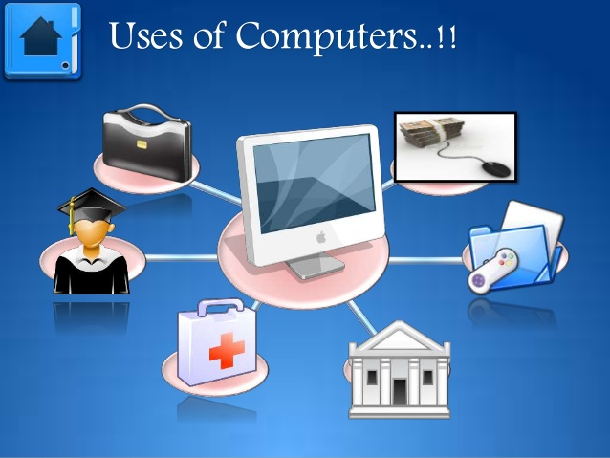**Objectives:**

The student should be able to:

* Describe the use of computers at home.
* List the use of computers in schools.
* Explain the use of computers in making films.

**Q.1 List four uses of computers at home?**

Ans. Computers are used at home for:

1. Playing games

2. Watching films

3. Writing letters

4. Listening to music

**Q.2 Are there any skills that you are not using anymore because of computers?**

Ans. I feel that I am not using certain skills like writing letters, as text messages and emails have replaced the need to do so. I am not using my dictionary-using skills because it is much easier to use online dictionaries.

**Q.3 Before computers, all official records such as school report cards, were either hand-written or typed using typewriters? How has the use of computers in schools changed this? Is it beneficial for you or for the school? Give reasons for your answers.**Ans. The use of computers in schools has benefitted schools because they can now create school report cards easily. The teachers can save a lot of time for other activities as they do not have to calculate students’ marks manually.

**Q.4 How are computers used in making films?**

Ans. Computers have made it easy to make cartoon films and other animations. With the help of computers pictures can be easily modified for making films. Computers also help in giving animation to the films.

* **Write T for the true statement and F for the false one.**

1. Computers are also used in homes. (T)
2. Computers are not used to watch movies. (F)
3. Animation is the technique of giving an object the appearance of movement. (T)

* **Choose the correct option.**

1. In which of the following areas are computers used?

1.home 2.office 3.bank 4.all of these

1. Students use computers for

1.preparing projects 2.performing operations 3.preparing bills 4.none of these

**Homework:** Read Page.2 from the book and explain the concept of animation.

**Topic: In Space Technology, In Offices, In Libraries**

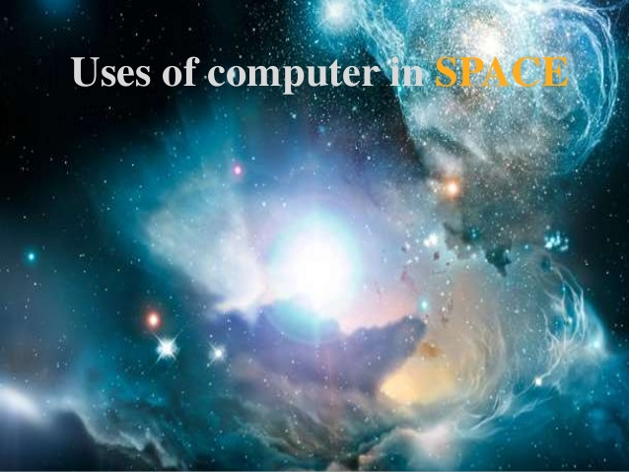**Objectives:**

* specify the use of computers in studying space.
* enumerate the use of computers in offices.
* list the use of computers in libraries.

**Q.1 How are computers used in space technology?**

Ans. Computers are used in space technology to monitor and control space equipment and satellites.

**Q.2 How are computers used in offices?**

Ans. Computers are used in offices to keep office records.

**Q.3 How are computers useful in libraries?**

Ans. In libraries, computers are used:

i. to maintain database of all books available there.

ii. to keep the track of issue and return of books.

* **Write T for the true statement and F for the false one.**

1. Computers are not used to monitor satellites. (F)
2. Computers are used in offices to maintain records. (T)
3. Computers are used in libraries to keep the track of issue and return of books. (T)

* **Complete these sentences using suitable words given.**

|  |  |  |  |  |  |
| --- | --- | --- | --- | --- | --- |
| **return** | **print** | **type** | **space** | **issue** | **computers** |

1. Computers are used in libraries to keep the track of issue and return of books.
2. Computers are used in offices to type and print documents.
3. Computers are widely used in space technology.
4. Space shuttles which take man into space are controlled by computers.

**Homework:** Read Book Page. 3 and explain why the use of computer is important in offices.