** E- Support and Learning Material / Session 2020-2021**

**PAKISTAN SCHOOL, M/O EDUCATION, KINGDOM OF BAHRAIN**

**Subject: Computer Grade: 2**

**Book: OXFORD KEYBOARD Book-2 (Third Edition)**

**FIRST TERM NOTES**

**Chapter 1:- A Smart Machine (Week 1)**

**Topic 1: - The Computer— A Machine**

**OBJECTIVE**

The student should be able to:

* **Identify** the computer as a machine

(i)Humans and Computers

* **Describe** differences between humans and computers.

**Q1. Write T for the true statement and F for the false one:-**

1. You should start and shut down a computer in the proper way. **__True___**
2. A desktop computer can run on battery. **__False**____
3. A labtop computer can be carried from one place to another. **__True___**
4. You should not switch off the UPS after shutting down the computer. **__True___**
5. The small pictures on the desktop are called images. **__False**____

|  |  |
| --- | --- |
| **Computers** | **Human beings** |
| A computer can work very fast. | Humans cannot work as fast as a computer. |
| A computer does not make a mistake. | Humans can make mistakes. |
| A computer never gets tired. | Humans do get tired after some time. |
| A computer can do the same work over and over again. It never gets bored. | Humans may sometimes get bored doing the same work over and over again. |
| A computer does not have any feelings, and it cannot take decisions. | Humans have feelings and they can take decisions. |

**Q2. Write the differences between humans and computers:-**

**Q3. List at least three tasks that computer can do but humans cannot. Do you think this is important to understand? Give reasons for your answer**

Ans: The following tasks can be done by computers.

1. A computer can do the same thing repeatedly without getting bored.
2. Computer have a very good memory and remember all the information unlike humans who may forget at times.
3. A computer can work much faster than humans.

------------------------------------------------------------------------------------------------------

**Chapter #1 (Topic 2: - Types of Computers)**

**OBJECTIVE**

The student should be able to:

* **Identify** computers based on size
* **Describe**  the different types of computers

**Q1.Fill in the blanks with correct words.**

1. The icons on the desktop are like small **__Pictures___.**
2. When you switch on the computer, the first screen that appears is called the **___desktop__.**
3. The power supply is kept ON to keep the **___UPS____** charged.
4. You can work on a tablet computer using your **___fingers___.**
5. Click the **__Start____** button to shut down the computer.

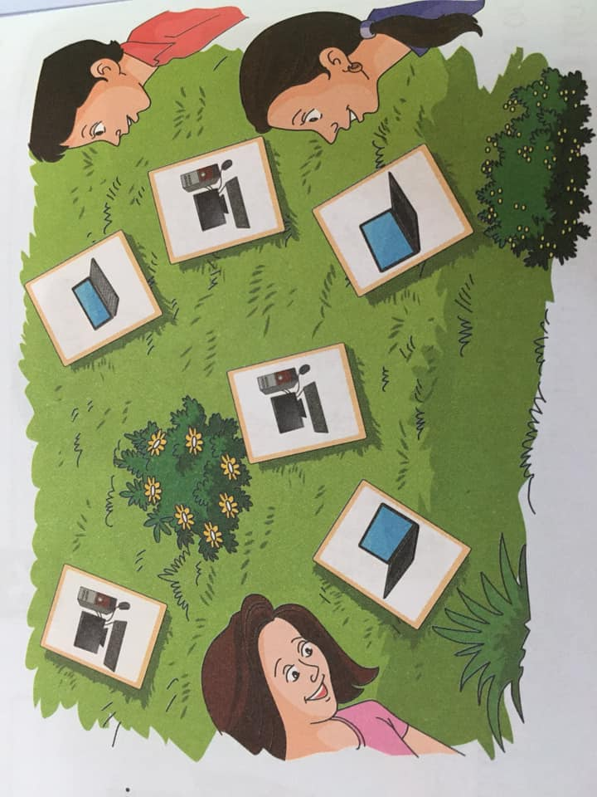**Q2 (a) Rohail and his friends were playing in the garden. One of them noticed some flash cards on the ground, the flash cards have a printer of a desktop, a laptop or a palmtop**

**Can you count the following:-**

A. Number of Desktop **__ 3________**

B.Number of Laptops **___2________**

C.Number of Palmtops **__1________**

**Q2 (b) Write Advantage and disadvantage of Desktop PC:-**

|  |  |
| --- | --- |
| **Advantages of Desktop PC** | **Disadvantages of Desktop PC** |
| Reasonably-priced, cheaper than laptops and tablets | Heavy to carry and move to another place. |
| Lots of memory space | Needs separate keyboard, mouse,  and monitor |
| Easy to upgrade and to repair | High power Desktop PCs produce noise |

**Q3.Circle or underline the correct options:-**

1. A type of computer:

(i)Desktop (ii) Labtop (iii) Palmtop **(iv) all of these**

1. The Full form of PC is

(i)Private computer **(ii) Personal computer** (iii) Pure computer (iv) Pilot computer

1. The small picture on the desktop are called

(i) Applications (ii) images **(iii) icons** (iv) diagrams

1. Which one is not true about a computer?

(i)Very fast (ii) never gets tired (iii) never make mistakes **(iv) can take decisions**

1. Which one is not true about humans?

(i) get tired after sometime (ii) have feelings

**(iii) never make mistake**  (iv)can take decision