

**E-support and learning Materials/session 2020-2021**

**Subject: Computer Grade: 1**

**Unit 1**: A Computer

**NOTES**

**PAKISTAN SCHOOL, M/O EDUCATION, KINGDOM OF BAHRAIN**

**FIRST TERM (Week 1)**

**TOPIC**: A machine

**Objectives**:-

* Identify the machines.
* Discuss different machines found inside and outside the house

**Q1: Identify the machines and circle it**:-



**Q2: Mark a (  ) in the box next to the machines that are used inside the house:**

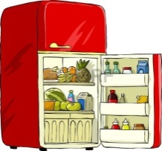 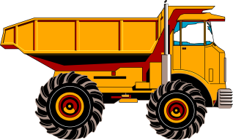



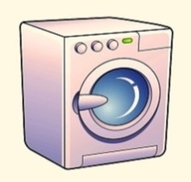



**Q3: Colour the machines used outside the house?**

