** E- Support and Learning Material / Session 2020-2021**

**PAKISTAN SCHOOL, M/O EDUCATION, KINGDOM OF BAHRAIN**

**Subject: Computer Grade: 2**

**Book: OXFORD KEYBOARD Book-2 (Third Edition)**

**FIRST TERM NOTES**

**Chapter 1:- A Smart Machine Week 2**

**Chapter #1 (Topic 3: - Starting and Shutting Down a Computer)**

**OBJECTIVE**

The student should be able to:

* **Identify** Starting a computer

1. Shutting down a computer

* **Describe**  the steps to Start a Computer

(i) Steps to shut down a computer

**Q1 (a) The Steps to start a computer are given below, Number the Steps in the correct order:-**

1. Switch on the monitor

b

d

1. Switch on the UPS.

c

1. Switch on the Power button on the CPU cabinet.

a

1. Switch on the main supply.

**Q1(b) Write the correct words from the given jumbled words:-**

1. **K S E T P D O**

Hint: This is a kind of computer kept on a desk.

Ans: **___Desktop_________**

1. **N S C O I**

Hint: These are the small pictures that appear on the desktop.

Ans: **___Icons_________**

1. **T R A S T**

Hint: This is a button present at the bottom left corner of the desktop.

Ans: **__Start________________**

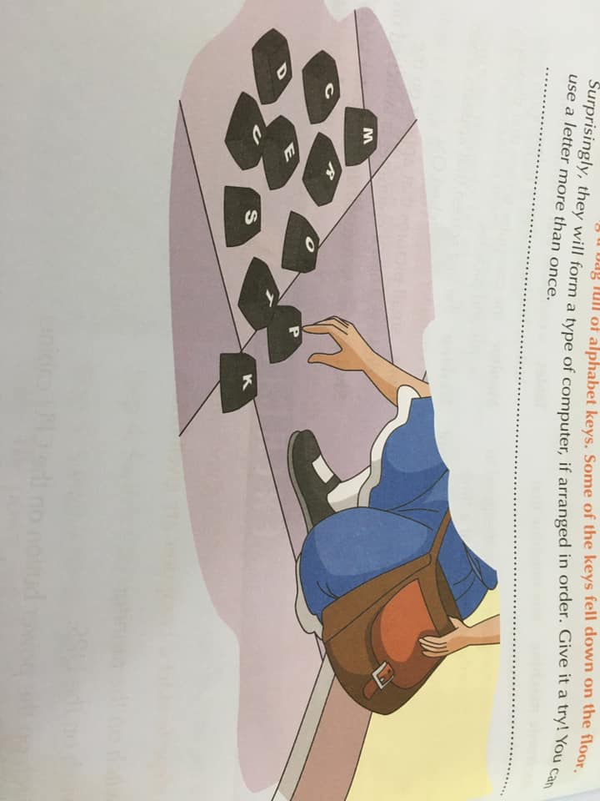**Q2 (a) Sonia was holding a bag full of alphabet keys. Some of the Keys fell down on the floor:-**

Surprisingly, they will form a type of computer, if arranged in order. Give it a try! You can use a letter more than ones.

Ans: **____________________ Desk Computer___________________**

**Q2 (b) Look at the following pictures carefully and name them:-**

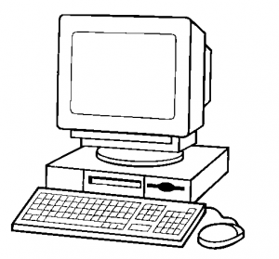

**Start button**

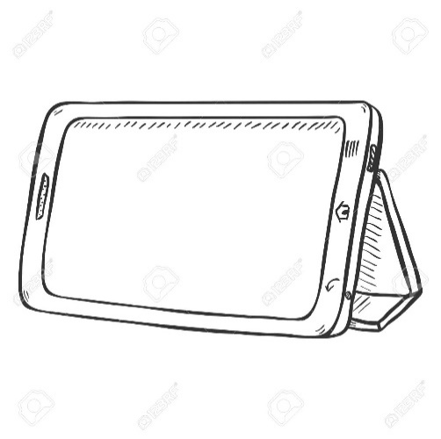 **Desktop Computer__**

**Tablet**

**Q3.Answer the following:-**

1. **Why is it important to always turn on and turn off the computer in the correct way?**

Ans: A computer is an electronic machine. It is very important that we open and shut down the computer properly. For example, directly turning the power off can damage the computer.

1. **Where do you think the name “icons” comes from? Do icons remind you of anything?**

Ans: - Icon is a **Latin and Greek** word which means image or picture. An icons is a small pictures that appear on the desktop.

1. **Would you like to have a desktop, a labtop, a palmtop, or tablet in your home? Give reasons for your answer.**

Ans: I would like to have a laptop for the following reasons:

* It is easy to carry around, as it is smaller and is lightweight.
* It can operate from a battery instead of a power cable.
* It is small enough to use on your lap.

**OR**

I would like to have a palmtop for the following reasons:

* I can carry it in my pocket.
* It is very handy and convenient.
* It runs on a battery instead of a power cable.

**OR**

I would like to have a tablet for the following reasons:

* It is convenient to carry.
* It has a touch screen so you can use it with your fingers or a pen-like device.
* It runs on a battery instead of a power cable.

**GOOD LUCK**

---------------------------------------------------------------------------------------------------------------------