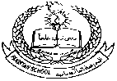**Pakistan School, Kingdom of Bahrain**

**E- Support and Learning Material / Session 2020-2021**

**Subject: Computer Grade: 4**

**Book: Oxford Keyboard Book 4 (Third Edition) FIRST TERM**

**Unit 1: Uses of Computers Week 2**

**Topic: In Medicine, In Banks, In Designing, In shops and Hotels**

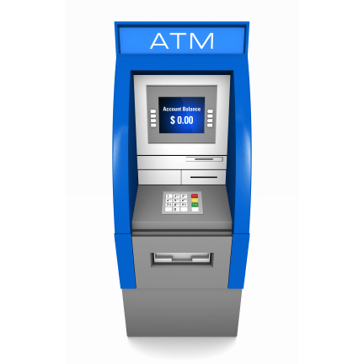**Objectives:**

|  |
| --- |
| * describe the use of computers in medicine. |
| * outline the use of computers in banks. |
| * explain the use of computers in designing. |
| * list the use of computers in shops and hotels. |

**Q.1 How are computers used in the field of medicine?**

Ans. Computers are used to maintain medical records of patients and to prepare medicines.

**Q.2 How are computers used in banks?**

Ans. Computers are used in banks to verify cheques.

**Q.3 What is the use of an ATM?**

Ans. An ATM is used for withdrawing money at any time.

**Q.4 How are computers used in designing?**

Ans. Computers are used to design buildings, houses, cars and dresses.

**Q.5 How are computers used in shops and hotels?**

Ans. Computers are used in shops for:

1. Maintaining records of stock.
2. Prices of items.
3. Preparing bills.
4. Managing security cameras.

* **Write T for the true statement and F for the false one.**

1. Computers can be used in shops for preparing bills. (T)
2. Computers are used in banks. (T)
3. Computers are used by engineers to diagnose diseases. (T)

* **Choose the correct option.**

1. A/An _____________ designs building and houses on computes.

1.architect 2.doctor 3.shopkeeper 4.none of these

b. The full form of ATM is _____________

1. automated teller machine 2. automatic telling machine

3. automatic teller machine 4. none of these

c. Computers are used to design _____________

1. houses 2. Buildings 3.cars 4.all of these

**Homework:** Tanya urgently needs some money. Since it is a bank holiday. How can she get the money if she does not want to borrow it?

**Topic: In Computer – Controlled Cameras, In Robots, In Airline and Railway Reservation Offices**

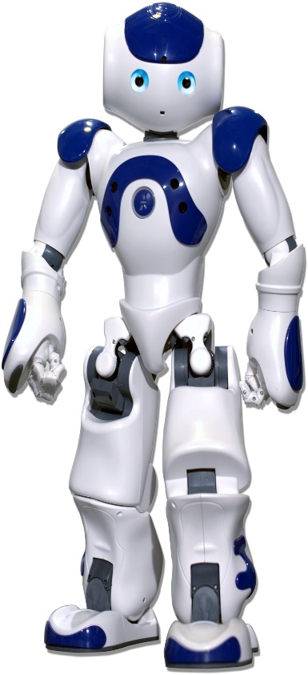**Objectives:**

|  |
| --- |
| * describe the use of computers in computer-controlled cameras. |
| * list the use of computers in robots. |
| * list the use of computers at airports. * describe the use of computers at railway stations. |

**Q.1 Write down any two uses of computer-controlled cameras?**

Ans.

1. On motorways they help to check vehicles.
2. Doctors use tiny cameras to look inside the human body.

**Q.2 What do you know about Robots?**

Ans. Robots are machines controlled by computers. They can be made to look like humans. They can do some work that humans cannot do.

**Q.3 Write any three uses of Robots?**

Ans.

1. Robots can help to know about space.
2. Robots can help doctors perform operations.
3. Robots can also go inside active volcanoes.

**Q.4 Do you think that computers have made places like shopping malls, airports, and hotels more secure in today’s society? Justify your response with good examples.**

Ans. Computers have made places like shopping malls, airports, and hotels more secure in today’s society with the use of CCTV cameras. CCTV cameras in public places help ensure public safety because they are being monitored for any suspicious activity.

**Q.5 Write the use of computers at railway stations?**

Ans. Computers are used in at railway stations to book tickets.

* **Write T for the true statement and F for the false one.**

1. Robots cannot be controlled by computers. (F)
2. Robots are human like machines. (T)
3. Robots cannot go inside active volcanoes. (F)

* **Choose the correct option.**

1. Computers are used for ticket reservations at the booking counters of ___________

1. railway stations 2.airports 3.both 1 and 2 4.none of these

b. Which of the following tasks is performed by robots?

1.help explore planets 2.handle dangerous chemicals

3. help doctors perform operations 4.all of these

**Homework:** Read Book Page. 5 and explain how computers are used by the police?

**Exercises Ref. Book Page # 6, 7**