**Pakistan School , Kingdom of Bahrain**

**E- Support and Learning Material / Session 2020-2021**

**Subject: English Grade : 6th**

**Book: Student Book 6 FIRST TERM**

**Unit 1 :- Frog Facts**

|  |  |  |
| --- | --- | --- |
| **SN** | **Words** | **Meanings** |
|  | depression | pushing down |
|  | damp | slightly wet |
|  | swell | increase in size |
|  | croak | to make a deep and harsh sound |
|  | clump | a group of similar things |
|  | devour | destroy completely |

|  |  |  |
| --- | --- | --- |
| **SN** | **Words** | **sentences** |
|  | depression | Scientists have found that chocolate has a chemical which helps fight depression. |
|  | damp | The climate is damp and hot. |
|  | swell | He seemed to swell with satisfaction. |
|  | croak | I had a sore throat and could only croak. |
|  | clump | There is a clump of bushes at the end of field. |
|  | devour | The lions devoured their prey. |

**Comprehension Skills (page :- 6)**

**Answer the following questions :-**

|  |  |
| --- | --- |
| **Q1.** | Which is larger, the male or female frog ? |
| **Ans.** | Female frogs are usually larger than male frogs. |

|  |  |
| --- | --- |
| **Q2.** | How many eggs are in a clump? |
| **Ans.** | There can be up to three thousand eggs in a clump. |

|  |  |
| --- | --- |
| **Q3.** | What does the tadpole do as soon as it hatches? |
| **Ans.** | The tadpole attaches to a weed after hatching. |

|  |  |
| --- | --- |
| **Q4.** | What are the main changes between the third and eighth week of a tadpole’s life? |
| **Ans.** | In the third week the external gills shrink and internal grow whereas in eighth week back legs form and air is breathed into the lungs . |

|  |  |
| --- | --- |
| **Q5.** | What is unusual about the way some tree frogs lay their eggs? |
| **Ans.** | A tree frog places its spawn in a folded leaf over a stream so that when the young tadpoles hatch they drop it into the stream and pond. |

|  |  |
| --- | --- |
| **Q6.** | Describe what a frog mostly feeds on? |
| **Ans.** | A frog mostly feeds on flies and other insects. |

|  |  |
| --- | --- |
| **Q7.** | What do these words mean?   1. Ectothermic (b) Metamorphosis |
| **Ans.** | Ectothermic :- It means cold blooded animals. Their body temperature remains similar to their surroundings.  Metamorphosis:- It is a process by which an animal physically develops after birth or hatching. |

**Language Skills :- (page:- 6)**

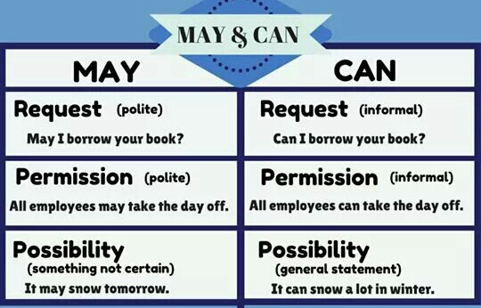**Using ‘may’ and ‘can’.**

**Write these sentences, putting *may* or *can* in the gaps.**

1. **May** we come with you ?
2. **Can** you see the frogs in the muddy water?
3. They **can** adjust their body temperature to match their surroundings.
4. **May** we take some frogspawn home?
5. You **can** if you **may** find a container, and if you promise to return the tadpoles to the pond later.

**‘re’ and ‘ex’ prefixes :- (page :- 7)** 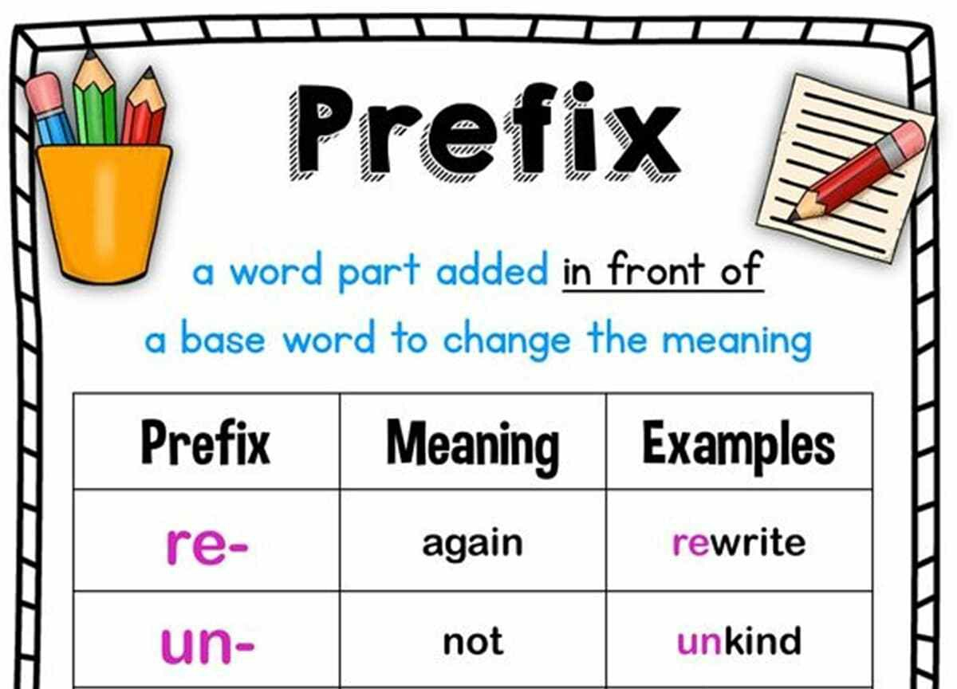

**Ex. A:- Some of these *ex* and *re* words are in the passage about frogs. Write what each word means .**

1. External means **Outside**
2. Return means **Come back**
3. Release means **Set free**
4. *Replace* means  **Exchange**
5. Recommence means **Begin again**

**Ex. B :- Select a word from the box to complete these sentences. (page :- 7)**

***expected relieved*** ***extend refused***

***exhausted replace express recall***

***expected relieved*** ***extend refused***

***exhausted replace express recall***

1. Our father asked if we could ***recall*** where we had found frogspawn last year.
2. He ***expected*** that we would find some frogspawn in the same pond this year.
3. We enjoyed hunting around in the pond so much he allowed us to ***extend*** our stay by an hour.
4. Our father ***refused*** to touch any rare creatures or plants .
5. By the time we reached home we were all ***exhausted*** after such a long walk.

**Ex. C :- Write three interesting sentences which include the words. (page :- 7)**

|  |
| --- |
| **Relieve :-** She blinked to relieve the stinging in her eyes. |
| **Express :-** I cannot find words to express to you my displeasure. |
| **Replace :-** Maybe when she got back she could replace her old one. |

**Adjectives and Adverbs :- (Page 8)** 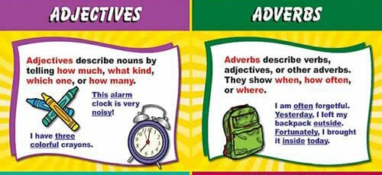

**Copy these sentences, and use a ruler to underline the adjectives in red and the adverbs in blue.**

1. A Little boy looked excitedly at the frogspawn.
2. Walk quietly so as not to frighten the tiny creatures.
3. Tomorrow we shall go to the bigger pond.
4. We shall go there in the white minibus.
5. Gently, she lifted the delicate creature on to her hand.

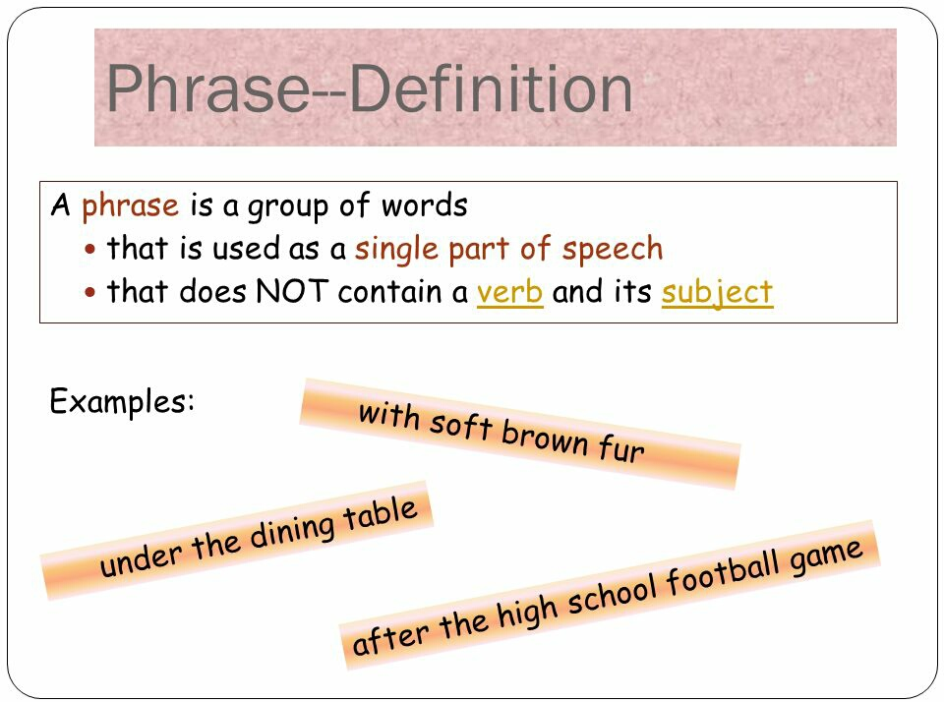**Phrases :- (Page 8)**

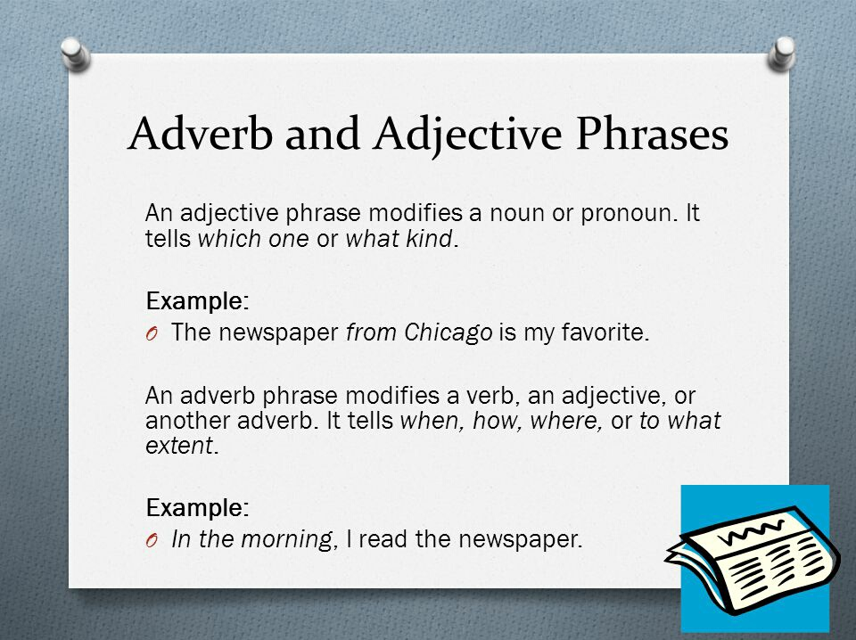

**Copy these sentences. Underline a phrase in each and write *adjective phrase* or *adverb phrase* after it.**

1. They were sitting on the bank of the river. *(adverb phrase*)
2. We ran as fast as our legs would carry us. (*adverb phrase)*
3. The male frog, smaller than the female, was croaking loudly. (*adjective phrase*)
4. The newts, sleek and delicate, could be seen basking in the sun. *(adjective phrase*)
5. We sat quietly and attentively, watching the female frog. *(adverb phrase*)
6. Her tiny but energetic tadpoles were eating the weeds. (*adjective phrase*)