**Pakistan School , Kingdom of Bahrain**

**E- Support and Learning Material / Session 2020-2021**

**Subject: English Grade :6th**

**Unit 1: Frog Facts Pg. No: 4-5**

**Homework:- Print and complete the work. Stick it in your notebooks with date.**

**Select any two species of frog, Search about them, give an introduction paragraph and at least 4 facts about it :-**

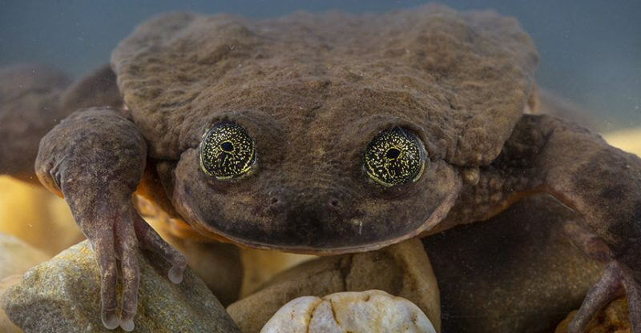

***Bolivian frog***

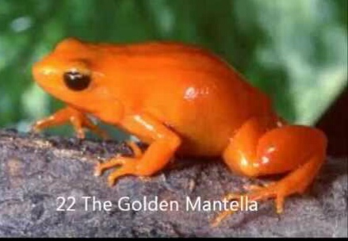

***The Golden Mantella***

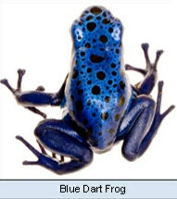

***Blue Dart Frog***

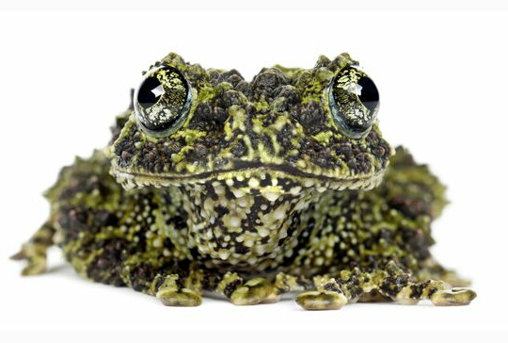

***Bizarre Frog***

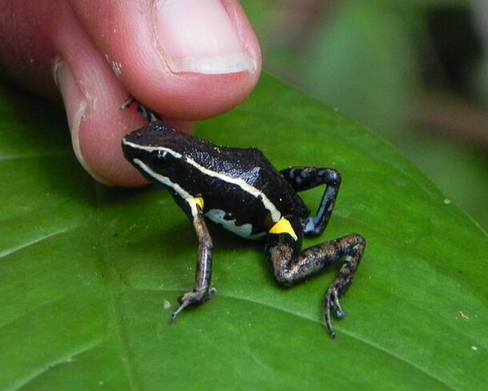

***Amazon Poison Dart Frog***