**Pakistan School , Kingdom of Bahrain**

**E- Support and Learning Material / Session 2020-2021**

**Subject: English Grade : 6th**

**Unit 1: Frog Facts Pg. No: 04**

**Worksheet:1 (Type your answers. Then print and stick in your notebooks>)**

***Life cycle of frogs***

**Q1. Describe the pictures in your own words /Describe each stage in your own words:-**

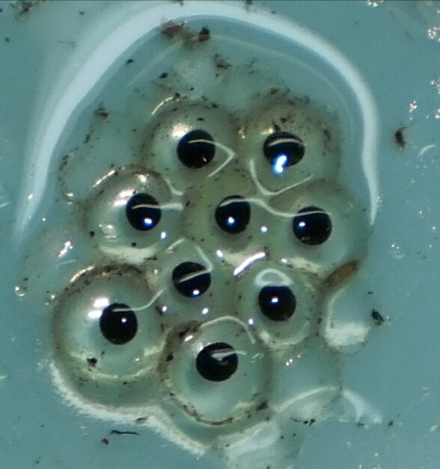

**Frogspawn:-**

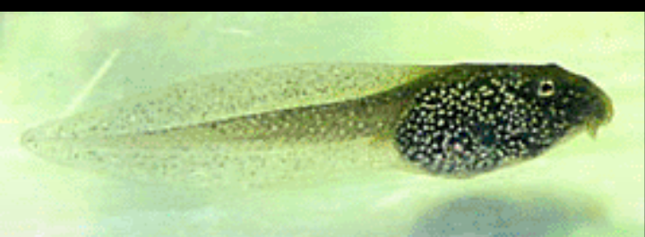

**Day 1:-**

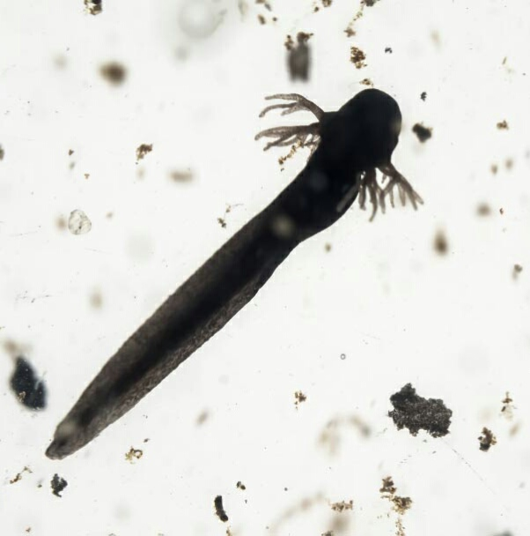

**Day 3 :-**

**3 weeks :-**

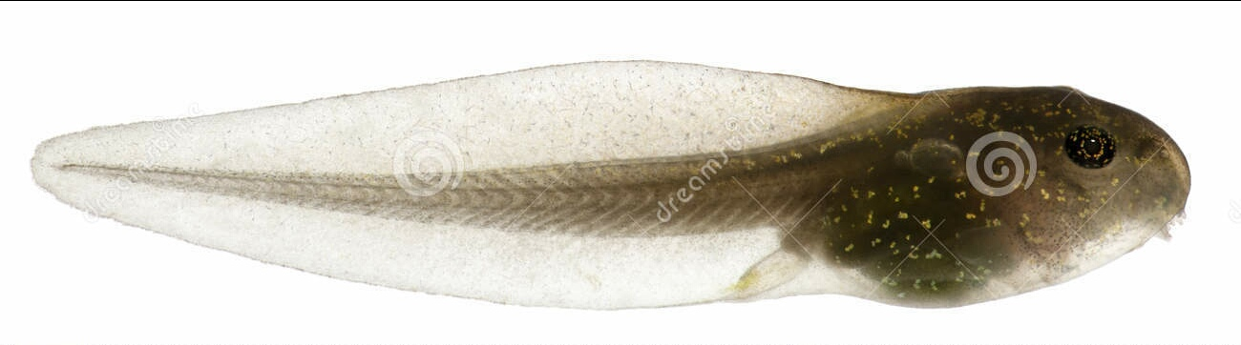

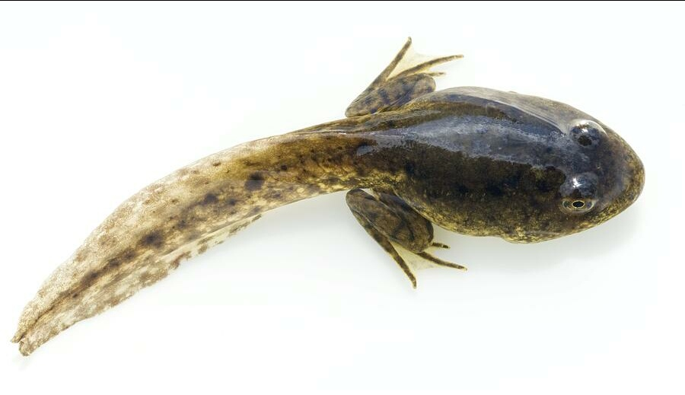

**8-10 weeks :-**

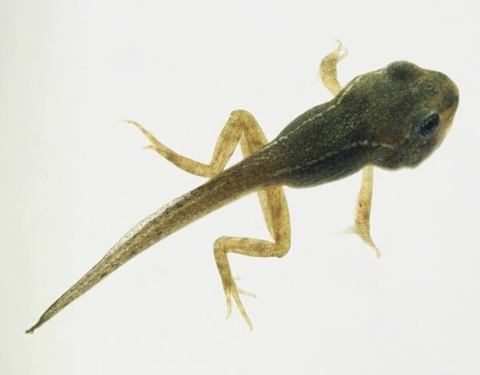

**12 weeks :-**

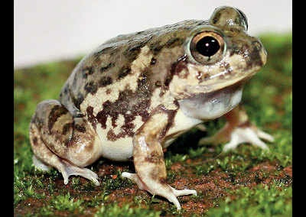

**14-16 weeks :-**

**Q2. Frog Fact File:-**

**Complete the sentences :-**

* Frogs are very useful creatures as they ___________________________.
* The tree frog places its spawn in a ______________________________.
* Frogs are amphibians ________________________________________.
* Many frogs lay their eggs in clumps; others lay ____________________.
* Most frogs can jump____________________________.
* The biggest frog is the ______________________.It can have a body length of _________.
* Frogs are ectothermic,_______________________________________.
* The process metamorphosis is in which tadpole’s body ______________________________________.

**Q3. Describe how a frog’s tongue work:**

**________________________________________________________________________________________________________________________________________________________________________________________________________________________________________________________________**