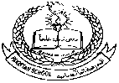**Pakistan School , Ministry of Education , Kingdom of Bahrain**

**E-Support and Learning /Session 2020-2021**

[](https://www.google.com/url?sa=i&url=https://creazilla.com/nodes/6267-panda-with-bamboo-clipart&psig=AOvVaw3YGF29ddU7NaIxbnmbcPX1&ust=1584685424704000&source=images&cd=vfe&ved=0CAIQjRxqFwoTCIij0LDzpegCFQAAAAAdAAAAABAD) **Subject : English - Grade : I**

**First Term**

**Book: Student Book 1 Pg.No – 4/5**

**Unit 1 : Animals**

1. **Vocabulary words**

b-e-a-r

bear

f-o-r-e-s-t

forest

[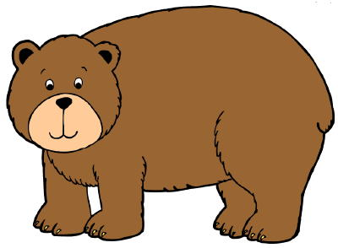](https://www.google.com/url?sa=i&url=https://clipartart.com/categories/free-bear-clipart-images.html&psig=AOvVaw3fbVwzbHIUhDKKnJOTc-yf&ust=1584685834624000&source=images&cd=vfe&ved=0CAIQjRxqFwoTCNiGyPr0pegCFQAAAAAdAAAAABAD)[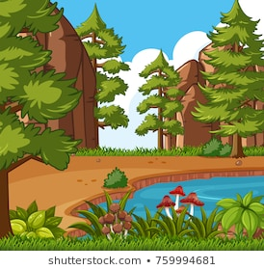](https://www.google.com/url?sa=i&url=https://www.shutterstock.com/search/forest%2Bclipart&psig=AOvVaw0_Tz_xNYAe1a0amMyn9ILs&ust=1584686109396000&source=images&cd=vfe&ved=0CAIQjRxqFwoTCMDIiPj1pegCFQAAAAAdAAAAABAD)

m-o-u-n-t-a-i-n

mountain

b-a-m-b-o-o

bamboo

[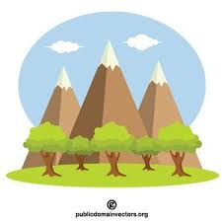](https://www.google.com/url?sa=i&url=https://publicdomainvectors.org/en/tag/mountain&psig=AOvVaw1isGlmxAghtKjgF84H4SPE&ust=1584686783672000&source=images&cd=vfe&ved=0CAIQjRxqFwoTCICipbn4pegCFQAAAAAdAAAAABAD)[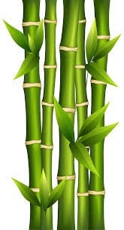](https://www.google.com/url?sa=i&url=https://clipartart.com/categories/small-bamboo-clipart.html&psig=AOvVaw2sYxUKJmPkEdSztT5wFqax&ust=1584686634052000&source=images&cd=vfe&ved=0CAIQjRxqFwoTCJiggfH3pegCFQAAAAAdAAAAABAD)

[](https://www.google.com/url?sa=i&url=https://clipartstation.com/china-clipart-2-3/&psig=AOvVaw0ZjAgWp9fCNQ8ZKbTUSV1u&ust=1584687764479000&source=images&cd=vfe&ved=0CAIQjRxqFwoTCPi29Iz8pegCFQAAAAAdAAAAABAJ)[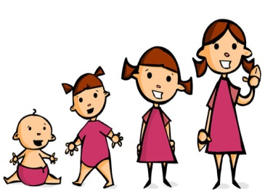](https://www.google.com/url?sa=i&url=https://www.clipart.email/clipart/child-growing-clipart-19848.html&psig=AOvVaw11ZgH2dJk9aAvnf11n7a6y&ust=1584686904347000&source=images&cd=vfe&ved=0CAIQjRxqFwoTCLiq9vP4pegCFQAAAAAdAAAAABAZ)

C-h-i-n-a

China

g-r-o-w

grow

**II- Write the meanings of :**

|  |  |
| --- | --- |
| **Words** | **Meanings** |
| 1. giant | huge |
| 2. fur | soft hair of animals |
| 3. kind | gentle |

[](https://www.google.com/url?sa=i&url=https://creazilla.com/nodes/6267-panda-with-bamboo-clipart&psig=AOvVaw3YGF29ddU7NaIxbnmbcPX1&ust=1584685424704000&source=images&cd=vfe&ved=0CAIQjRxqFwoTCIij0LDzpegCFQAAAAAdAAAAABAD)

III – **Answer these questions:**

Q1). What do pandas eat?

Ans). Pandas eat bamboo.

[](https://www.google.com/url?sa=i&url=https://clipartstation.com/china-clipart-2-3/&psig=AOvVaw0ZjAgWp9fCNQ8ZKbTUSV1u&ust=1584687764479000&source=images&cd=vfe&ved=0CAIQjRxqFwoTCPi29Iz8pegCFQAAAAAdAAAAABAJ)

Q2). Where do pandas live?

Ans). Most Pandas live in China.

**IV - Make sentences:**

|  |  |
| --- | --- |
| **Words** | **Sentences** |
| 1. bamboo | A panda likes to eat bamboo. |
| 2. giant | Panda is a giant animal. |
| 3. black | I have a black hat |

**Student Book 1 (Page # 4, Exercise A)**

[](https://www.google.com/url?sa=i&url=https://creazilla.com/nodes/6267-panda-with-bamboo-clipart&psig=AOvVaw3YGF29ddU7NaIxbnmbcPX1&ust=1584685424704000&source=images&cd=vfe&ved=0CAIQjRxqFwoTCIij0LDzpegCFQAAAAAdAAAAABAD)

**Look at the pictures and choose the correct ending.**

1). The panda has **black / white** ears.

2). In the big picture the panda is **asleep. / looking for food.**

3). The panda finds its food **in the forest. / in the river**.

**Student Book 1 (Page # 5, Exercise B)**

**Choose the correct words and complete the sentences:** **(Page # 5, Exercise B)**

[](https://www.google.com/url?sa=i&url=https://creazilla.com/nodes/6267-panda-with-bamboo-clipart&psig=AOvVaw3YGF29ddU7NaIxbnmbcPX1&ust=1584685424704000&source=images&cd=vfe&ved=0CAIQjRxqFwoTCIij0LDzpegCFQAAAAAdAAAAABAD)

1). A panda is a kind of bear. ( bear or dog )

2). Most of its fur is coloured white. ( black or white )

3). Its ears and legs are black. ( white or black )

4). Pandas like to eat bamboo. ( grass or bamboo )

**Student Book 1 (Page # 5, Exercise C)**

[](https://www.google.com/url?sa=i&url=https://creazilla.com/nodes/6267-panda-with-bamboo-clipart&psig=AOvVaw3YGF29ddU7NaIxbnmbcPX1&ust=1584685424704000&source=images&cd=vfe&ved=0CAIQjRxqFwoTCIij0LDzpegCFQAAAAAdAAAAABAD)**Write True or False:**

1). Pandas live in large groups. **( False )**

2). Pandas live on their own. **( True )**

3). Most Pandas live in India. **( False )**

4). They look friendly. **( True )**

5). Pandas don’t like eating bamboo. **( False )**

6). Most of them live in China. **( True )**

**Student Book 1 (Page # 6, Exercise A)**

**Write the correct rhyming words for the given words:**

sleep , tree , wish , log , how , luck

[](https://www.google.com/url?sa=i&url=https://creazilla.com/nodes/6267-panda-with-bamboo-clipart&psig=AOvVaw3YGF29ddU7NaIxbnmbcPX1&ust=1584685424704000&source=images&cd=vfe&ved=0CAIQjRxqFwoTCIij0LDzpegCFQAAAAAdAAAAABAD)

1). duck - **luck**

2). fish - **wish**

3). frog - l**og**

4). sheep - **sleep**

5). cow - **how**

6). bee - **tree**

**Student Book 1 (Page # 6, Exercise B)**

**Write the correct rhyming words to fill each gap.**

coat , socks , hat , pants

1). Did you ever see a cat wearing a **hat**  ?

2). Did you ever see a goat wearing a **coat** ?

3). Did you ever see ants wearing pink **pants** ?

4). Did you ever see a fox wearing green **socks** ?

**Student Book 1 (Page # 7, Exercise A)**

**Write the letters which come after the given letters.**

1. a **___b___** 2. d **___e___** 3. j **__k____** 4. s **__t____** 5. w **___x___**

**Write the missing letters.** **(Page # 7, Exercise B)**

1. a **b**  c 2. f  **g**  h 3. n **o**  p 4. t  **u**  v 5. x  **y**  z

**Student Book 1 (Page # 7, Exercise C)**

**Write the missing letters.**

1. ant ___**a**___

2. bee ___**b**___

3. camel ___**c**___

4. dolphin ___**d**___

5. elephant ___**e**___

6. frog ___ **f**___

**Student Book 1 Writing Skills (Page # 7, Exercise A)**

**Write the capital letters for the given small letters.** **(Page # 7, Exercise A)**

1. a **A**  2. o  **O**  3. c **C**  4. p  **P**  5. d  **D**

6. f **F**  7. g  **g**  8. l **L**  9. i  **I**  10. y  **Y**

**Student Book 1 Writing Skills (Page # 7, Exercise B)**

**Put in the missing capital letters and full stops.**

1. owls can see in the dark

1. **O**wls can see in the dark **.**

2. a frog has long back legs

2. **A** frog has long back legs **.**

3. whales are the biggest animals

3. **W**hales are the biggest animals **.**

4. pandas have black legs

4. **P**andas have black legs .