

**PAKISTAN SCHOOL , KINGDOM OF BAHRAIN.**

**E-Support and Learning Material/Session 2020-2021**

**Subject: English Grade: 2**

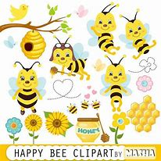

* **Unit : 1 Bees: page No: 4**
* **Vocabulary Words**

**k-i-n-d**

**kind**

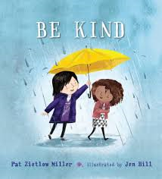

**d-r-o-n-e-s**

**drones**

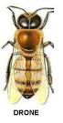

**w-o-r-k-e-r**

**worker**

**l-i-v-e**

**live**

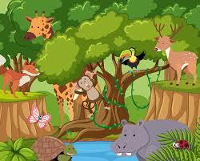

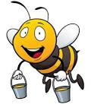

S





**b-i-g-g-e-s-t**

**q-u-e-e-n h-i-v-e f-i-n-d biggest**

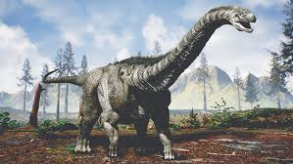 **queen** **hive find**

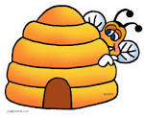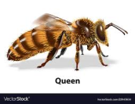

**Q: Write the meanings of given words.**

|  |  |  |
| --- | --- | --- |
| **S.N** | **Words** | **Meanings** |
| 1. | hive | house of bees |
| 2. | find | to get |
| 3. | kind | type |

**COMPREHENSION SKILLS . TEXT BOOK PAGE (5)**

**Q: Fill in the missing words to complete the sentences.**

1: There are **three** kinds of bees in a hive .

2: Male bees are called **drones** .

3: The smallest bees are the **worker** bees .

**Q: Make meaningful sentences using these words.**

|  |  |  |
| --- | --- | --- |
| **S.N** | **Words** | **Sentences** |
| 1. | bees | Bees give us honey. |
| 2. | little | She has a little doll. |
| 3. | eggs | I like to eat eggs. |
| 4. | feed | I feed my pet cat. |

**COMPREHENSION SKILLS . TEXT BOOK PAGE (5)**

* **Answers the following questions.**

Q:1 Where do bees live?

Ans: Bees live in a hive.

Q: 2 Which is the biggest bee in the hive?

Ans: The queen bee is the biggest bee in the hive.

Q: 3 Why do the worker bees need to feed the queen bee?

Ans: Worker bees need to feed the queen bee because she stays in hive all the time.



**PAKISTAN SCHOOL , KINGDOM OF BAHRAIN.**

**E-Support and Learning Material/Session 2020-2021**

**Subject: English Grade: 2**

**Topic : “ee” and “ea” Patterns: Text Book page (6)**

**Q: Draw 2 leaves and write some “ee” and “ea” sound words on them.**



**“ee” “ea”**

bee , tree seat , meat

see , knee sea , beat

meet leaf