**PAKISTAN SCHOOL , KINGDOM OF BAHRAIN**

**E-Support and Learning Material/Session 2020-2021**

**Subject: English Grade: 2**

**UNIT : 1 Bees ACTIVITY : 1**

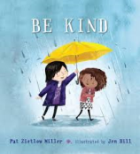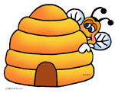**Q: Write the missing letters: Text Book page (4)**

1: h ___ v ___ 2: k ___ n ___

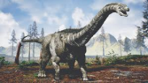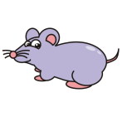

3: s ____ a ____ _____ 4: b ___ g g ___ r

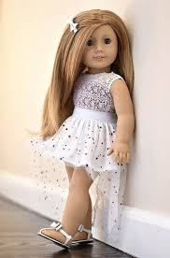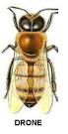

5: d ____ o ____ e 6: l ____ t ____ l e

**Q: Write one word answers of the following questions. Text Book PG. (4)**

1: What are the male bees called?

Ans: ____________________________________________________

2: How many kinds of bees live in a hive?

Ans: _____________________________________________________

**Q: Draw or stick a picture of bee and colour in it.**

**Home work: Write any 5 more vocabulary words from Text Book Pg. (4)**



**PAKISTAN SCHOOL , KINGDOM OF BAHRAIN**

**E-Support and Learning Material/Session 2020-2021**

**Subject: English Grade: 2**

**UNIT : 1 Bees ACTIVITY : 2**

**Q: 1 Make meaningful sentences using these words.**

|  |  |
| --- | --- |
| **Words** | **Sentences** |
| queen C:\Users\Qurrat ul Ain\Desktop\queennn.png |  |
| C:\Users\Qurrat ul Ain\Desktop\food.png  food |  |
| C:\Users\Qurrat ul Ain\Desktop\finddd.png  find |  |

**Q: 2 Read the 2nd passage from Text book page (4) and find whether the statements are True or False:**

1: The smallest bee is the queen . ___________

2: The worker bee feed the queen bee. _________

3: The queen bee lays eggs all the time. _________

**Q: 3 Draw or stick the picture of bee hive and colour it.**

**Home work: Choose any 3 more words from Text Book page (4) and make sentences of your own.**

**Note: Solve these worksheets, print them and stick in your notebooks.**