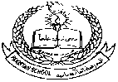**Pakistan School , Kingdom of Bahrain**

**E- Support and Learning Material / Session 2020-2021**

**Subject: English Grade : 3**

**Book: Nelson English Book 3 FIRST TERM**

**Lesson 1: The Wooden Horse, Pg 4-5**

**Vocabulary Words**

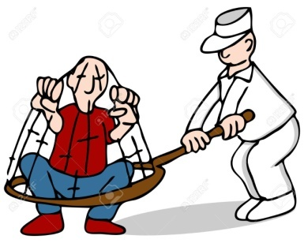 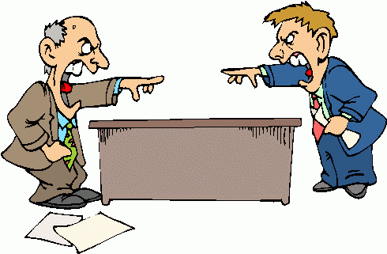

**c – a – p – t- u – r - e a – r – g- -u – m –e –n -t**

**capture argument**

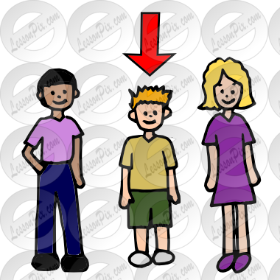 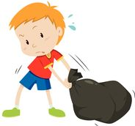

**m – i- d – s – t d – r –a – g – g – e – d**

**midst dragged**

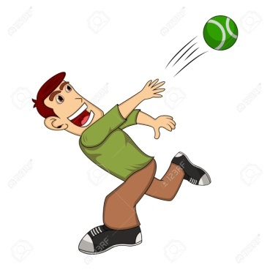 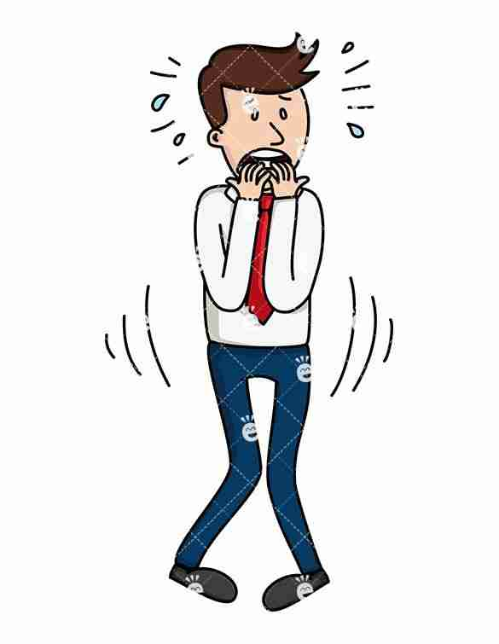

**f– l – i – n –g t – r – e – m – b – l – i – n – g**

**fling trembling**

**Practice dictation sentences**

1. The ancient Greeks fought many wars.
2. The camp lies in ashes.
3. The gates of Troy were flung open.

**Word Meanings**

|  |  |  |
| --- | --- | --- |
| 1 | Capture | to take by force |
| 2 | Midst | middle |
| 3 | Argument | an exchange of different ideas |
| 4 | Dragged | pulled |
| 5 | Fling | to throw by force |

**Word Sentences**

|  |  |  |
| --- | --- | --- |
| 1 | capture | The photo did not capture the full beauty of the valley. |
| 2 | midst | The table is in the midst of the room. |
| 3 | argument | We should not have unnecessary arguments. |
| 4 | dragged | I dragged my bag out of the room. |
| 5 | fling | Do not fling the ball at him. |

**Comprehension Skills: Questions and Answers – Pg 5**

Q1: Who was the king of troy?

Ans: King Priam was the king of Troy.

Q2: How do you think the Trojans felt when they saw that the Greeks had gone?

Ans: The Trojans felt happy and excited when they saw that the Greeks had gone.

Q3: What did the Trojans do with the wooden horse?

Ans: They brought it inside the city of Troy.

Q4: Who was inside the wooden horse?

Ans: The Greek army was inside the wooden horse.

Q5: What did they do?

Ans: When the first light of morning came, they slowly crept out of the wooden horse and opened the gates for the Greek army.

**Writing Skills: Planning a story (Pg 7)**

**Look at the pictures and write the beginning , middle and end of the story.**

**Title: 'The Big Bully'**

**Beginning of the story:**

One day Sara and Ali were walking down a lane when suddenly a boy on a bicycle came up behind them.

**Middle of the story:**

He snatched their basket and rode on looking back at them.

**End of the story:**

As he was looking back at them, he didn’t see the tree in front and smashed into it.