**Pakistan School, Kingdom of Bahrain**

**Class: 3 Section: ________ Subject: English**

**Name: ___________________ Please encircle: Isa town/ Manama campus**

**Lsn 1: The Wooden Horse (Pg 4-5)/ Activity 1**

**Q1: Find words from the text which match the following meanings.**

1. Very old : _________________________
2. Having a wall all over : _________________________
3. To take by force : _________________________
4. For sure : _________________________
5. Middle : _________________________

**Q2: Give one word answer:**

1. Who won the Trojan war ? _________________
2. Who ruled Troy? _________________
3. How long did they try to capture Troy? _________________
4. What was there in the midst of the ruins? _________________

**Q3: Write whether the statements are True or False:**

1. People of Troy are called Trojans. _______________
2. Troy was a walled city. _______________
3. There was no Wooden Horse in the midst of the ruins. _______________

**Q4: Color the picture of the Wooden Horse and write one line about what you think of it.**

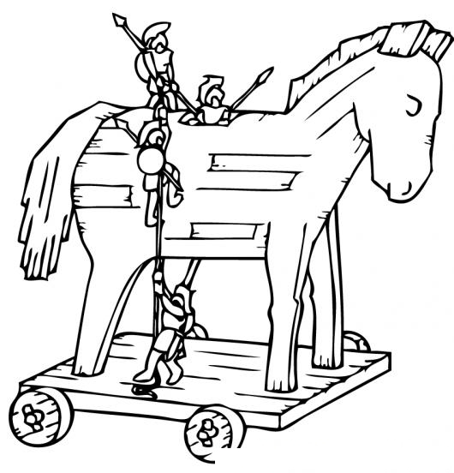

1:_____________________________________

_____________________________________

_____________________________________

_____________________________________

**Pakistan School, Kingdom of Bahrain**

**Class: 3 Section: ________ Subject: English**

**Name: _______________________ Please encircle: Isa town/ Manama campus**

**Lsn 1: The Wooden Horse (Pg 4-5)/ Activity 2**

**Q1: Match the words with their suitable meaning.**

|  |  |  |  |
| --- | --- | --- | --- |
|  |  |  | Ans |
| 1 | Argument | a big meal |  |
| 2 | Dragged | shaking with fear or cold |  |
| 3 | Trembling | pulled |  |
| 4 | Feast | having different views on a topic |  |

**Q2: Give one word answer.**

1. Did the Trojans agree on one thing in the beginning? ________________
2. Was it easy to bring the horse into Troy? ________________
3. Who was inside the Wooden Horse? ________________

**Q3: Circle the correct answer from the brackets.**

1. Some wanted to fling the horse into the (sea/ desert) while other wanted to bring it inside

(Troy/ Greece).

1. They (celebrated/ cried) in their joy.
2. They had a (big/ small) feast.
3. Inside the Horse the (Greeks/Trojans) were sitting (dancing/trembling) with fear.
4. They pulled down a section of the (city/wall).

**Q4: Design and colour your own Wooden Horse in the box below.**

**Homework:**

[**https://youtu.be/TEXP5FIFTAw**](https://youtu.be/TEXP5FIFTAw) **( Press Ctrl+ Click to follow the link)**

**Listen to the story and write the beginning , middle and end of the story in one sentence each.**

**Title: ________________________________________**

