**Pakistan School, Ministry of Education, Kingdom of Bahrain**

**E- Support and Learning / April 2020**

**1st term English notes – GRAMMAR CLUB - Grade 3**

**Grammar Club: Unit 1 – Can, can’t (Pg10)**

**Ex A: Put the words in correct order**

1. juggle. / I / can **I can juggle.**
2. ride a unicycle./ can/ i **I can ride a unicycle.**

**Ex B: Complete the questions using the correct names. Then complete the answers using *He can* or *She can.***

1. What can **Adam** do? **He can** do a handstand.
2. What can **Emma** do? **She can** walk on stilts.
3. What can **Jenny** do? **She can** juggle.
4. What can **Harry** do? **He can** ride a unicycle.

**Grammar club: Unit 1– Can, can’t (Pg11)**

**Ex C: Complete the questions and write the answers.**

1. **What can** Jenny **do**? **She can juggle**.

**She can walk on stilts.**

1. **What can** Adam **do**? **He can juggle.**

**He can do a handstand.**

**He can ride a unicycle.**

1. **What can** Harry **do**? **He can walk on stilts.**

**He can ride a unicycle.**

1. **What can** Emma **do**? **She can juggle.**

**She can walk on stilts.**

**Grammar Club: Unit 1– Can, can’t (Pg12)**

**Ex D: Write questions using *Can he*. Answer the questions using *Yes, he can* or *No, he can’t*.**

1. Walk on a tightrope

**Can he walk on a tightrope? Yes, he can.**

1. Ride a unicycle

**Can he ride a unicycle? No, he can’t.**

1. Do a handstand

**Can he do a handstand? Yes, he can.**

1. Juggle

**Can he juggle? No, he can’t.**

1. Walk on stilts

**Can he walk on stilts? Yes, he can.**

**Grammar Club: Unit 1– Can, can’t (Pg13)**

**Ex E: Write *Can she juggle*…….? Circle the correct answer.**

1. Can she juggle two balls?

Yes, she can / No, she can’t.

1. Can she juggle three balls?

Yes, she can/ No, she can’t.

1. Can she juggle four balls?

Yes, she can/ No, she can’t.

1. Can she juggle five balls?

Yes, she can/ No, she can’t.

**Grammar Club: Unit 1 – Can, can’t, Review (Pg14)**

**Ex A:Put the words in the correct order.**

1. can/ a/ handstand /He/ do **He can do a handstand.**
2. unicycle? /Can /ride/ you/ a **Can you ride a unicycle?**
3. can’t/ No,/ I **No, I can’t.**
4. skip /I/ can **I can skip.**
5. do?/ she/ What/ can **What can she do?**
6. stilts /She/ walk/ can/ on **She can walk on stilts.**
7. she /juggle?/ Can **Can she juggle?**
8. can /she/ Yes, **Yes, she can.**

**1st term English notes – WORKBOOK - Grade 3**

**Work Book (Pg 3): Find the *sh* and *ch* words**

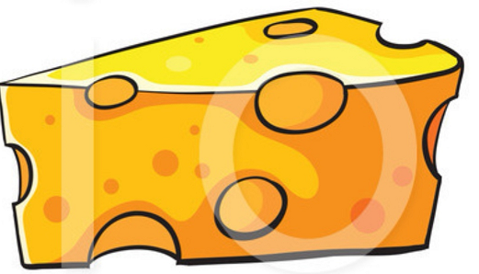



1.Cheese, 2. Chart, 3. Sheep, 4. Shop, 5. Chest, 6. Shed , 7. Shell, 8. Cherry, 9. Shelter, 10. Chop

**Ex A:**

**Ex B:**

1. Chemist 2. Choir 3. Christmas 4. Ache 5. Echo 6. Technical 7. Orchestra 8.Christian

**Work Book (Pg 25): Ending a sentence**

**Ex A: Put a full stop (.), a question mark (?) or an exclamation mark (!) at the end of these sentences.**

1. Pet fish like to live in large bowls with clean water**.**
2. Is the bowl large enough**?**
3. Don’t you dare drop the bowl**!**
4. How many fish are there**?**
5. You must feed the fish each day**.**

**Ex B: Write these sentences, but put in the missing capital letters and the missing punctuation marks.**

1. **W**hat do you give your fish to eat**?**
2. **M**y fish is called **F**red**.**
3. **W**ill it bite my finger**?**
4. **D**on’t be silly**!**
5. **I** will ask if I can have a pet fish**.**

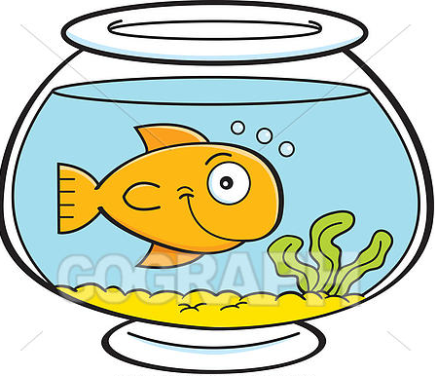

**WORKSHEET Subject: English Grade : 3**

**Name: ___________________ Please encircle: Isa town/ Manama campus**

**Punctuation Marks**

Punctuation Marks List

|  |  |
| --- | --- |
| **.** | Full stop |
| At the end of a simple sentence. | |

|  |  |
| --- | --- |
| **?** | Question mark |
| At the end of a question. | |

|  |  |
| --- | --- |
| **,** | Comma |
| To separate different things in a sentence. | |

|  |  |
| --- | --- |
| **!** | Exclamation mark |
| To show ones feelings. | |

* **Put full stop (.) or question mark (?) where needed.**

1. I study in grade 3 ____
2. Can I go to my friend’s house ____
3. How did you do this _____
4. Sara is a kind girl _____

* **There are three types of punctuation marks**

**missing from the following sentences.**

**Put them appropriately in the blanks.**

1. The little girl sat on the chair _____
2. I am Ms. Sara _______ teacher of Grade 3_____
3. Will you help me with my work______
4. The bird flew out of the window______

* **Rewrite the sentences putting in proper punctuation marks and capital letters :**

1. i want to have a sandwich for lunch

_____________________________________________________________________________

1. Yay we won the game

_____________________________________________________________________________

1. sara amna ali and ahmed went to the garden

_____________________________________________________________________________

1. where did you keep the bag

|  |  |  |  |  |  |  |  |  |  |  |  |  |  |  |  |  |
| --- | --- | --- | --- | --- | --- | --- | --- | --- | --- | --- | --- | --- | --- | --- | --- | --- |
| **Content Accuracy** | | | | **Creativity** | | | | **Completeness** | | | | **Neatness** | | | | **Total Points** |
| **1** | **2** | **3** | **4** | **1** | **2** | **3** | **4** | **1** | **2** | **3** | **4** | **1** | **2** | **3** | **4** |  |
| **1- Excellent 2 – Good 3- Satisfactory 4- Needs Improvement** | | | | | | | | | | | | | | | | |

**Rubric:**