**Pakistan School , Kingdom of Bahrain**

**E- Support and Learning Material / Session 2020-2021**

**Subject: English Grade : 6th**

**Book: Student Book 6 FIRST TERM**

**Unit 2:- Sandra Street Pg. No: 11-12**

|  |  |  |
| --- | --- | --- |
| **Sr no.** | **Words** | **Meanings** |
|  | Composition | a written piece of work on a topic |
|  | Wilderness | uncultivated area |
|  | Delightful | great pleasure |
|  | Particular | special |
|  | Gaze | look steadily |
|  | Trailed | track/trace |

|  |  |  |
| --- | --- | --- |
| **Sr no.** | **Words** | **sentences** |
|  | Composition | Your **composition** is perfect except for a few mistakes. |
|  | Wilderness | The battle of the Wilderness went on for two days, with little advantage to either side. |
|  | Delightful | It was a delightful surprise. |
|  | Particular | The crowd seemed clustered at one particular spot. |
|  | Gaze | Alex shifted a faintly amused gaze to Carmen. |
|  | Trailed | The words of formality trailed off as she stared at the room. |

**Comprehension Skills (page :- 11)**

**Answer the following questions :-**

|  |  |
| --- | --- |
| **Q1.** | Suggest a different title for the passage? |
| **Ans.** | ‘Home Sweet Home’ |

|  |  |
| --- | --- |
| **Q2.** | The boy who wrote about Sandra Street obviously doesn’t like it. Pick out the words and phrases in the passage which give the reader this impression? |
| **Ans.** | The words and phrases are:-   * Sandra street is dull and uninteresting. * A wilderness of big trees. |

|  |  |
| --- | --- |
| **Q3.** | Where does the narrator, Steve, live? |
| **Ans.** | The narrator Steve lives in Sandra Street. |

|  |  |
| --- | --- |
| **Q4.** | What is the ‘other side of the town’ like? |
| **Ans.** | The other side of the town is bright and fashionable having a big grassy plain for playing cricket and football. |

|  |  |
| --- | --- |
| **Q5.** | What does the narrator think of Sandra street? |
| **Ans.** | He thinks that Sandra street is standing alone, away from the noise and profusion of houses. |

|  |  |
| --- | --- |
| **Q6.** | The narrator speaks of the ‘profusion of houses’. What does he mean? |
| **Ans.** | He means that there are a lot of houses. |

|  |  |
| --- | --- |
| **Q7.** | Both the narrator and the boy who wrote the composition see the same things in Sandra street but they feel very differently about it. How do they feel? Why do you think their feelings are so different? |
| **Ans.** | The narrator and the writer both have different feelings about Sandra street. The writer talks about the pleasure of the other side of the town but the narrator thinks that Sandra street is his home sweet home. |

**Language Skills :- (page:- 12)**

**Prefixes:-**

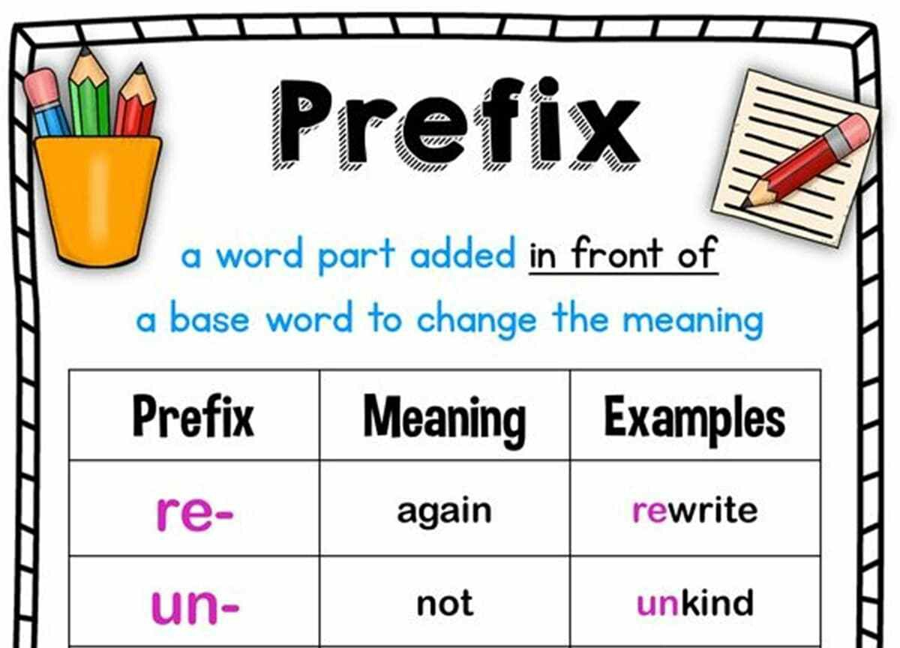

**List all the words which have double letters as a result of adding these prefixes:-**

1. **Dis** dissatisfy , dissimilar
2. **Un**  unnecessary , unnumbered , unnatural , unnamed
3. **Over**  overreach , override , overrule , overrun
4. **Im** immeasurable , immoral , immodest , immoral ,

immovable

**Antonyms and Synonyms:- (page:- 12)**

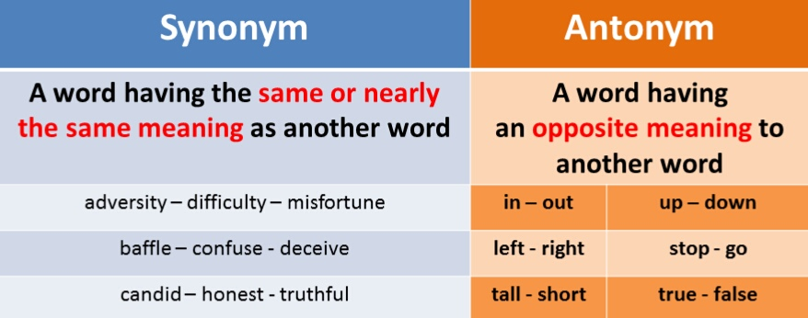

**Look at the word in bold letters and then select two words from those next to it. One should be an antonym, and the other a synonym, of the word in bold.**

|  |  |  |
| --- | --- | --- |
| **Words** | **Synonyms** | **Antonyms** |
| **Danger** | peril | safety |
| **Shout** | yell | whisper |
| **Sudden** | quick | gradual |
| **Climb** | ascend | descend |
| **Certain** | sure | doubtful |
| **Protect** | safeguard | attack |

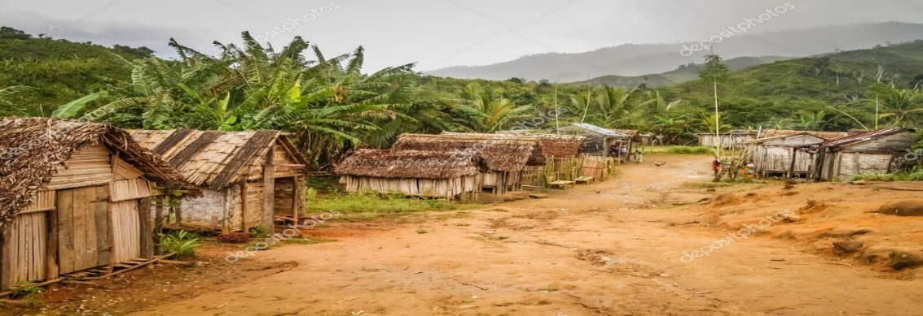

**Worksheet**

**Subject : English – Grade 8**

**Name: ______________________________________**

**Unit:- 2 : Sandra Street**

**Q1. Answer the following questions in your own words:-**

* What is the name of the narrator?

______________________________________________

* What is the name of the teacher?

______________________________________________

* Where does the boys of Sandra Street play?

______________________________________________

**Q2- Do any One:**

**A. Describe the composition written by boy in your own words :-**

**____________________________________________________________________________________________________________________________________________________________________________________________________________________________________________________________________________________________________________________________________________________________**

**__________________________________________________________________________________________________________________________________________________________________________________________________________________________________________________________________________________________________________________________________________________________________________________________________________________________________________________________________________________________________________________________________________**

**B - Compare Sandra Street with the other side of the town in the form of a paragraph.**

**_____________________________________________________________________________________________________________________________________________________________________________________________________________________________________________________________________________________________________________________________________________________________________________________________________________________________**

**_________________________________________________________________________________________________________________________________________________________________________________________________________________________________________________________________________________________________________________________________________________________________________________________________________________________________________________________________________________________________________________________________________________________________________________________________________________________________________________________________________**

**Rubric:**

|  |  |  |  |  |  |
| --- | --- | --- | --- | --- | --- |
| **1- Main Idea:**  **Clear focus.**  **Writer understands**  **Task.** | | **2- Content:**  **Detail/evidence relevant to main idea.**  **Accurate Conclusion.** | **3- Organization:**  **Introduction**  **Body**  **Conclusion** | **4- Language Use:**  **Accurate**  **vocabulary.**  **Sentence form and**  **structure.**  **Coherence.** | **5- Mechanics:**  **Spelling.**  **Capitalization & Punctuation.**  **Grammar** |
| **1 /2/3/4** | | **1/2/3/4** | **1//2/3/4** | **1/2/3/4** | **1/2/3/4** |
| **1. Excellent 2. Good 3. Satisfactory 4. Needs Improvement** | | | | |

**Homework:**

**Writing Assignment**:

**Describe your area in which you live .**

**Note: Refer Pg. 13 of Textbook for describing your area.**

**(Rubric as above.)**