**Pakistan School , Kingdom of Bahrain**

**E- Support and Learning Material / Session 2020-2021**

**Subject: English Grade : 7**

**Book: Student Book 2 FIRST TERM**

**Unit 1.1 There was the Alderman…. Pg. No: 4 to 9**

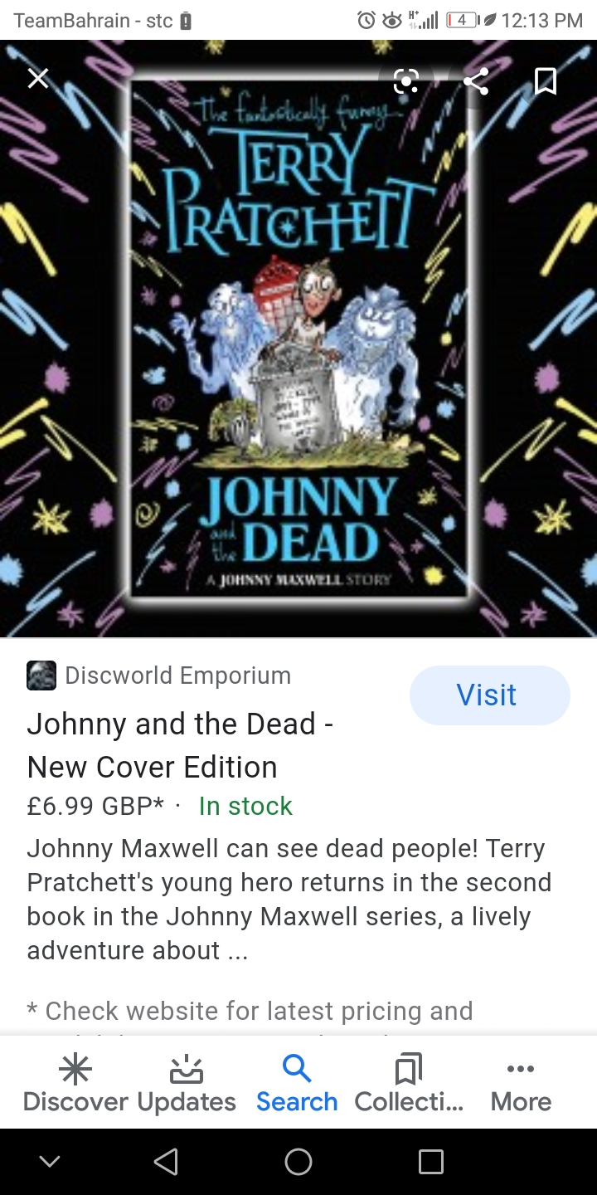

**Vocabulary Words.**

|  |  |  |
| --- | --- | --- |
| Alderman | Lurch | Ooze |
| Focus | Substances | Zombies |
|  |  |  |

**Pg.6 Ex. C : Words Meanings:**

|  |  |  |
| --- | --- | --- |
| **No.** | **Words** | **Meanings** |
| **1** | Alderman | Member of the local council |
| **2** | Lurch | Sudden /unsteady |
| **3** | Ooze | Discharge |
| **4** | Substance | Physical matter |
| **5** | Focus | point |
| **6** | Zombies | a dead person. |

**Words Sentences:**

|  |  |  |
| --- | --- | --- |
| **No.** | **Words** | **Sentences** |
| 1 | Alderman | The Aderman has worked for its constitution.. |
| 2 | lurch | Some people were running around but they didn't lurch. |
| 3 | ooze | He ooze green from his mouth blanched with horror.. |
| 4 | focus | This moment we have to focus on the situation. |
| 5 | substance | This substance is a great need for our experiment |
| 6 | zombies | She **was like a zombie** lying on the cold marble floor. |

**Comprehension**

**Pg.5 Ex. A Fill in the missing words:**

1. The old woman wore a **long** dress.
2. The Alderman was **transparent** around edges.
3. Johnny didn't feel it was a good **idea** to tell Wobbler.
4. Wobbler wanted to go and do his **homework** .

5***.***Wobbler thought that Johnny was just trying to **speak** his friends.

**Pg.6 Ex. B Answer these questions.**

**Q1. Explain the following in your own words.**

1. Three of the dead people are named .What are their names?
2. The three dead people are:

Mr. Alderman

Mr. William Stickers

Old woman

Q2. What does Johnny notice about the dead people from early ages?

1. Johnny noticed that they all were in odd assortments with old fashioned Victorian clothes.

Q3. What does Johnny realize about his friends?

**Ans.** He realized that his friends were really getting scared.

Q4. Yo.less thinks that there is something odd. What two things do the boys notice that was unusual.?

1. Yo.less looked around and saw the rook had flown away.
2. Johnny noticed that they were surrounded by them.

Q5.Why do you think that Mr. Vincenti says that it is for their own good that the living cannot see the dead?

1. He said so because that is the safest way from getting disturbed and distracted.

Pg.6 Spelling: The words in the box come from the extract you have to read.

1.dozen2.home3.air.idea.4 living

|  |  |  |
| --- | --- | --- |
| Word | Language | Meaning |
| **Aira…. Air** | Old French | Atmosphere |
| Lifda… Life | Old English | To have life |
| Dozeine… dozen | Old English | Twelve |
| Ham.. Home | Old English | Dwellings |
| Idealis.. Idea | Old English | Mental image |

**Grammar and Punctuation**

**NOUNS --- COMMON / PROPER / COLLECTIVE / ABSTRACT**

**Pg. 7 Ex. A COPY and COMPLETE the table to show which type of noun each word is.**

|  |  |  |  |  |
| --- | --- | --- | --- | --- |
| **Noun** | **Common** | **Proper** | **Collective** | **Abstract** |
| Mr. Vicenti |  | P |  |  |
| Homework |  |  |  |  |
| Fear |  |  |  | A |
| Zombies | C |  |  |  |
| Crowd |  |  | C |  |
| Bigmac |  | P |  |  |
| Bravery |  |  |  | A |

**Pg.7 EX.C. What nouns in the extract are these Adjectives describing**.

1.colourless…. William Stickers.

2.transparent…. Alderman

3.shaped……… air

4.strange….. directions.

5.historial……. people

6.empty……. cemetery.