**Pakistan School , Kingdom of Bahrain**

**E- Support and Learning Material / Session 2020-2021**

**Subject: English Grade : 7**

**Book: Student Book 2 FIRST TERM**

**Unit 1.2 I heard a heavy step… Pg. No: 10 to 15**

**Q.1 Vocabulary Words. Page 10 to 12**

|  |  |  |
| --- | --- | --- |
| Chink | Clean. Shaven | Enter |
| Gasp | Cruel | Bloodless |

**Q.2 Words Meanings. Page 12**

|  |  |  |
| --- | --- | --- |
| **No.** | **Words** | **Meanings** |
| **1** | Chink | small crack |
| **2** | clean. Shaven | without a beard or moustache |
| **3** | Enter | to get in |
| **4** | gasp | tight grip |
| **5** | bloodless | pale. |

**Q.3. Words sentences. Page 12**

|  |  |  |
| --- | --- | --- |
| **No.** | **Words** | **Sentences** |
| 1 | Chink | The boy noticed a chip on his new table. .. |
| 2 | Clean. Shaven | Mr. Harker noticed that count was clean shaven. |
| 3 | Enter | She entered the house without permission. |
| 4 | Gasp | His grip made me gasp with pain |
| 5 | Cruel | She is a cruel woman. |
| 6 | Bloodless | That boy after prolong sickness looks bloodless |

**Q.4 Comprehension. Page .11**

**Write True OR False for each of these statements:**

1. The door to count Dracula house was locked.. T
2. Count Dracula could not speak very good English ...F
3. Count Dracula and Mr. Harker had supper together….F
4. Mr Harker had brought a letter for the Court… T
5. They heard dogs barking outside… F

**Q. 5 Answer the questions. Page 12**

**Explain the following in your own words.**

**Q1.Find and copy three phrases which describes count Dracula as he strands in the doorway.**

1. A tall old man stood there.
2. He was clean shaven with long white moustache.
3. He dressed in black from head to toe.

**Find and copy three of the odd things Mr. Harker noticed about Count Dracula.**

1. Three odd things about Count were.
2. His face was strong and his eyebrows bushy
3. Teeth were very pointed and stuck out over his red lips.
4. His ears were pointed.

**Q3. How do you know that Mr. Harker arrived at night?**

1. Because the lamp was lit.
2. And he offered Mr. Harker for supper and later showed him the bedroom.

**Q4. Why did Mr. Harker want to be sick all over the carpet?**

1. Count leaned over on Mr. Harker. He shivered and his breathe was so bad. So, he was sick over the carpet.

**Q5. How do you know the count was pleased to hear the wolves howling?**

1. COUNT'S EYES LIT UP.

And he said '' listen to them. They are the children of the night. What music they make.!

**C. EXPLAIN IN YOUR OWN WORDS.**

**How you think Mr. HARKER was feeling as he went to his bedroom?**

1. **Mr. Harker was been advised to take long rest. And count said have pleasant dreams.**

**Grammar and Punctuation page 13.**

**Spelling:-**

SYLLABLES ARE SOUNDS THAT MAKE UP A WORD.

ALL SYLLABLE MAKES A SOUND OF ITS SOUND.

**Copy each word and divide it into syllables.**

1. behind. Be/hind
2. rattling. ra/ttling
3. key. Ke/y
4. silver. Si/lver
5. Dracula. Dra/cula
6. already. al/ready
7. moustache. moust/ache
8. Children. Chil/dren

**GRAMMAR AND PUNCTUATION. Pg13**

Prepositions are words which tell us where something is.

**E. g.. Write the preposition in these sentences.**

1. I went through the doorway.
2. Through
3. Under his white moustache his mouth was a. cruel.
4. Under
5. Supper was on the table.
6. On
7. There were hairs growing from the middle of his palms.
8. From
9. Count Dracula was seated at the table.
10. At
11. The wolves were in the valley.
12. In.

**B. Write the opposite of these preposition**

1. in. out

2. inside. outside

3. above. beneath

4. of **on**

5.up. down

6.near. far.

7.before. After

8.over. under.

9.in front. At back of

C. The preposition in a **bold** are not correct. Write sentences correctly.

1.MR.HARKER entered **into** the door.

MR. HARKER entered ***through*** the door.

2.Mr. Harker knocked **to** the door.

Mr. Harker knocked *at the door.*

3.Mr.Harker was frightened **off** the Count.

Mr.Harker way frightened *of* the count.

4.He had come **for** a long way that night.

He had come *from* a long way that night.

5. The wolves were heard **on** the silence.

The wolves were heard *in* the silence.

**WORKSHEET**

**Subject: English - Grade : 7**

**Name: ________________________________________**

**Unit 1.2 I heard a heavy step…**

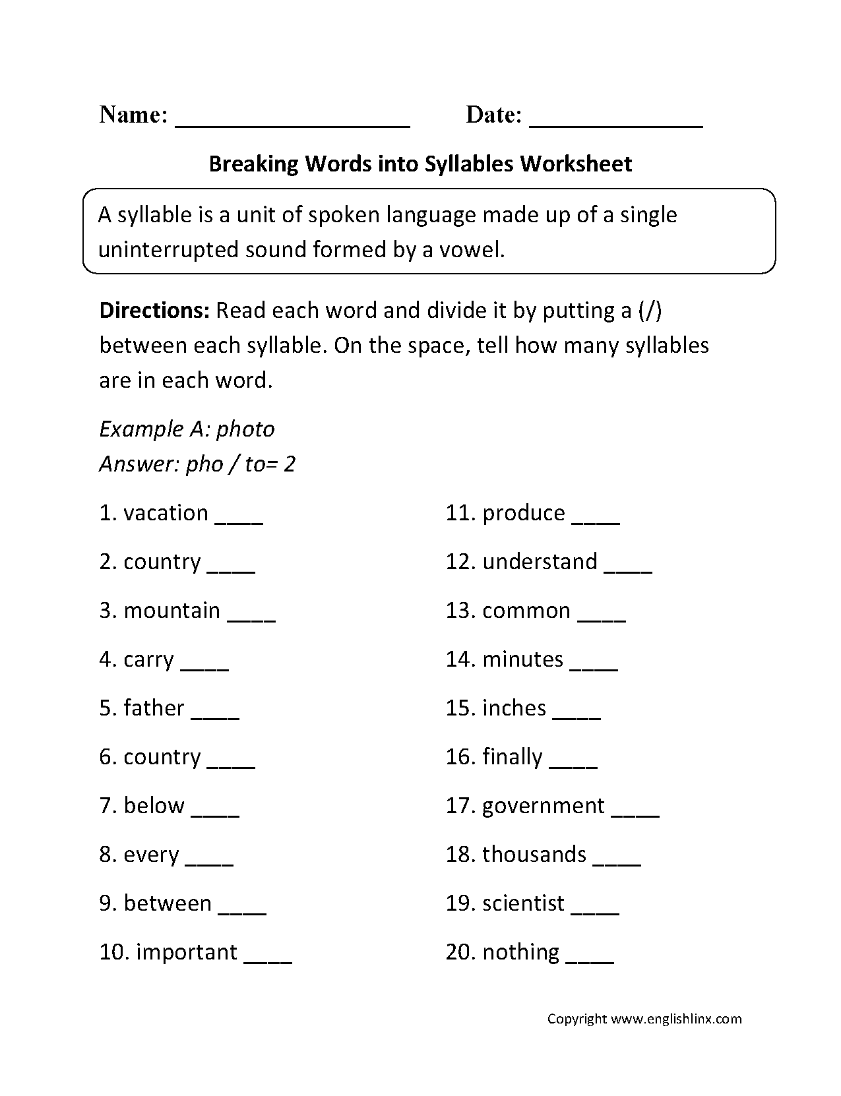

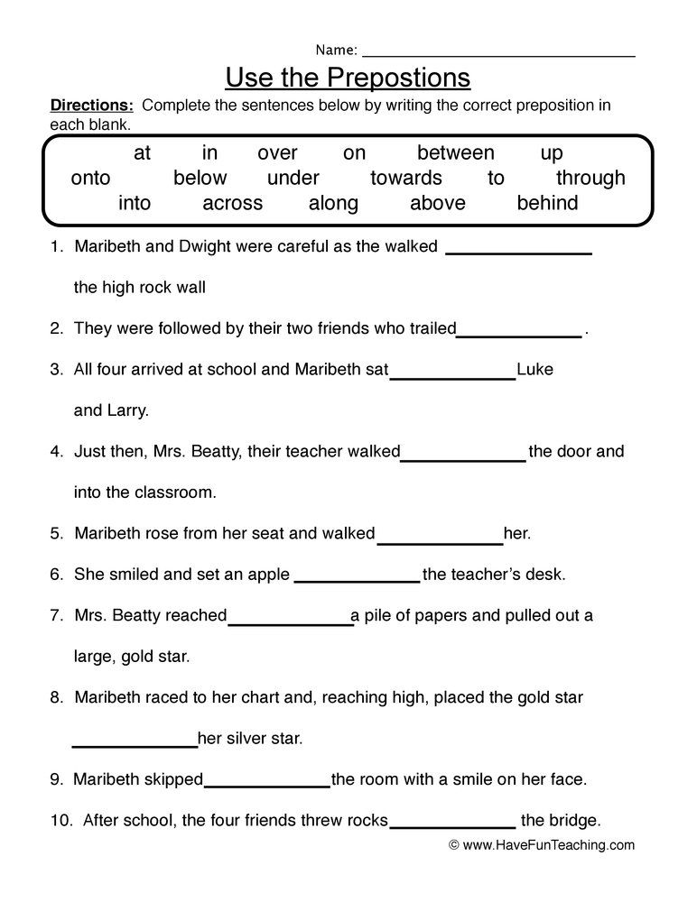

|  |  |  |  |  |  |  |  |  |  |  |  |  |  |  |  |  |
| --- | --- | --- | --- | --- | --- | --- | --- | --- | --- | --- | --- | --- | --- | --- | --- | --- |
| **Content Accuracy** | | | | **Creativity** | | | | **Completeness** | | | | **Neatness** | | | | **Total Points** |
| **1** | **2** | **3** | **4** | **1** | **2** | **3** | **4** | **1** | **2** | **3** | **4** | **1** | **2** | **3** | **4** |  |
| **1- Excellent 2 – Good 3- Satisfactory 4- Needs Improvement** | | | | | | | | | | | | | | | | |

**Rubric:**

**Homework:-**

**Writing Assignment:-**

**Imagine you are Count Dracula. Write a description of Mr.Harker as you first see him at the door and look more closely at him over Supper.**

**The picture will help you .**

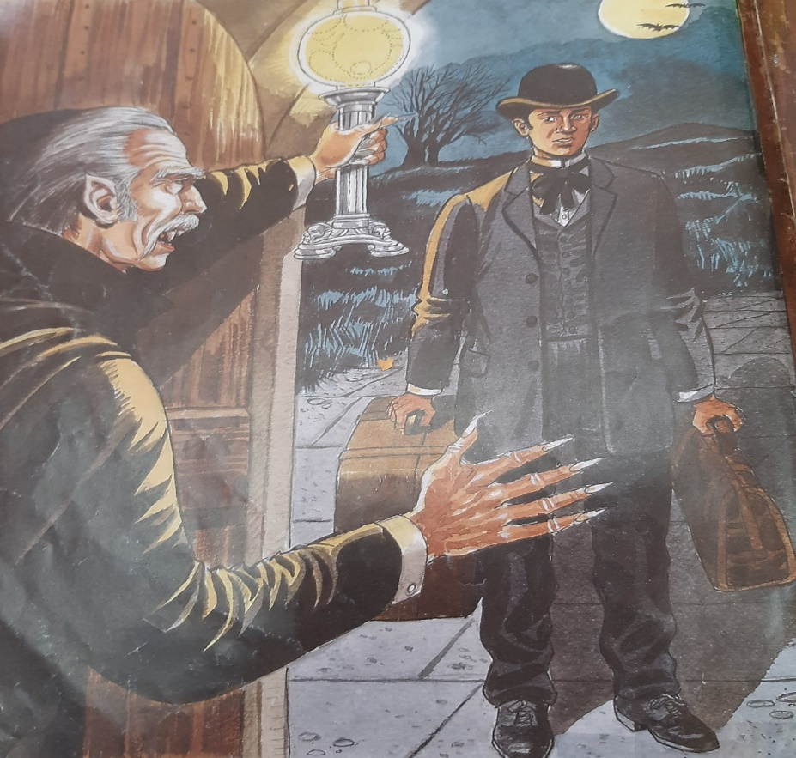

**Rubric:**

|  |  |  |  |  |  |
| --- | --- | --- | --- | --- | --- |
| **1- Main Idea:**  **Clear focus.**  **Writer understands**  **Task.** | | **2- Content:**  **Detail/evidence relevant to main idea.**  **Accurate Conclusion.** | **3- Organization:**  **Introduction**  **Body**  **Conclusion** | **4- Language Use:**  **Accurate**  **vocabulary.**  **Sentence form and**  **structure.**  **Coherence.** | **5- Mechanics:**  **Spelling.**  **Capitalization & Punctuation.**  **Grammar** |
| **1 /2/3/4** | | **1/2/3/4** | **1//2/3/4** | **1/2/3/4** | **1/2/3/4** |
| **1. Excellent 2. Good 3. Satisfactory 4. Needs Improvement** | | | | |