**Pakistan School , Kingdom of Bahrain**

**E- Support and Learning Material / Session 2020-2021**

**Subject: English Grade : 8**

**Book: Student Book 3 FIRST TERM**

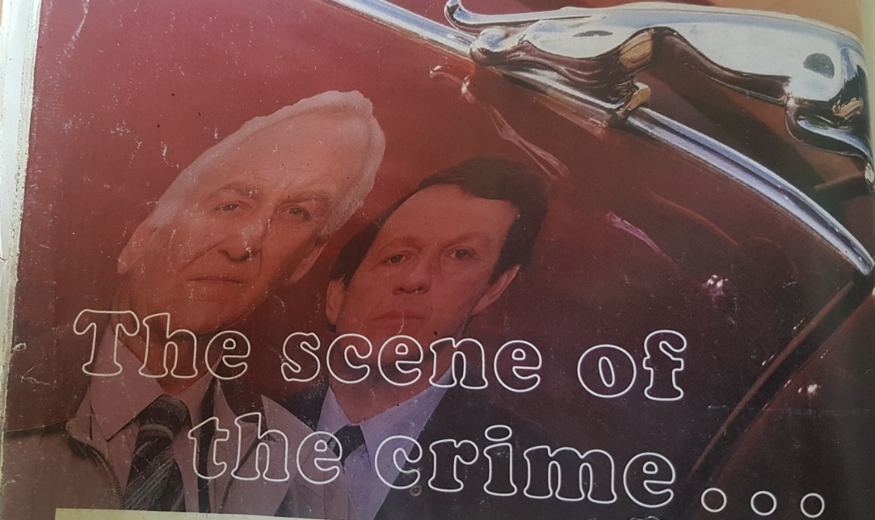**Unit. 1.2 The scene of the crime……… Page 10 to 15**

**Vocabulary words.**

|  |  |  |
| --- | --- | --- |
| Sniffed | Crusted | Armchair |
| Flanked | Remarkably | Alcove |
| Posture | Flickering | Occasionally |

**Words Meanings.**

|  |  |  |
| --- | --- | --- |
| **No.** | **Words** | **Meanings** |
| **1** | depressed | in a state of unhappiness |
| **2** | foetal | relating to a foetus |
| **3** | cyanide | a poisonous chemical |
| **4** | dilated | expanded |
| 5 | morbid | not healthy |
| 6 | amateurishly | unprofessionally |

**Words Sentences**

|  |  |  |
| --- | --- | --- |
| **No.** | **Words** | **Sentences** |
| **1** | depressed | She left her room in a depressed mood. |
| **2** | foetal | The fertilized egg implants and becomes a **foetus** |
| **3** | cyanide | They've been killing themselves with **cyanide** pills. |
| **4** | dilated | Your pupils are **dilated**. |
| **5** | morbid | He'd always had a **morbid** sense of humor. |
| **6** | amateurishly | It was done pretty **amateurishly by the young one.** |

**Comprehension.**

**Write ‘True’ or ‘ False' for each of these statements. Page 11**

1. The murder victim lived in a downstairs room at No. 1 pinewood Close. T
2. There was z bottle of brandy on the coffee table. F
3. They thought it likely that the man had been poisoned. T
4. The waste- paper basket was to the right of the fire. F
5. Morse thought he had been dead for two or three days. T

**Questions Answers. Page 12**

1. **Tightly clenched.** It means to press or squeeze something. In the lesson , it is used for Mr. Quinn whose jaws were tightly clenched after death.
2. **A post-mortem.** It means to examine the body to know the cause of death.
3. **I dunno.** This word means I don't know and in the lesson it was spoken by Morse.

**Q2. Why do you think Morse wanted to make sure that Lewis hadn't left his ‘ prints all over the place'?**

**Ans**. Morse wanted to make sure that Lewis hadn't left his ‘prints all over the place ‘ because he didn't want to lose the clues related to the killer.

**Q3. Why does Morse think that ,’ we hardly need a post -mortem on this one'?**

**Ans.** Morse said that they hardly need a post-mortem of the body. There were clear signs of the cyanide that was the cause of death.

**Q4. How does Morse know which chair Quinn was sitting I before he died?**

**Ans.** Quinn was sitting on that armchair which was placed beside the coffee table and Morse recognizes it easily as he sees the empty Sherry glasses on the table.

**Grammar and Punctuation page 13**

**Exercise A page 13 Singular and Plural**

**Armchair** armchairs **gas** gases **basket** baskets

**Glass** glasses **parent** parents **flame** flames

**Fire** fire **night** nights **match** matches

**Exercise B write the plural page 13**

**Tooth** teeth **salmon** salmon **woman** women

**Mouse** mice **sheep** sheep **goose** geese

**Work Book page. 13**

**Ex. A page 13**

**Write the plurals for the following nouns.**

|  |  |
| --- | --- |
| **Singular** | **Plural** |
| **Kangaroo** | **Kangaroos** |
| **Bush** | **Bushes** |
| **Horse** | **Horses** |
| **Grasshopper** | **Grasshoppers** |
| **Match** | **Matches** |
| **Whale** | **Whales** |
| **Box** | **Boxes** |

**Ex. B page 7**

**Use a dictionary to help you write the plurals fir these nouns.**

|  |  |
| --- | --- |
| **Singular** | **Plural** |
| **Rhinoceros** | **Rhinoceroses** |
| **Goose** | **Geese** |
| **Grouse** | **Grouses** |
| **Matrix** | **Matrixes** |
| **Foot** | **Feet** |
| **Mouse** | **Mice** |
| **Datum** | **Datums** |
| **Sheep** | **Sheep** |
| **Trout** | **Trouts** |
| **Tooth** | **Teeth** |

**WORKSHEET**

**ENGLISH – GRADE 8**

**Name: _____________________________________**

**Unit. 1.2 The scene of the crime………**

**Do any 10:**

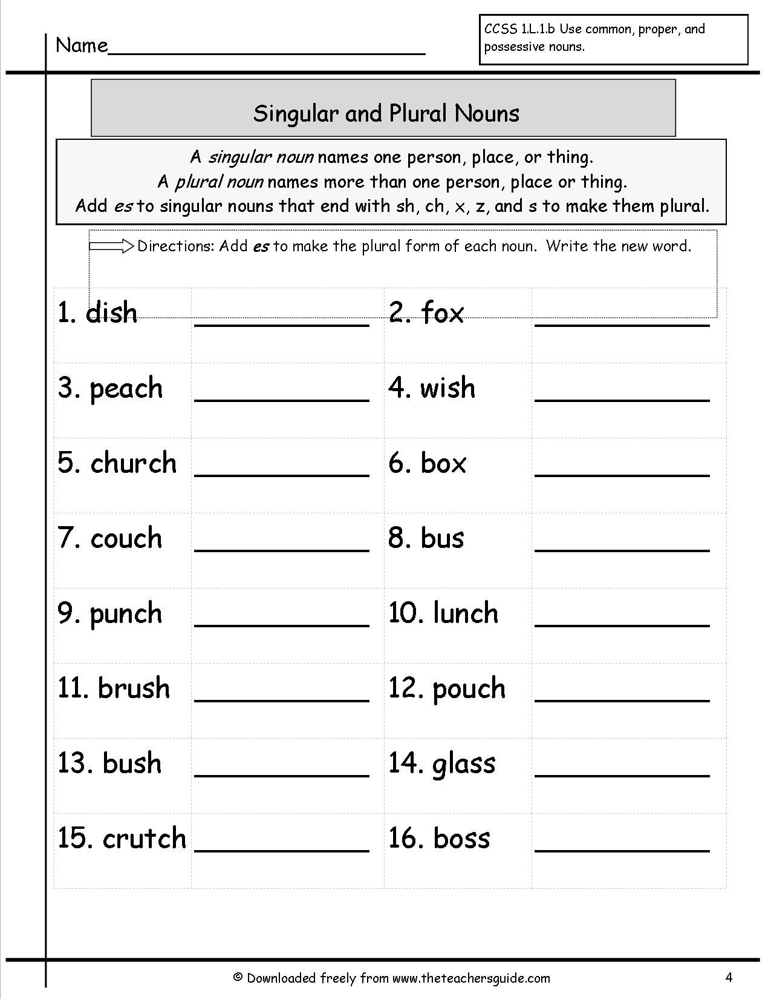

**DO ANY 8**

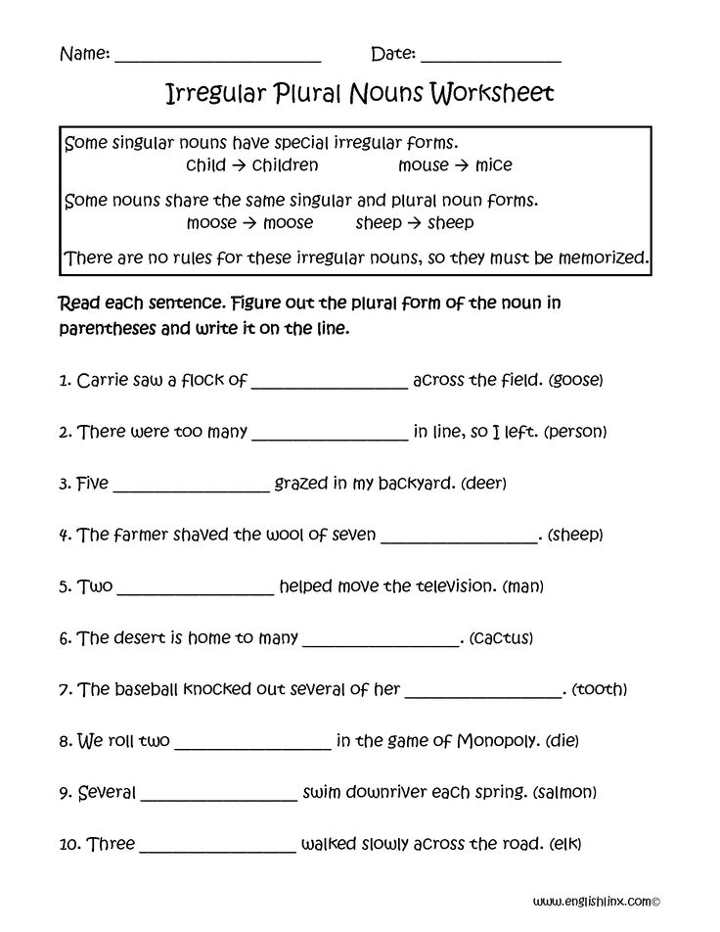

|  |  |  |  |  |  |  |  |  |  |  |  |  |  |  |  |  |
| --- | --- | --- | --- | --- | --- | --- | --- | --- | --- | --- | --- | --- | --- | --- | --- | --- |
| **Content Accuracy** | | | | **Creativity** | | | | **Completeness** | | | | **Neatness** | | | | **Total Points** |
| **1** | **2** | **3** | **4** | **1** | **2** | **3** | **4** | **1** | **2** | **3** | **4** | **1** | **2** | **3** | **4** |  |
| **1- Excellent 2 – Good 3- Satisfactory 4- Needs Improvement** | | | | | | | | | | | | | | | | |

**Rubric:**

**Homework:**

**WRITING ASSIGNMENT (Page:15): Descriptive Writing.**

* **Do it on an A4 sized coloured paper.**
* **Be as creative as you can.**

**Imagine a crime has been committed and you are the detective. Write a detailed description of the scene of a crime. It can be a murder or a robbery.**

**Remember:**

* **Describe what you can see at the scene of the crime.**
* **Give details of colour, position, etc.**
* **Include a description of something that you feel is unusual.**

**Rubric:**

|  |  |  |  |  |  |
| --- | --- | --- | --- | --- | --- |
| **1- Main Idea:**  **Clear focus.**  **Writer understands**  **Task.** | | **2- Content:**  **Detail/evidence relevant to main idea.**  **Accurate Conclusion.** | **3- Organization:**  **Introduction**  **Body**  **Conclusion** | **4- Language Use:**  **Accurate**  **vocabulary.**  **Sentence form and**  **structure.**  **Coherence.** | **5- Mechanics:**  **Spelling.**  **Capitalization & Punctuation.**  **Grammar** |
| **1 /2/3/4** | | **1/2/3/4** | **1//2/3/4** | **1/2/3/4** | **1/2/3/4** |
| **1. Excellent 2. Good 3. Satisfactory 4. Needs Improvement** | | | | |