**Pakistan School , Ministry of Education , Kingdom of Bahrain**

**E-Support and Learning /Session 2020-2021**

**Subject : English - Grade : 9**

**Unit 2: Patriotism**

**Meanings of Difficult Words:**

|  |  |  |  |
| --- | --- | --- | --- |
| **Words** | **Meanings** | **Words** | **Meanings** |
| **commendable** | **to be praised** | **instance** | **example** |
| **safeguard** | **protection** | **invasion** | **To take control by force** |
| **supreme** | **highest** | **compromise** | **concession** |
| **galvanize** | **to stimulate** | **devoid** | **without** |

**PG. 15 Comprehension**

**Ex. A : Answer the following questions:**

**Q1. How will you define patriotism?**

**Ans. Patriotism means love of and devotion to one’s country. A patriot is ready to give everything he has for his country. He is even ready to sacrifice his life for his country and nation.**

**Q2. What are the qualities of a patriot?**

**Ans. A patriot loves his country and nation and uses all his powers to protect their interests. He accepts the country’s complete control over its affairs, unity and honour as the best principles. He cannot make concessions to anyone on these principles.**

**Q3. As a citizen of Pakistan what are your duties towards your country?**

**Ans. As a citizen of Pakistan my first and foremost duty to my country is loyalty to it. I should always be willing to sacrifice my life for the freedom and honour of my country. I should work hard for the progress and prosperity of my country.**

**Q4. What makes us stay alert in the wake of foreign invasion?**

**Ans. The passion of patriotism makes us active and careful. We become active and careful when other countries are going to attack us. There are many examples of people sacrificing their lives for their country.**

**Q5. How will you elaborate Quaid-e-Azam Muhammad Ali Jinnah’s quote?**

**“We must develop a sense of patriotism which galvanizes us all into one united and strong nation.”**

**Ans. The Quaid’s words mean that we must have a strong feeling of love for and devotion to our country and nation. Patriotism means this feeling. It makes us all a united and strong nation because we live and work for common aims and purposes.**

**Vocabulary : PG. 16**

**Ex. A: Guess the meaning of the following words. Confirm your meaning from the dictionary.**

|  |  |  |
| --- | --- | --- |
| **Word** | **Guessed meaning** | **Dictionary meaning** |
| Conservation | Conservation | Protection |
| Instance | Incident | Example |
| Fidelity | Faithfulness | Loyalty |
| Shield | Protection | Protect |
| Reward | Compensation | Prize |

**Ex. B. Make as many words as you can from these root words:**

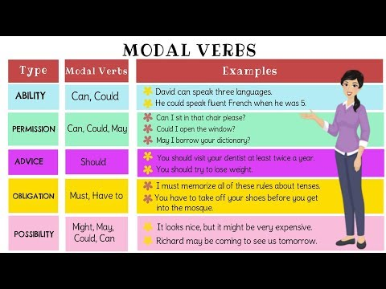

**GRAMMAR PG. 19**

**Ex. A. Use appropriate modals to:**

**1. describe your three abilities and capacities**

**i- I can speak Chinese.**

**ii- I can see quite clearly what you are doing.**

**iii- He could ski well when he was young.**

**2. ask teacher’s permission for going out**

**i- May I go to drink water,please?**

**3. ask a friend to lend you a book**

**i- Would you lend me your book?**

**4. express necessity to get up early**

**i- You must get up early in the morning.**

**5. express duty/obligation to follow traffic rules**

**i- You should follow the traffic rules.**

**6. share some past habit**

**i- I used to eat a lot of junk food.**

**Kinds of Sentences**

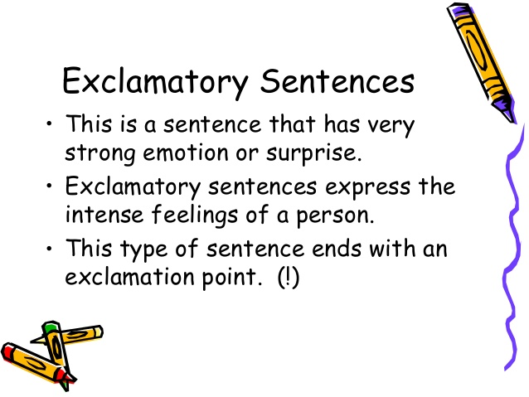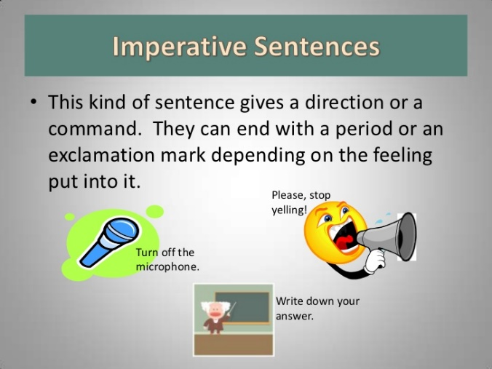

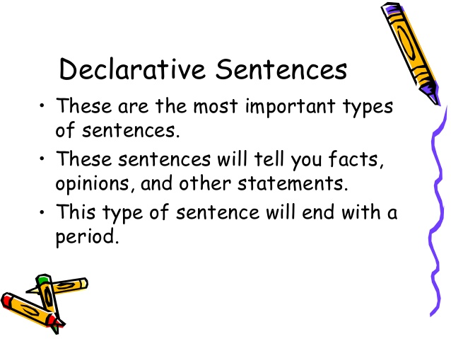 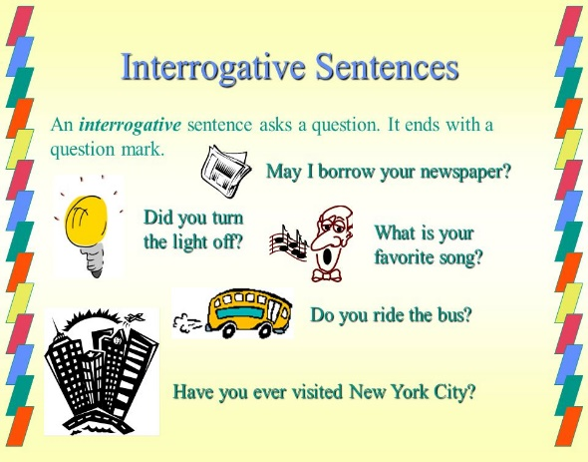**Ex. B. Identify the kinds of the following sentences. ( exclamatory,assertive , interrogative,negative,imperative):**

1. Art is another subject in which I am particularly interested. **(assertive)**
2. What a beautiful painting! **(exclamatory)**
3. Teach him to lean! **(imperative)**
4. How would I know? **(interrogative)**
5. She did not make a false statement. **(Negative)**

**Ex. C Punctuate the following**:

Captain Mohammad Sarwar,Major Tufail Mohmmad, Major Aziz Bhatti, Pilot Officer Rashid Minhas, Major Mohammad Akram, Major Shabbir , Sowar Mohammad Hussain , Lance Naik Mohammad Mahfooz , Captain Karnal Sher Khan and Havildar Lalak Jan- all embraced martyrdom while fighting bravely for their motherland. All of them were awarded Nishan -e-Haider, the highest military award given to great patriots who lay down their lives for the country.

**Writing Skills: Pg. 20**

**Ex E: Write a short dialogue between a political activist and a teenager in which the political activist tries to make the teenager understand the importance of patriotism.**

**Teenager:** Sir! Excuse me Can I have your attention please?

**Political Activist:** Yes. Sure why not sure.

**Political Activist:** What would you want to know?

**Teenager:** Sir! What does patriotism mean?

**Political Activist:** It means love for the motherland or loyalty to one’s country.

**Teenager:** Sir! What role does it play in the lives of the people?

**Political Activist**: Its spirit makes us stay alert in the wake of foreign invasion .

**Teenager**: Sir! What does patriotism give us?

**Political Activist**: Patriotism gives people the strength and courage to safeguard the interests of the country and nation.

**Teenager**: What is most important thing for a patriot?

**Political Activist**: Respect, honor, and integrity is the most important thing for a patriot.

**Teenager:** Thank you Sir!

**Political Activist**: You are welcome.

**WORKSHEET - Subject : English - Grade : 9**

**Unit 2: Patriotism**

**Identifying Four Kinds of Sentences**

**There are four kinds of sentences in the English language.**

1

**. Imperative- gives a command (.)**

2

**. Declarative- makes a statement (.)**

3

**. Interrogative- asks a question (?)**

4

**. Exclamatory- expresses strong feeling (!)**

**Directions: Read each sentence and add the correct punctuation mark. Then, label it; imperative, declarative, interrogative or exclamatory.**

***Example A: You did an excellent job***

***Answer: You did an excellent job. Declarative***

1. **How was your day in school _______ __________________________**
2. **Do your assignments in class on time ______ ___________________________**
3. **I’m so excited I passed the test ______ ___________________________**
4. **Walking up that mountain is dangerous _____ ___________________________**
5. **Who is the most popular singer ______ ___________________________**
6. **You need to get with the program ______ ___________________________**
7. **He is the leader of the group _______ ___________________________**
8. **What is your favorite magazine _______ ___________________________**
9. **Congratulations on your achievement _____ ___________________________**
10. **That was a physical game ______ ___________________________**
11. **Can you cancel the concert ______ ___________________________**

**12. What chapter are we reading ______ ___________________________**

**Modal Verbs:**

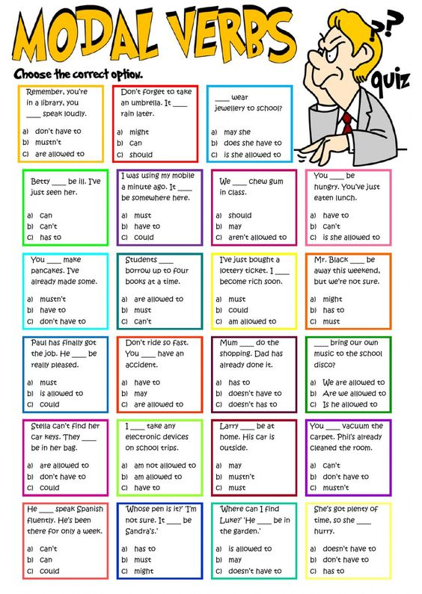

**Rubric:**

|  |  |  |  |  |  |  |  |  |  |  |  |  |  |  |  |  |
| --- | --- | --- | --- | --- | --- | --- | --- | --- | --- | --- | --- | --- | --- | --- | --- | --- |
| **Content Accuracy** | | | | **Creativity** | | | | **Completeness** | | | | **Neatness** | | | | **Total Points** |
| **1** | **2** | **3** | **4** | **1** | **2** | **3** | **4** | **1** | **2** | **3** | **4** | **1** | **2** | **3** | **4** |  |
| **1- Excellent 2 – Good 3- Satisfactory 4- Needs Improvement** | | | | | | | | | | | | | | | | |