**Pakistan School , Kingdom of Bahrain**

**E- Support and Learning Material / Session 2020-2021**

**Subject: English Grade : 9**

**Book: English Book 9 Worksheet**

**Unit 1 : THE SAVIOUR OF MANKIND**

|  |
| --- |
| **ADJECTIVES** |
|  |
|  |
|  |
|  |
|  |
|  |
|  |
|  |
|  |
|  |

**Q1. Pick out at least 10 adjectives from this paragraph:**

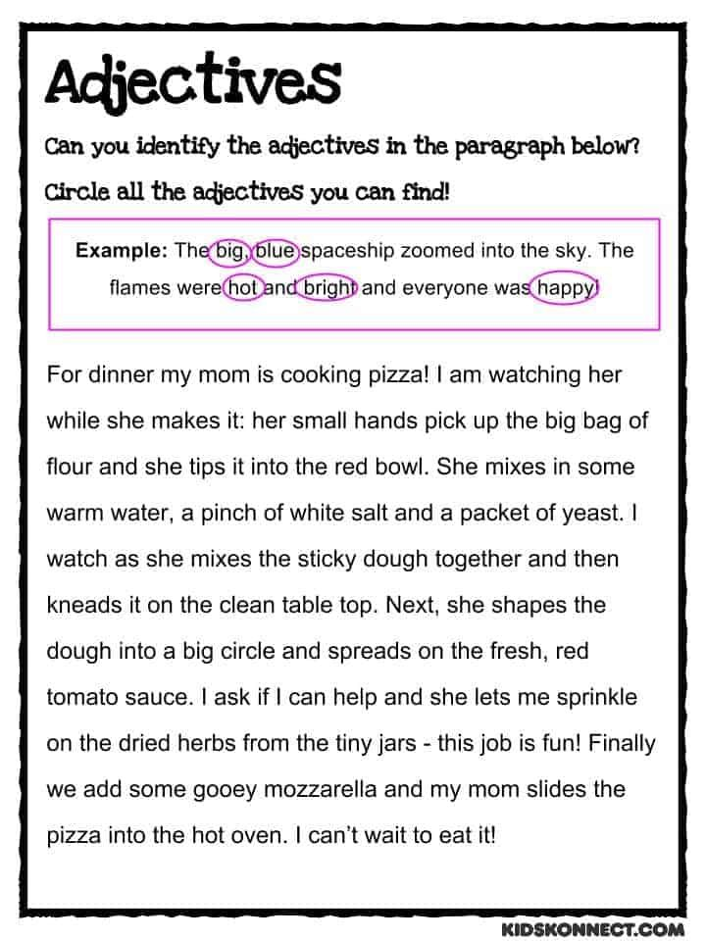

**First Conditional Sentences**:

**Watch the video very carefully using this link:**  [**https://youtu.be/Tz-35-2pWpU**](https://youtu.be/Tz-35-2pWpU)

* **some more examples :**

[**https://drive.google.com/file/d/1PRcS7Jg5resX7aKNyJOWynHHao7uL-4o/view?usp=sharing**](https://drive.google.com/file/d/1PRcS7Jg5resX7aKNyJOWynHHao7uL-4o/view?usp=sharing)

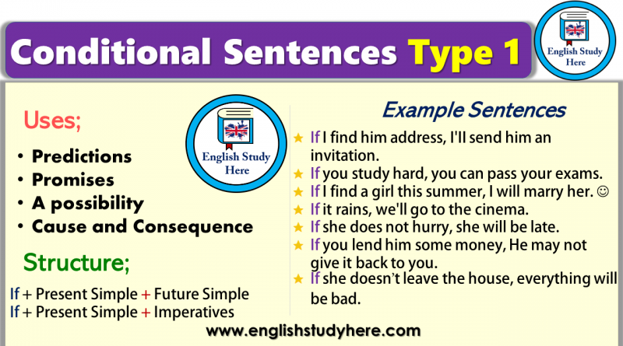

***Q2.Complete the Conditional Sentences (Type I) by putting the verbs into the correct form.***

1. If you (send)  this letter now, she (receive)  it tomorrow.
2. If I (do)  this test, I (improve)  my English.
3. If I (find)  your ring, I (give)  it back to you.
4. Peggy (go)  shopping if she (have)  time in the afternoon.
5. Simon (go)  to London next week if he (get)  a cheap flight.
6. If her boyfriend (phone / not)  today, she (leave)  him.
7. If they (study / not)  harder, they (pass / not)  the exam.
8. If it (rain)  tomorrow, I (have to / not)  water the plants.
9. You (be able/ not)  to sleep if you (watch)  this scary film.
10. Susan (can / move / not)  into the new house if it (be / not)  ready on time.

**HOMEWORK:**

**Learn the questions and answers of this lesson.**