Name: __________________________ LKG Sec: __________ Isa Town / Manama

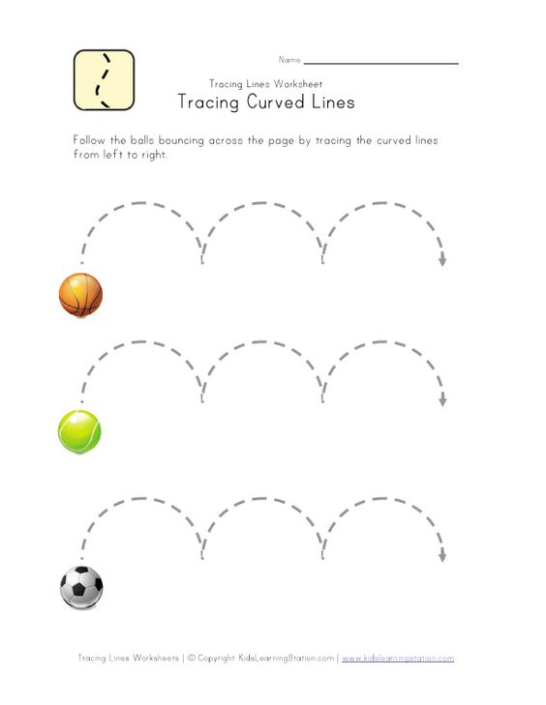

**Trace the bumpy bump:**

**Trace the Straight lines:**

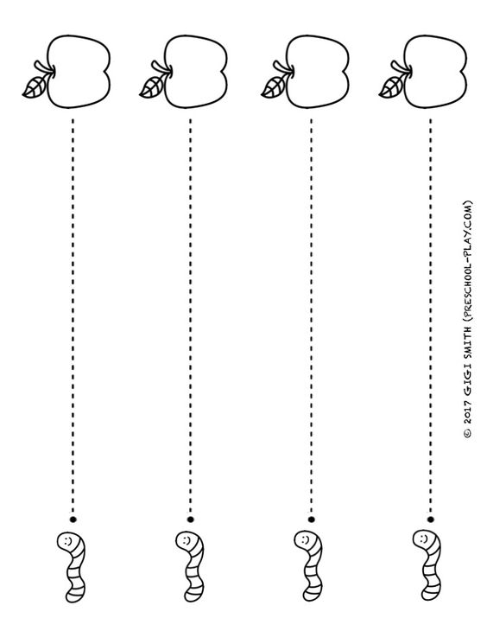

**Trace the Slanting Lines:**

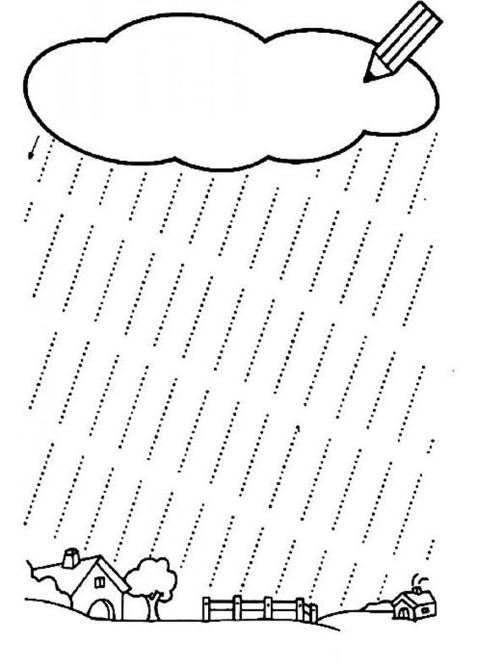

**Trace the bumpy bump lines:**

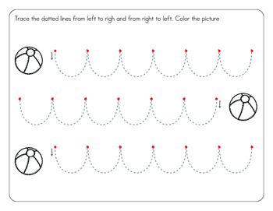

**Trace the Curves:**

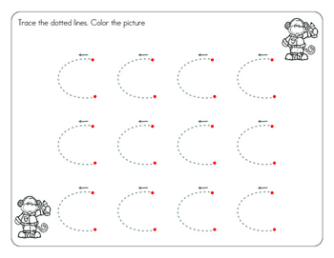

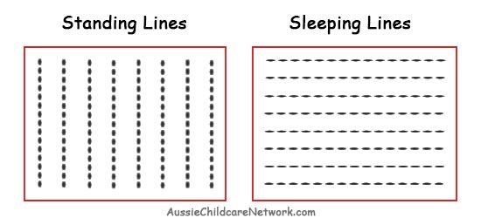

**Trace the Standing & Sleeping Lines:**

**Trace the Sleeping Lines:**

