**Pakistan School, Kingdom of Bahrain**

**E- Support and Learning Material / Session 2020-2021**

**Subject: English Grade: 4**

**Book: Nelson English Student Book 4 FIRST TERM**

**Unit 2: Gale Warning Pg. No: 18-21**

**Vocabulary words.**

**I. Underline the word with the correct spellings.**

1.breze ,  **breeze** , breez

2. **accurate** , acurate , accurete

3. adaptid , adepted , **adapted**

4. **effects** , efects , effacts

**II. Write the missing letters to form a sensible word.**

1. o **c** c **u** r

2. g **e** n **t** l **e**

3. q **u** i **c** k **l** y

4. h **u** r **r** **i** c **a** n **e** s

**III. Rearrange the jumbled letters to form a sensible word.**

1. lbwongi: blowing

2. ipmrotnat: important

3. ifnormtaoin: information

4. srtneght: strength

**IV. Write the meanings for the given words:**

|  |  |  |
| --- | --- | --- |
| **Sr.No** | **Words** | **Meanings** |
| 1 | gentle | kind, good natured |
| 2 | strength | power |
| 3 | breeze | a slight wind |
| 4 | accurate | correct, without mistakes |
| 5 | adapt | adjust, change |
| 6 | hurricanes | extremely strong wind |
| 7 | occur | to take place, exist |
| 8 | gale | very strong wind |

**V. Make sentences of the given words:**

|  |  |  |
| --- | --- | --- |
| **Sr.No** | **Words** | **Sentences** |
| 1. | strength | He checked the strength of the cables. |
| 2. | gentle | The boy gently lifted the kitten. |
| 3. | breeze | There is lovely cool breeze today. |
| 4. | accurate | He gave an accurate report. |
| 5. | storm | The roof of the house was damaged by the storm. |
| 6. | occur | I hope this won’t occur again. |

**Textual Comprehension**

**V1. Answer the following questions.**

**Q1). What can you see when there is a strong breeze?**

**Ans). Large branches move when there is a strong breeze.**

**Q2). What speed is the wind when there is a hurricane blowing?**

**Ans). The speed of the wind is over 117 kph when there is a hurricane blowing.**

**Q3). What is the type of wind when you can see twigs breaking off?**

**Ans). When you see twigs breaking off, it is a gale.**

**Q4). What is the force of the wind when it is travelling at 30-39 kph?**

**Ans). The force of the wind is 5 when it is travelling at 30-39 kph.**

**Q5). What do you know about Sir Francis Beaufort?**

**Ans). Sir Beaufort Francis was a British Admiral and he worked out what happened when the**

**air moved at different speeds.**

**VII.Complete the sentences using suitable sentences.**

1. When the air moves, we say that the wind is **blowing**.

2. Sometimes the air moves very quickly and **hurricanes** occur.

3. The Beaufort scale has been adapted for the effects of **wind** on the land.

4. **Accurate**, means free from mistakes.

5. Sir Francis worked out about what happened when the air moved at **different** speeds.

**VIII. Match column A with column B and write answer in column C.**

|  |  |  |  |
| --- | --- | --- | --- |
| **Sr.No** | **Column A** | **Column B** | **Column C** |
| 1 | mistral | a very strong wind that spins quickly causing a lot of damage. | 2 |
| 2 | tornado | a strong windy storm | 4 |
| 3 | typhoon | a strong, cold, dry northernly wind of southern France | 1 |
| 4 | tempest | a storm with strong circular wind | 3 |

**WORKSHEETS**

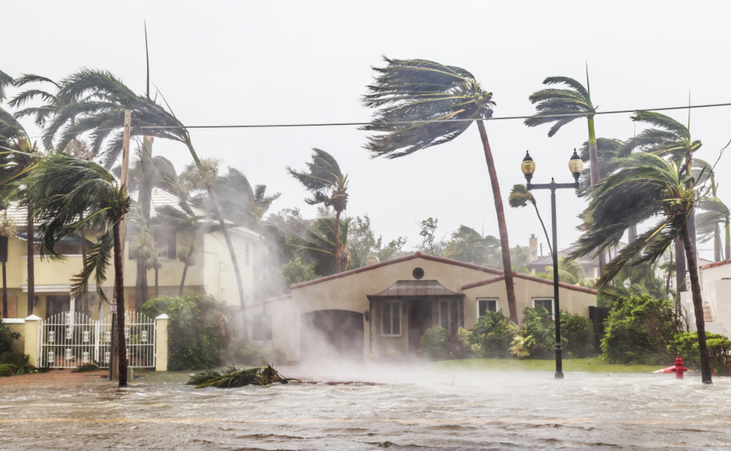**Unit : 04 Gale Warning**

**Q1.Read the passage and encircle the correct spellings of the following words:**

1. breze breeze breez
2. accurate acurate accurette
3. adapted adepted adapted
4. effects effects effacts
5. warning warning wernning

**Q2. Complete the following sentences by using suitable words form the word bank given below.**

**wind, breeze, mistakes**

**hurricane, scale,**

1. When the air moves we say that the ____________ is blowing.

2. Sometimes the air moves very quickly and __________occurs.

3. The Beaufort__________ has been adapted for the effects of wind on the land.

4. The air moves slowly and we get a gentle __________________.

5. Accurate means free from _____________.

**Q3. Match column (A) with column (B) and write the correct answers in the column (C)**

|  |  |  |  |
| --- | --- | --- | --- |
| **Sr#** | **Column A** | **Column B** | **Column C** |
| 1. | Mistral | A very strong wind that spins quickly causing a lot of damage. |  |
| 2. | Tornado | A strong windy storm |  |
| 3. | Typhoon | A strong, cold, dry northerly wind of southern France |  |
| 4. | Tempest | A storm with strong circular wind |  |

|  |  |  |  |  |  |  |  |  |  |  |  |  |  |  |  |  |
| --- | --- | --- | --- | --- | --- | --- | --- | --- | --- | --- | --- | --- | --- | --- | --- | --- |
| **Content Accuracy** | | | | **Creativity** | | | | **Completeness** | | | | **Neatness** | | | | **Total Points** |
| **1** | **2** | **3** | **4** | **1** | **2** | **3** | **4** | **1** | **2** | **3** | **4** | **1** | **2** | **3** | **4** |  |
| **1- Excellent 2 – Good 3- Satisfactory 4- Needs Improvement** | | | | | | | | | | | | | | | | |

**Rubric:**

**Unit: 04 Gale Warning – HOMEWORK**

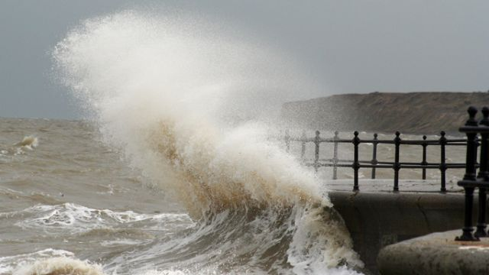

**Instructions: These words describe types of wind. Look the words up in the dictionary and write description of any five.**

|  |  |  |
| --- | --- | --- |
| **S.No** | **Type of wind** | **Description** |
| **1.** | **Hurricane** |  |
| **2.** | **Breeze** |  |
| **3.** | **Gale** |  |
| **4.** | **Typhoon** |  |
| **5.** | **Tempest** |  |
| **6.** | **Mistral** |  |
| **7.** | **Tornado** |  |