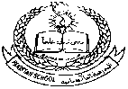**FGT**

**Pakistan School , Kingdom of Bahrain**

**E- Support and Learning Material / Session 2020-2021**

**Subject: English (worksheet: 2) Grade: 4**

**Book: Nelson English Student Book 4 FIRST TERM**

**Unit 1: How Mowgli joined the wolves Pg. No: 04**

**Passage ( Directly in front of him, holding …………………………………… he laid it down among the cubs.)**

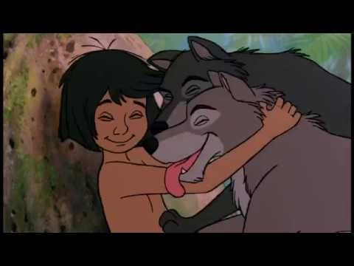

**Q1. Fill in the missing letters by looking at the picture to complete the word.**

|  |  |
| --- | --- |
| Cave Clipart**C___v___** | b__e__k__ng |
| Lion Cub Clip Art**C__b** | Lower Jaw PNG Clip Art - High-quality PNG Clipart Image in cattegory Dental PNG / Clipart from ClipartPNG.comJ__w |

**Q2. Read the statement weather True or False.**

1. “Is that a man’s cub?” Said mother. _______________
2. Mowgli looked up into mother wolf ‘s face and laughed. _______________
3. Father wolf’s jaws closed right on the child’s back. ______________
4. As hard as dimples a little atom as over came to a wolf’s came at night._________
5. A tooth scratched the skin as he laid it down among the cubs. _______________

**Q3. Read the above passage from the book, find the verbs in the past tense and list them down.**

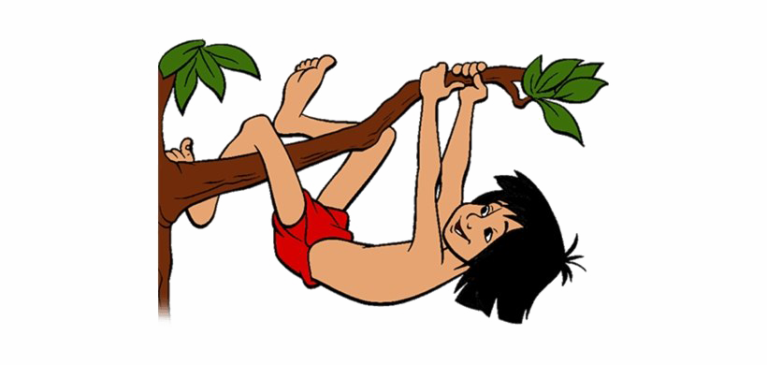**1._______________**

**2._______________**

**3._______________**

**4._______________**

**5._______________**

**6._______________**

**7._______________**

**8._______________**

**9._______________**

**10._____________**