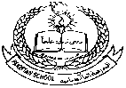**FGTS**

**Pakistan School , Kingdom of Bahrain**

**E- Support and Learning Material / Session 2020-2021**

**Subject: English (worksheet : 3)**

**Book: Nelson English Student Book 4 FIRST TERM**

**Unit 1: How Mowgli joined the wolves Pg. No: 04**

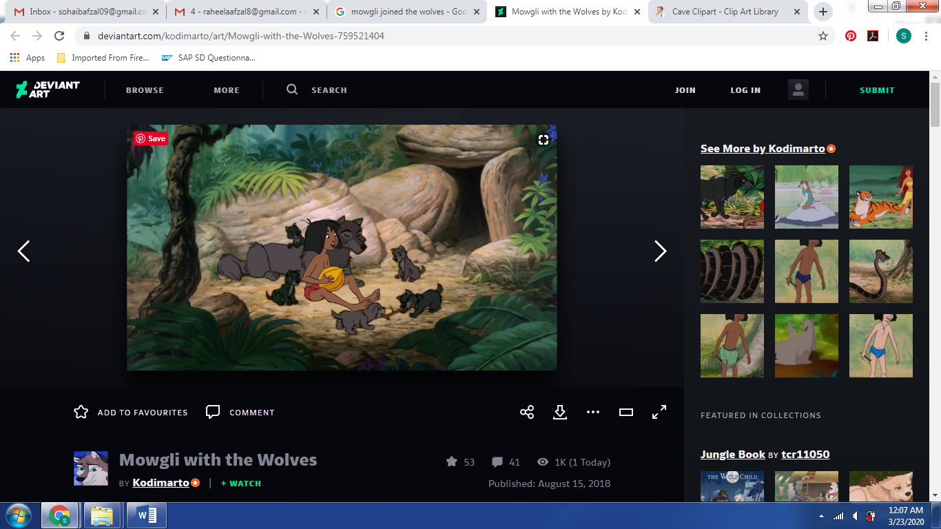 **Passage ( How little, how naked, and how – bold! ……………………… The jungle book by Rudyard Kipling.)**

**Comprehension skills**

**Q1. Summarize the story “How Mowgli joined the wolves” in your own words.**

**________________________________________________________________________________________________________________________________________________________________________________________________________________________________________________________________________________________________________________________________**

**Q2. Fill in the blanks by using suitable words from the above passage.**

1. The baby was pushing his way between the ________to get close to the warm hide.
2. I could kill him with the touch of my _____________.
3. He looks up and he is not ___________________ .
4. “How little! How naked and how ________________”, said mother wolf.
5. He came naked, by night, alone and very ________________.

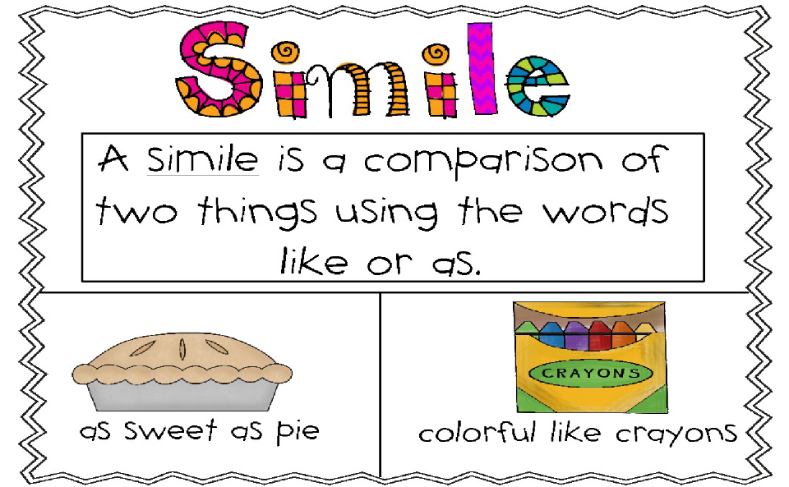 Languagae skills

**Q3). Complete each simile sentence with words from the box.**

**lion dogs baby bullet tortoise**

1. The young girl is as brave as a ____________________.
2. The siblings fought like cats and __________________.
3. He runs as fast as ____________.
4. She walks as slow as a ______________________.
5. Last night I slept like a _________________.