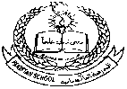**Pakistan School, Kingdom of Bahrain**

**E- Support and Learning Material / Session 2020-2021**

**Subject: English (worksheet: 1) Grade: 4**

**Book: Nelson English Student Book 4 FIRST TERM**

**Unit 1: How Mowgli joined the wolves Pg. No: 4**

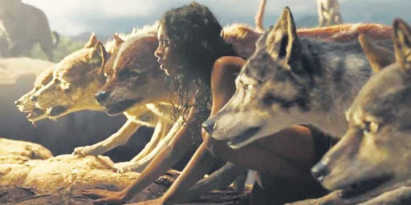**Passage (It was seven o’clock of a very warm…………….., ready for his leap.)**

**Q1) Read the passage and fill in the missing letters by looking at the pictures.**

|  |  |  |
| --- | --- | --- |
| Image result for kid yawning**y__w__ed** | Image result for scratched**s__r__t__h** | **w__l__**  Gray wolf. Getty Images |
| Image result for grassy bushes clip art**b__s__es** | Free Image on Pixabay - Wolf, Footprint, Lion, Tiger, Paw Wolf Paw Print, Tiger Claw, Lion Paw, Great Wolf Lodge, Tattoo Hals, Scroll Saw Patterns, Coloring Pages To Print, Online Art, Cross Stitch Patterns**p__w** | print on steel Animals wolf wolves space galaxy howl unique colorful neon colors pruple violet. This is the greatest galaxy wolf type thing I've ever seen! Galaxy Wolf, Galaxy Art, Galaxy Painting, Galaxy Space, Wolf Wallpaper, Galaxy Wallpaper, Drawing Wallpaper, Fantasy Kunst, Fantasy Art**s__u__al** |

**Q2) Read the passage and find out if the statement is true or false.**

1. **It was eight o’ clock of a very warm evening in the Seeonee hills._____**
2. **Father wolf woke up first. _______**
3. **Mother wolf lay with her nose across her four cubs. __________**
4. **“Something is coming uphill,” Said father wolf. ________**
5. **The bushes rustled a little in the thicket._________**

**Q3) Present the title of the lesson” How Mowgli joined the wolves” with the help of drawing.**