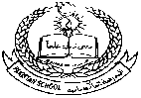**Pakistan School, Kingdom of Bahrain**

**E- Support and Learning Material / Session 2020-2021**

**Subject: G.Science Grade : 4**

**Book: Simply Science FIRST TERM week:1**

**Unit 2: Gases around us. Pg. No: ___16__**

**Topic: Grouping materials. (continued)**

**Answer the following questions**

**.Q.1 Define matter?**

**Ans: Anything that has mass and occupy space is called matter.**

**E.g Chair, table, water and air etc.**

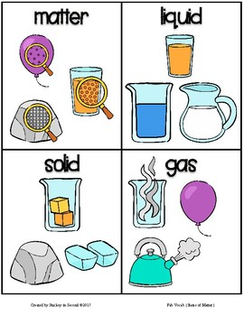**Q.2 How many states of matter write their names?**

**Ans: There are three states of matter.**

1. **Solid**
2. **Liquid**
3. **Gas**

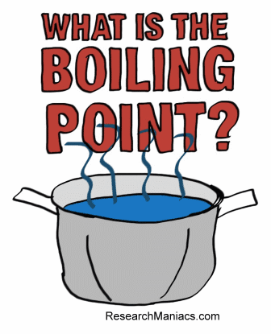 **Q.3 What is meant by boiling point?**

**Ans: The temperature at which a liquid start to boil and become a vapor.**

**E.g . water boiling point is 100 C**

**Q.4 What would have happened, if steam is cooled?**

**Ans: If steam is cooled, the particles slow down and turn into liquid water.**

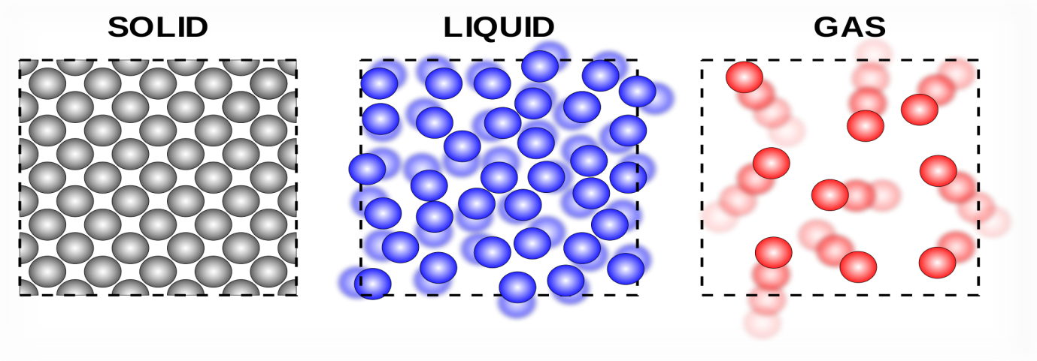 **Q.5. Describe in your own words why the tiny particles in solids, liquids and gases behave differently?**

**Ans: Solids:**

**In a solid the particles are packed close together so that they hardly move.**

**Liquid:**

**In a liquid the particles move around a little.**

**Gas:**

**In a gas the particles move around freely at high speed.**

**Pakistan School, Kingdom of Bahrain**

**E- Support and Learning Material / Session 2020-2021**

**Subject: G.Science Grade : 4**

**Book: Simply Science FIRST TERM**

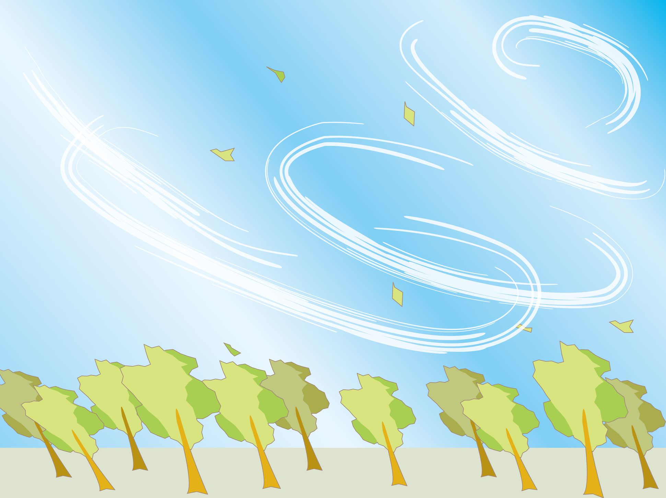 **Unit 2: Gases around us. Pg. No: ___18__**

**Topic: Gases in the air**

**Choose the correct answer from the given option.**

**1.You cannot see ………………**

**(a) Air (b) Solids (c) Liquid (d) None**

**2. Air has ………...**

**(a) Smell (b) Taste (c) weight (d) None**

**3. More than…………….km there is no air in the sky.**

**(a) 1000 (b) 2000 (c) 3000 (d) None**

**4.Air is mixture of ………….**

**(a) water (b) Gases (c) Solids (d) None**

**ANS;**

**1…Air**

**2…. Weight**

**3….1000 4…Gases**

**Pakistan School, Kingdom of Bahrain**

**E- Support and Learning Material / Session 2020-2021**

**Subject: G.Science Grade : 4**

**Book: Simply Science FIRST TERM**

**Unit 2: Gases around us. Pg. No: ___18__**

**Topic: Gases in the air (continued)**

**Short questions answers.**

**Q.1 Define Air?**

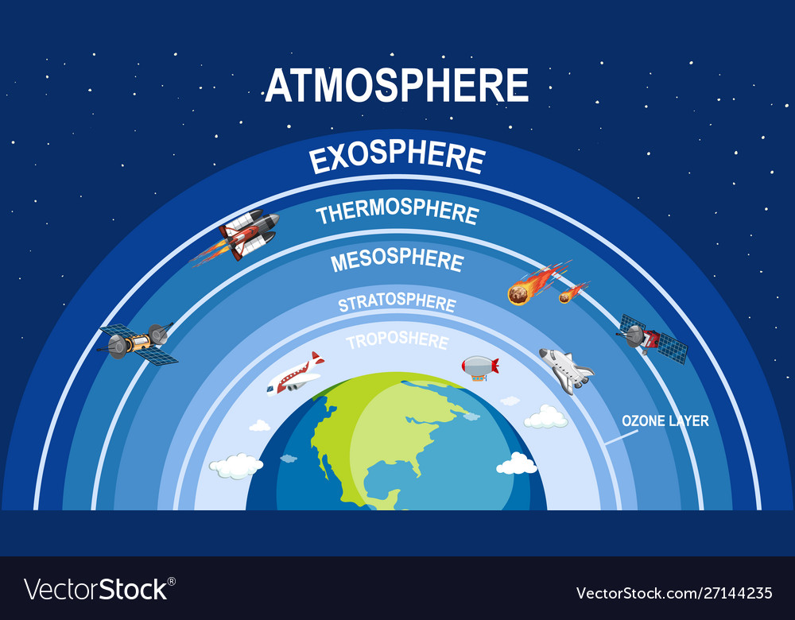**Ans: Air is the mixture of gases that are surrounded us. We cannot see, taste and smell it. But air has weight.**

**Q.2 Define Atmosphere?**

**Ans: Atmosphere is thick layer of air that surrounds the earth.**

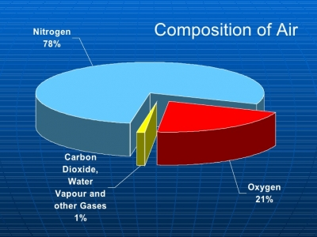**Q.3. Write down the percentage of gases in the air?**

**Ans: The Percentage of gases in the air is:**

1. **Nitrogen 78%**
2. **Oxygen 21%**
3. **Other gases 1%**

**Q.4 How does compressed air works? Explain it**

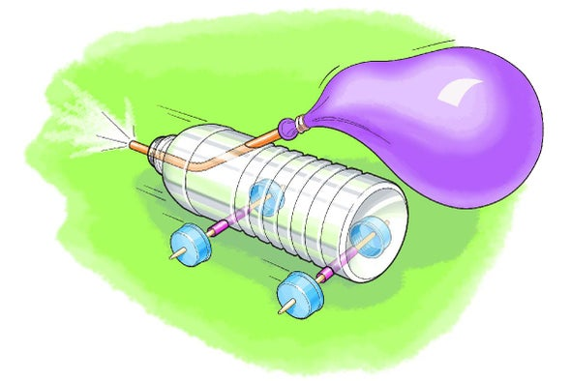 **Ans: We can compress air into smaller size. When you take atmospheric air and force it into a smaller volume, molecules take up less space and the air is compressed.**

**Q.5 Add a pinch of bicarbonate of soda to some vinegar in a jar. What do You notice?**

**Ans: If we add a pinch of bicarbonate of soda to some vinegar in a jar, the mixture fizzes violently as the carbon dioxide gas is produced.**

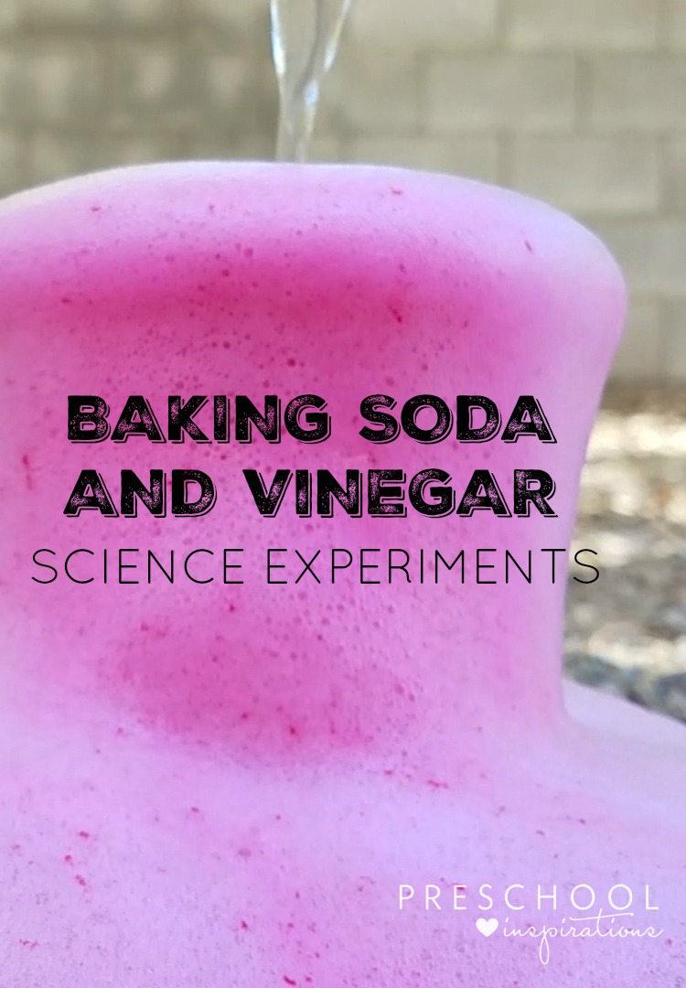 **This is a chemical change.**

**Pakistan School, Kingdom of Bahrain**

**E- Support and Learning Material / Session 2020-2021**

**Subject: G.Science Grade : 4**

**Book: Simply Science FIRST TERM week:1**

**Unit 4: Gases around us. Pg. No: ___16__**

**Topic: Gases in the air.**

**Note: Attempt any two worksheet .**

**Worksheet:1**

**Q1. Write true or false:**

**1.If water is cooled further, solid ice is formed. T/F**

**2.There are five different types of matter. T/F**

**3.In the solid particles packed close together T/F**

**4. Air is not a mixture of gases. T/F**

**5. We can feel the air. T/F**

**6. Climbers on the highest of mountains have to take air or oxygen**

**With them. T/F**

**Q.2 F ill in the blanks.**

**1. If we weighed all the air in a room, it would weigh more than………….**

**2. A bicycle pump can squeeze or compressed the ……….**

**3. The………….is surrounded by a huge layer of air.**

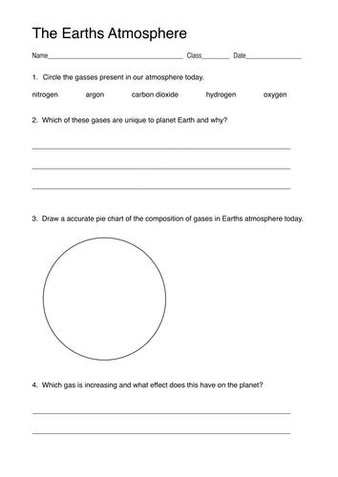**Work sheet: 2**

**Worksheet: 3:**

