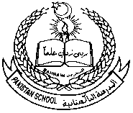 **Pakistan School, Kingdom of Bahrain**

**E- Support and Learning Material**

**Subject: GK Week -1**

**Name:______________________ LKG Sec: ________ Isa Town / Manama**

**Topic : My Self ( Oral)**

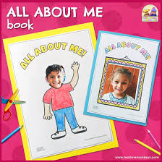 **Lesson:1 About Myself (Oral)**

* **I am a ________ . ( boy / girl)**
* **My name is ___________________ .**
* **I am four years old.**
* **I am in LKG .**
* **The name of my school is Pakistan School.**