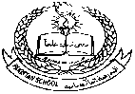**Pakistan School , Kingdom of Bahrain**

**E- Support and Learning Material / Session 2020-2021**

**Subject: GOP Grade: 9 Sec: ______**

**WORKSHEET – 1**

**Chapter 1: Introduction ( Pgs.1-4)**

**Choice Board Activity**

**Q. Choose any 4 questions and answer them briefly:**

**1. Which provinces made up West Pakistan at the time of independence?**

**2. What is the location of Pakistan?**

**3. What is Durand Line?**

**4. Enlist the administrative divisions of Pakistan.**

**5. What do we have in the north of Pakistan?**

**6. Name the three members of ECO.**

**LOCATE Pakistan and neighbouring countries on the map.**

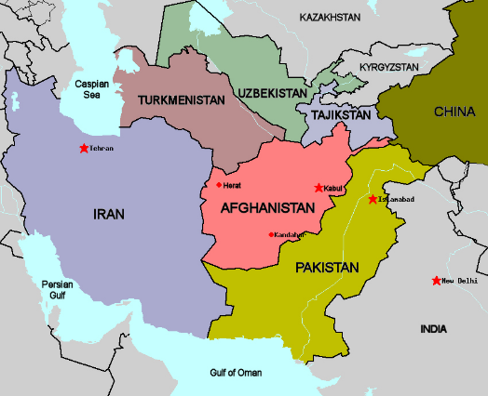

**NOTE : Learn the questions and answers from the given notes.**