**Pakista**

**n School ,**

**Kingdom of Bahrain**

**E**

**-**

**Support and Learning Material**

**/ Session 2020**

**-**

**2021**

**Subject:**

**GOP**

**Grade :**

**9**

**th**

**Book:**

**GOP**

**for foreign students**

**FIRST TERM**

**Unit 1:**

**Introduction**

**Pg. No: 1**

**-**

**8**

**Ex.1**

**-**

**Short Questions**

**:**

**Q#1:**

**-**

**W**

**rite**

**names**

**of princely states in**

**1947**

**.**

Ans:

A

t the time of partition small princely states like

Chitral

,

Di

r,

Kalat,

Les

b

ela Sawat

,

Amb,

B

ahawalpur

and khairpur .

T

he states of Junaga

r

h and

Manavader

acceded to Pakistan

.

**Q#2:**

**-**

**D**

**escribe the location of**

**Pakistan**

**.**

Ans:

Pakistan extends between the latitudes

24

degree

N

orth and 37 degree

N

orth

and

longitudes 61 degree

E

ast and 75.5 degree

E

ast

.

Pakistan has an area of 796096 square

ki

lometre

,

and

thus

occupies 18.78% of South Asia

0.06

% of the world

.

Q#3:

-

W

rite about the

neighbors

of Pakistan

.

Ans:

India lies on Pakistan’s Eastern

border.

China in

north

,

Afghanistan in Northwest ,

Iran in west ,

Arabian sea in south

.

Q#4:

-

W

hat does CIS

stands

for

.

Ans:

-

Central

I

ndependent

S

tate

.

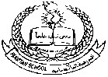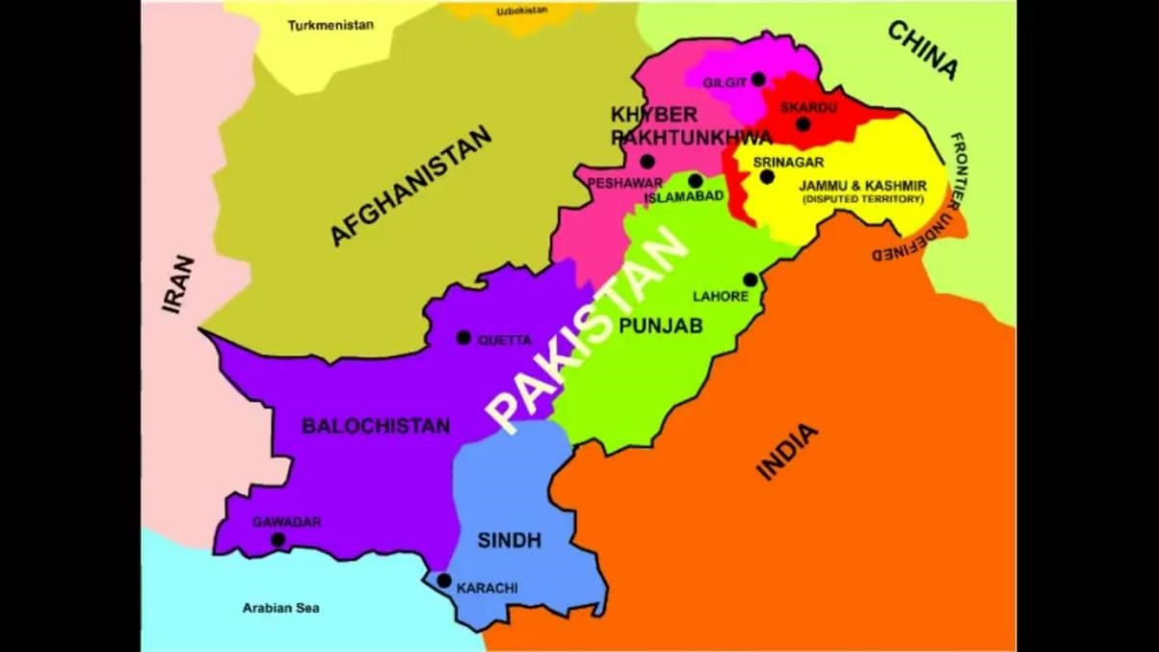

|  |  |  |  |  |  |  |  |  |
| --- | --- | --- | --- | --- | --- | --- | --- | --- |
| Q#5:- What is Durand Line.  Ans:- in the west ,Pakistan has a common border of about 2252 kilometre with Afghanistan known as durand line ,and a common border of about 805 km with Iran to the south of the durand line .  Q#6:- What does ECO stand for.  Ans:- Economic Cooperation for Development .  Q#7:- Write the capitals provinces of Pakistan.  Ans:- Administratively the country is divided into four provinces some travel agency some travel agency .Islamabad is the federal capital.  The capitals of provinces are:-   |  |  | | --- | --- | | Punjab | Lahore | | Sindh | Karachi | | K.P.K | Peshawar | | Balochistan | Quetta |     Q#8:- What do you know about the Congress.  Ans:- The Indian National Congress was founded in 1885 to achieve Independence for the whole India.in the later part of the nineteenth century the Hindus organized themselves to present their demands .in 1885 they set up a political party known as the Indian National Congress and styled itself the only representative body of the whole of India.in the beginning the Muslim joined hands with the Hindus in the freedom movement under the banner of the Congress but soon they discovered that the Indian National Congress was a Hindu organization .  Q#9:- What do you know about the Muslim League?  Ans:- in 1906 the Muslims of the subcontinent were convinced that they must have a political party of their own to present their view point before the government in an effective manner .The Muslim lead the foundation of all India Muslim League at Dhaka in 1906. |