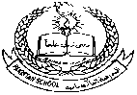 **Pakistan School, Kingdom of Bahrain**

**E- Support and Learning Material / Session 2020-2021**

**Subject: Islamiyat Grade: 1**

**Book: Islamiyat for primary classes- 1 Week 1 FIRST TERM**

**Unit 1: Memorization and Translation:**

**Ta’awwuz:**

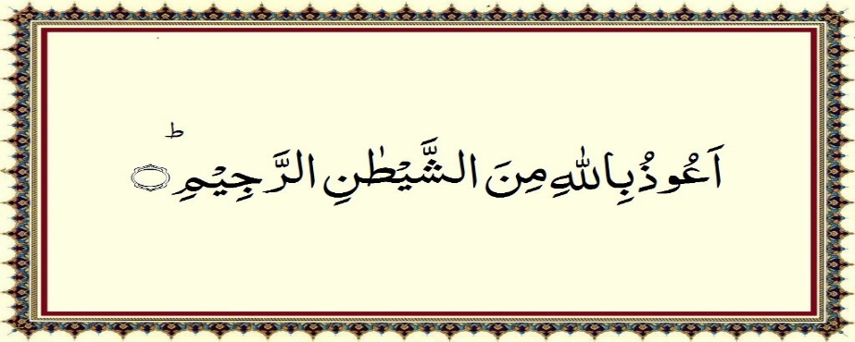

**I seek refuge in Allah from shaytan the cursed.**

**Tasmiya:**



**In the name of Allah the most Gracious, the most Merciful.**

**Note: Recite and learn by heart Ta’awwuz and Tasmiya with Translation.**

**Surah Al Kawthar**

**Listen to the recitation and learn the surah with Tajweed by using this link.**

[**https://youtu.be/9JqOsNS8c8w**](https://youtu.be/9JqOsNS8c8w)

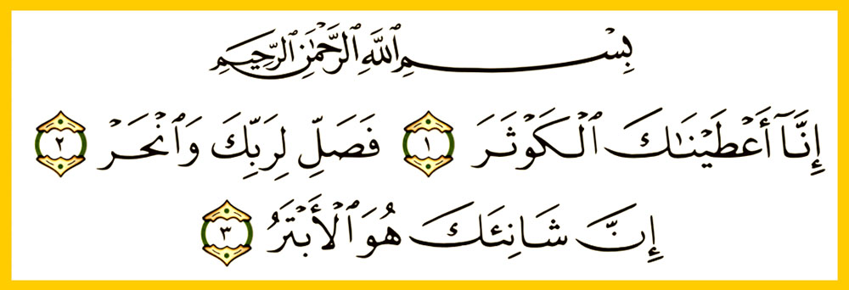

**Homework: Learn it by heart.**