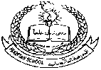**Pakistan School , Kingdom of Bahrain**

**E- Support and Learning Material / Session 2020-2021**

**Subject: Islamiat Grade : 3**

**Book: Islamiat for primary classes (FIRST TERM)**

**Unit: 1** Recitation and Memorization **(Surah Al- Falaq) book page#2**

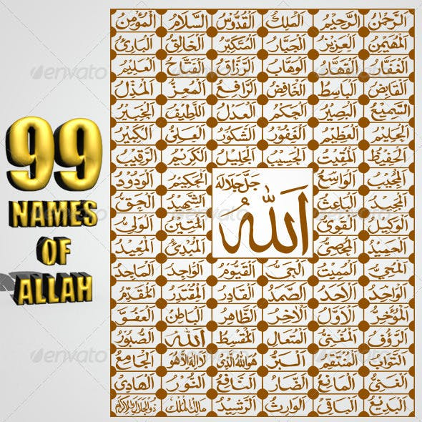 **Listen to the recitation and learn the surah with Tajweed by using this link.**

[**https://youtu.be/PvgZn2LfK58**](https://youtu.be/PvgZn2LfK58)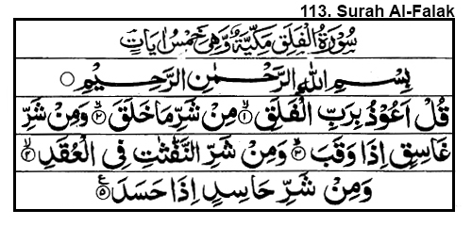



Asma-e-Ilahi

**Book page: 14**

Allah has 99 beautiful names.

Some of these are**: (Learn these names with meanings)**



The subtle one The aware The forbearing one

The great one The all forgiving The appreciative