**Pakistan School, Kingdom of Bahrain**

**E- Support and Learning Material / Session 2020-2021**

**Subject: Islamiyat Grade: 4**

**Book: Islamiyat for Primary Classes Second Edition FIRST TERM**

**Unit 1: Memorization and translation**

**Topic: Memorization**

**Surah Quraish**

**Listen to the recitation and learn the surah with Tajweed by using this link.**

[**https://youtu.be/-I2wz7rof0k**](https://youtu.be/-I2wz7rof0k)

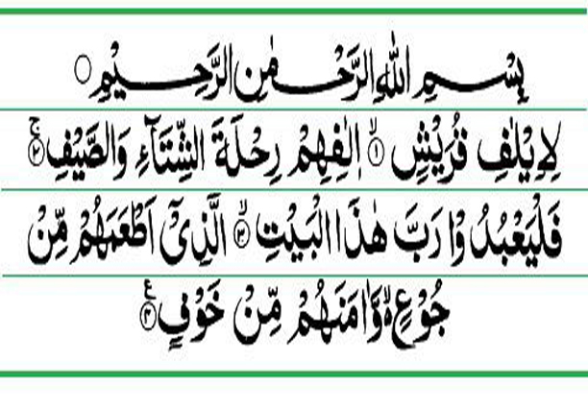

**Topic: Translation**

**Surah Quraish**

* In the name of Allah, the Most Gracious, the Most Merciful.

1. Since the Quraish became accustomed.
2. Accustomed to the journey of winter and summer.
3. Therefore let them worship the Lord of this house.
4. Who fed them against hunger and secured them against fear.

**Homework: Learn the translation of Surah Quraish.**