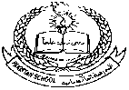**Pakistan School , Kingdom of Bahrain**

**E- Support and Learning Material / Session 2020-2021**

**Subject: Islamiyat Grade: 6th**

**Book: Oxford Week -1**

**Unit 1: Memorization and Translation Pg. 3**

**Topic no:1 Surah Al Inshirah**

**Listen to the recitation and learn the surah with Tajweed by using this link.**

[**https://youtu.be/XoaQvMIXXf8**](https://youtu.be/XoaQvMIXXf8)

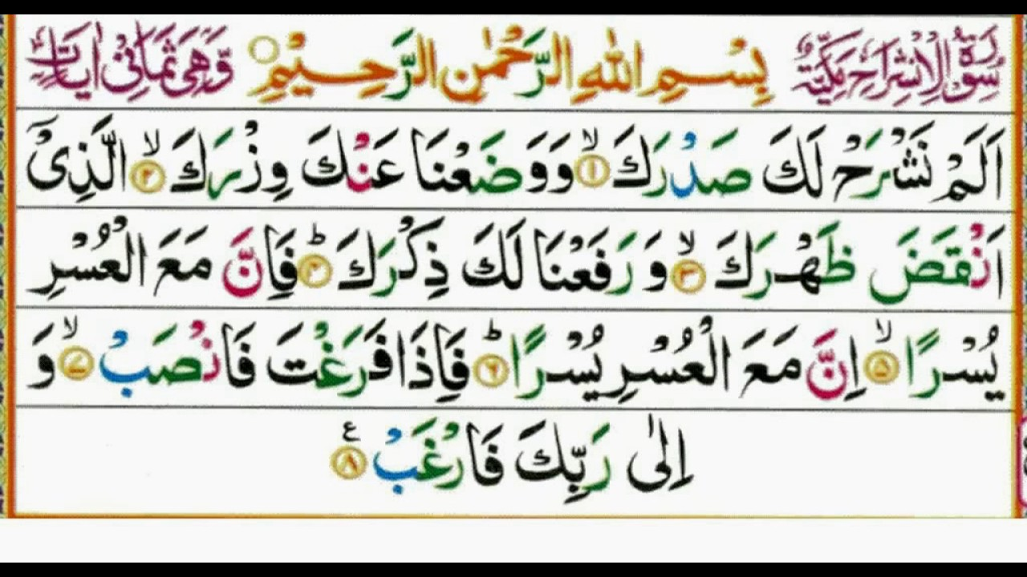

**HOMEWORK: Learn this surah by heart.**

**Dua Memorization and Translation:**

**Listen to the dua and learn it with Tajweed by using this link.**

[**https://youtu.be/_uODHRiItNM**](https://youtu.be/_uODHRiItNM)

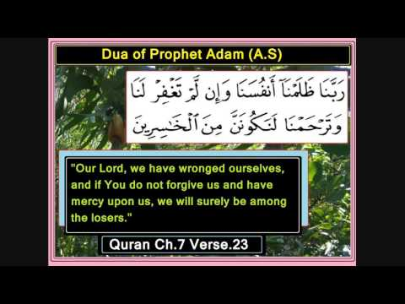

**Homework: Learn this dua with translation.**