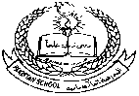**Pakistan School , Kingdom of Bahrain**

**E- Support and Learning Material / Session 2020-2021**

**Subject: Islamiyat Grade: 7th**

**Book: Oxford Islamiyat FIRST Week**

**Chapter #01 Al Quran Al Kareem**

**Memorization and Translation**

**Topic no:1 Surah Ad Duhaa**

**Listen to the recitation and learn the surah with Tajweed by using this link.**

[**https://youtu.be/0nmXvbiCw4A**](https://youtu.be/0nmXvbiCw4A)

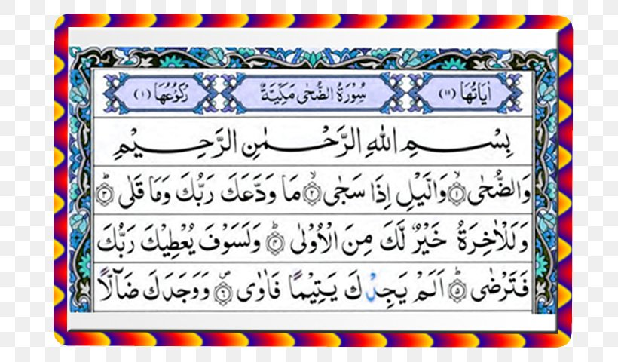

**Homework: Learn this surah by heart.**

**Memorization and Translation**

**Topic no:2 Surah Al Zilzaal**

**Listen to the recitation and learn the surah with Tajweed by using this link.**

[**https://youtu.be/XunR9qLCaco**](https://youtu.be/XunR9qLCaco)

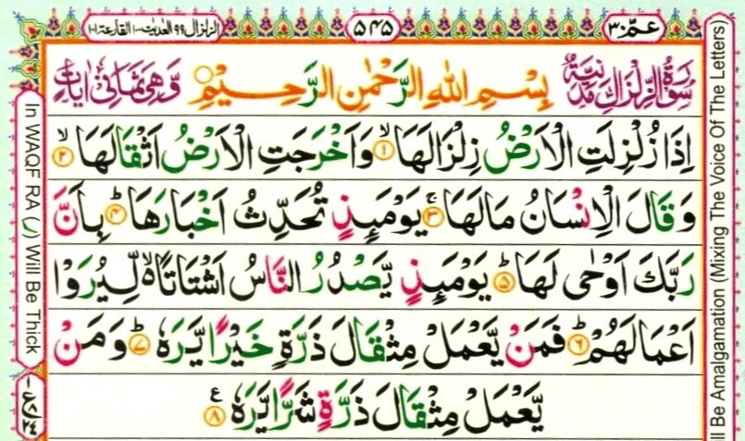

**Homework: Learn this surah by heart.**