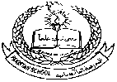**Pakistan School , Kingdom of Bahrain**

**E- Support and Learning Material / Session 2020-2021**

**Subject: Islamiyat Grade: 8th**

**Book: Oxford Islamiyat FIRST Week**

**Chapter #01 Al Quran Al Kareem Pg :3**

**Memorization and Translation**

**Topic no:1 Surah Al Adiyat**

**Listen to the recitation and learn the surah with Tajweed by using this link.**

**<https://youtu.be/1CgLf-2C2jw>**

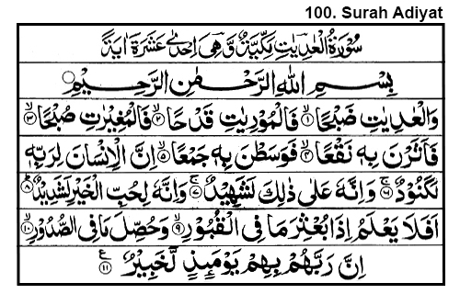

**Homework: Learn this surah by heart.**

**Memorization and Translation**

**Topic no:1 Surah At Takasur**

**⮚ Memorization of Surah At Takasur**

**Listen to the recitation and learn the surah with Tajweed by using this link.**

[**https://youtu.be/UItRQ3hkj6k**](https://youtu.be/UItRQ3hkj6k)

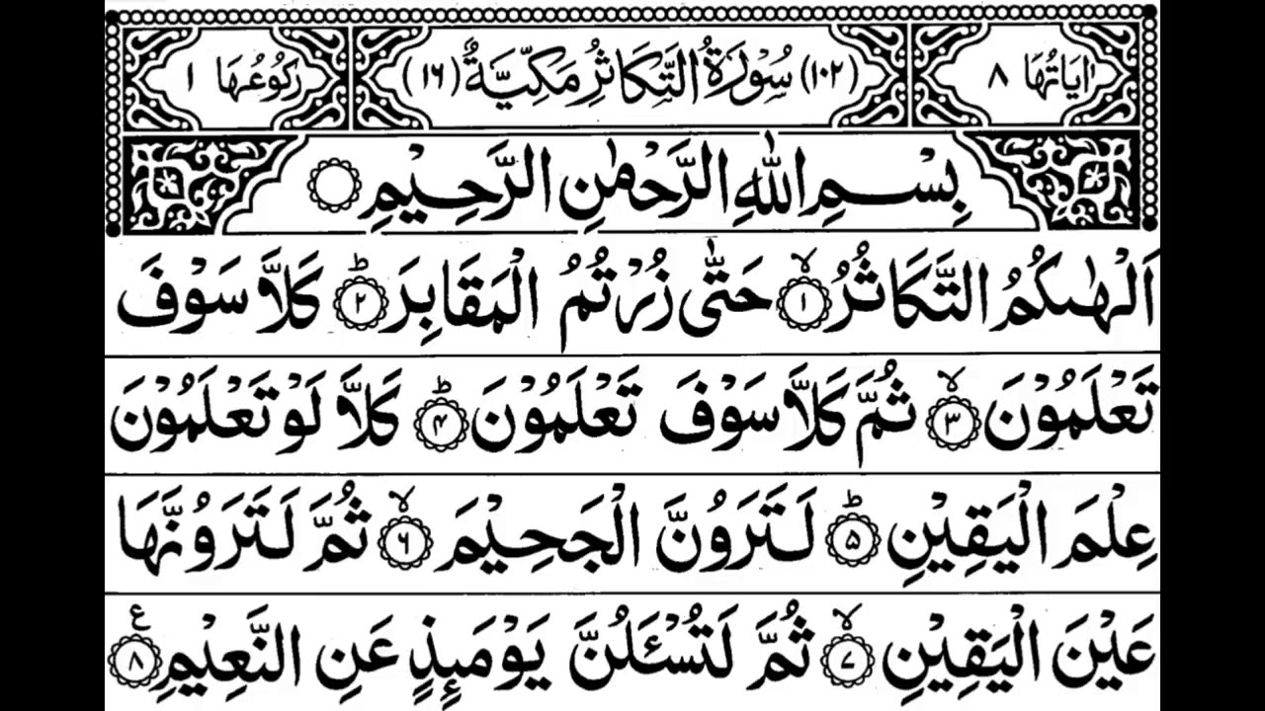

**Homework: Learn this surah by heart.**