** E- Support and Learning 1st Term Session 2020-2021**

**PAKISTAN SCHOOL, ISATOWN BAHRAIN**

**Subject: Computer Grade: 2**

**Book: OXFORD KEYBOARD Book-2 (Third Edition) Activity (1)**

**Student name: ___________________________________________**

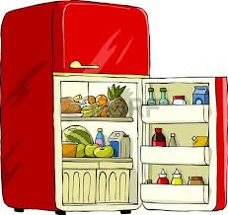Q1.Circle the thing that work on electricity:-

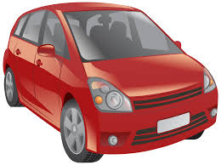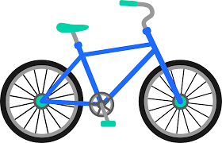

Q2. Circle the things that made by man or human:-

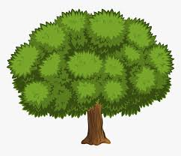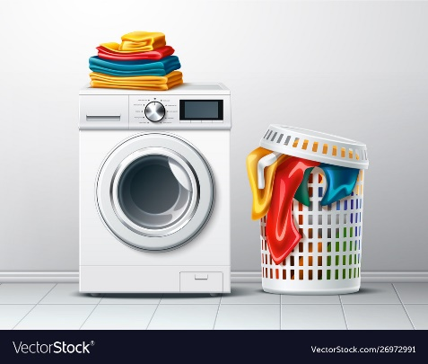

Q3. Memorize the spelling of these words at home:-

1. Electricity
2. Bicycle
3. Refrigerator
4. Washing Machine 5. Car