**Pakistan School , Kingdom of Bahrain**

**E- Support and Learning Material / Session 2020-2021**

**Subject: G.Science Grade : 4**

**Book: Simply Science FIRST TERM**

**Unit 2: Gases around us. Pg. No: ___20_**

**Topic: OXYGEN.**



**(A) Short questions answers.**

**Q.1 What would happen, if there were no plants on the earth?**

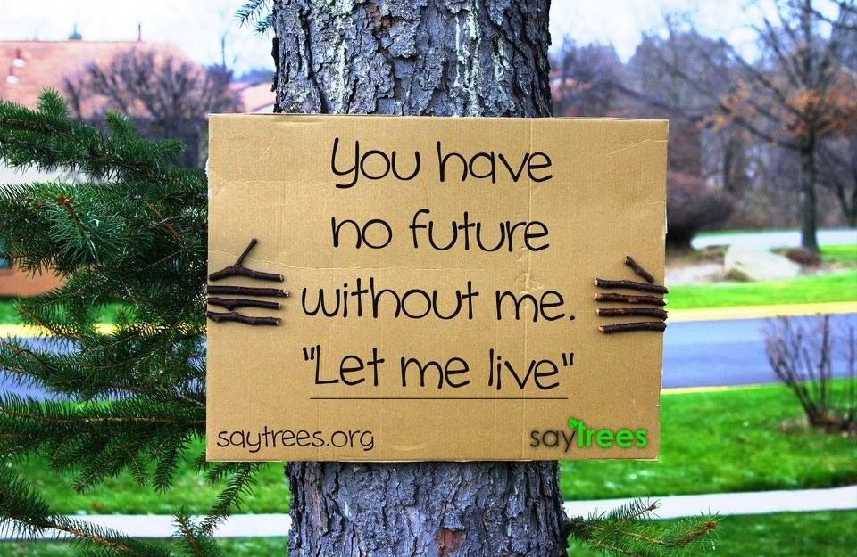**Ans: If there were no plants on the earth, then it could not be possible for everything to live on the earth.**

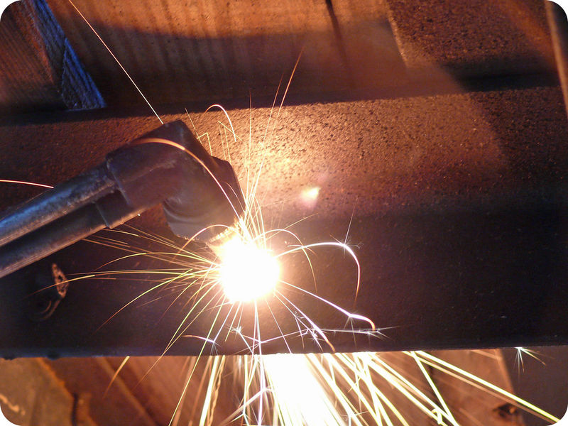**Q.2 Write the uses of acetylene?**

**Ans: Oxygen mixed with Acetylene is used to:**

1. **Cutting the metals such as iron**
2. **Welding the metals such as steel.**

**Q.3 IN your words ,describe why oxygen is vitally important to all living things?**

**Ans: Oxygen is vitally important to all living things, because they need this gas to chemically burn up their food to produce oxygen , the chemical name for this process is respiration.**

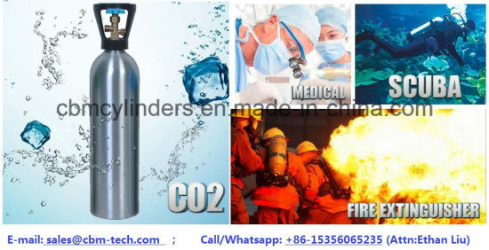**Q.4 Write some uses of oxygen?**

**Ans:**

**1) Oxygen is used by plants and animals in the respiration.**

**2) Firefighters carry bottles of oxygen when they fight smoky fires.**

**3) Oxygen are used in medicine to treat people with breathing problem.**

** Pakistan School , Kingdom of Bahrain**

**E- Support and Learning Material / Session 2020-2021**

**Subject: G.Science Grade : 4**

**Book: Simply Science FIRST TERM**

**Unit 2: Gases around us. Pg. No: ___20**

**Topic: OXYGEN.**

**(A) MCQS**

**Choose the correct answer from the given option.**

**1 One of the gases in the air is………….**

**(a) Oxygen (b) Nitrogen (c) Sodium (d) None**

**2. Because there is no ………………at all in space .Astronauts have to take their oxygen with**

**them.**

**(a) Air (b) Solids (c) Liquid (d) None**

**3 .we breathe in ………...**

**(a) Nitrogen (b) Sodium (c) Oxygen (d) None**

**4. Oxygen, mixed with a gas called……………..is used in special torches.**

**(a) Acetylene (b) Sodium (c) Nitrogen (d) None**

**5.Oxygen gas turns into a liquid if it is cooled below minus ………….**

**(a) 183 C⁰ (b) 148C⁰ (c) 149C⁰ (d) 145C⁰ n**

**ANS;**

**Mcq 1…….OXYGEN**

**Mcq 2……….AIR**

**Mcq 3………..OXYGEN**

**Mcq 4………….ACETYLENE**

**Mcq 5…………… 183 C⁰**

**Pakistan School , Kingdom of Bahrain**

**E- Support and Learning Material / Session 2020-2021**

**Subject: G.Science Grade : 4**

**Book: Simply Science FIRST TERM**

**Unit 2: Gases around us. Pg. No: ___22__**

**Topic: Some more everyday gases.**

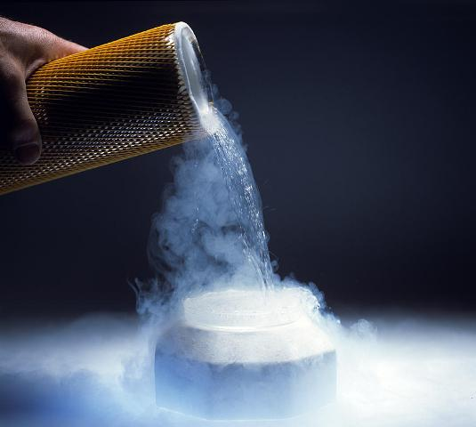 **(A) Short questions answers.**

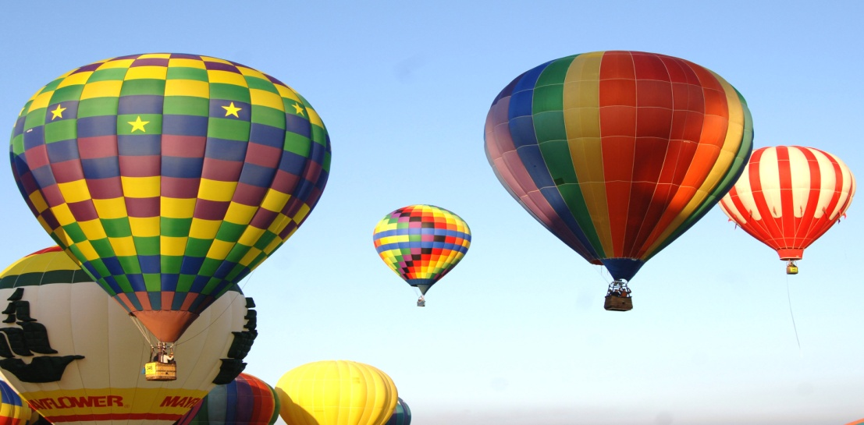**Q.1 Why Helium is used in balloons and in airships instead of hydrogen?**

**Ans: Hydrogen gas burn quickly and the helium is a gas that does not burn. Because of this reason we use helium instead of hydrogen.**

**Q.2 What is a fire extinguishers?**

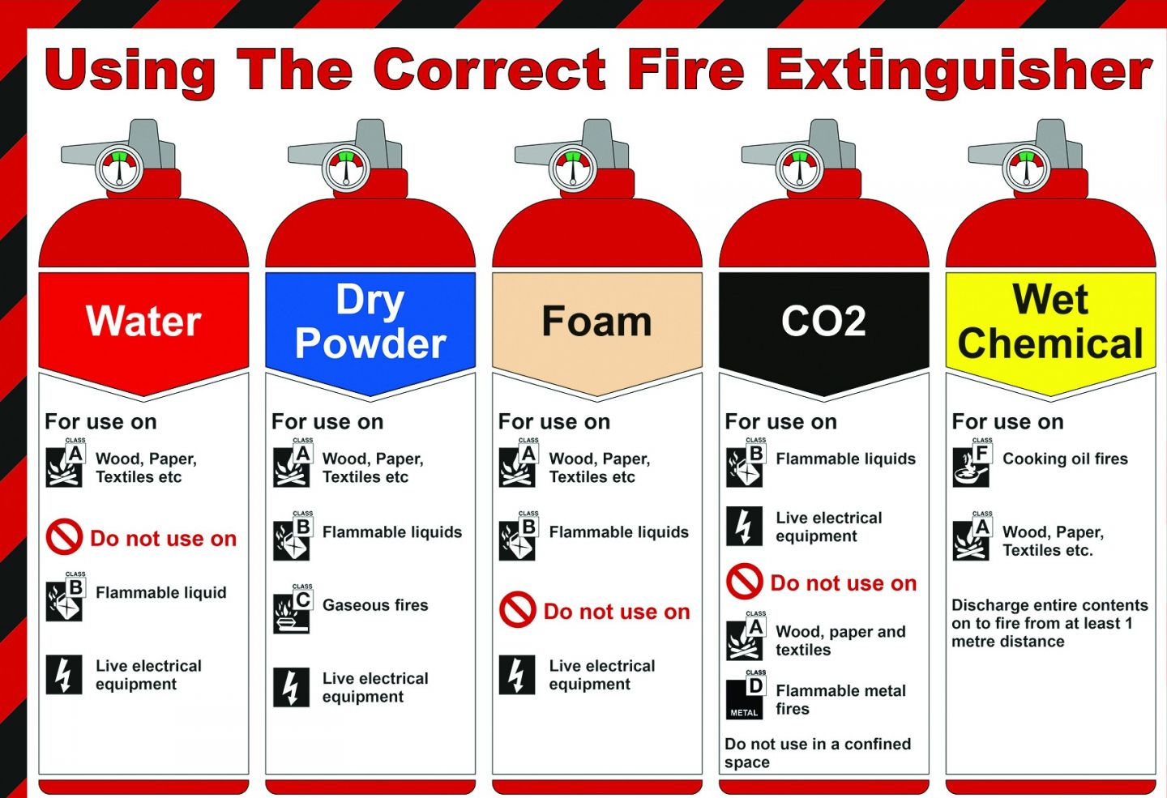**Ans: It is a fire protection device used to control fire. Some fire extinguishers also produce carbon dioxide which can stop oxygen getting to a fire**

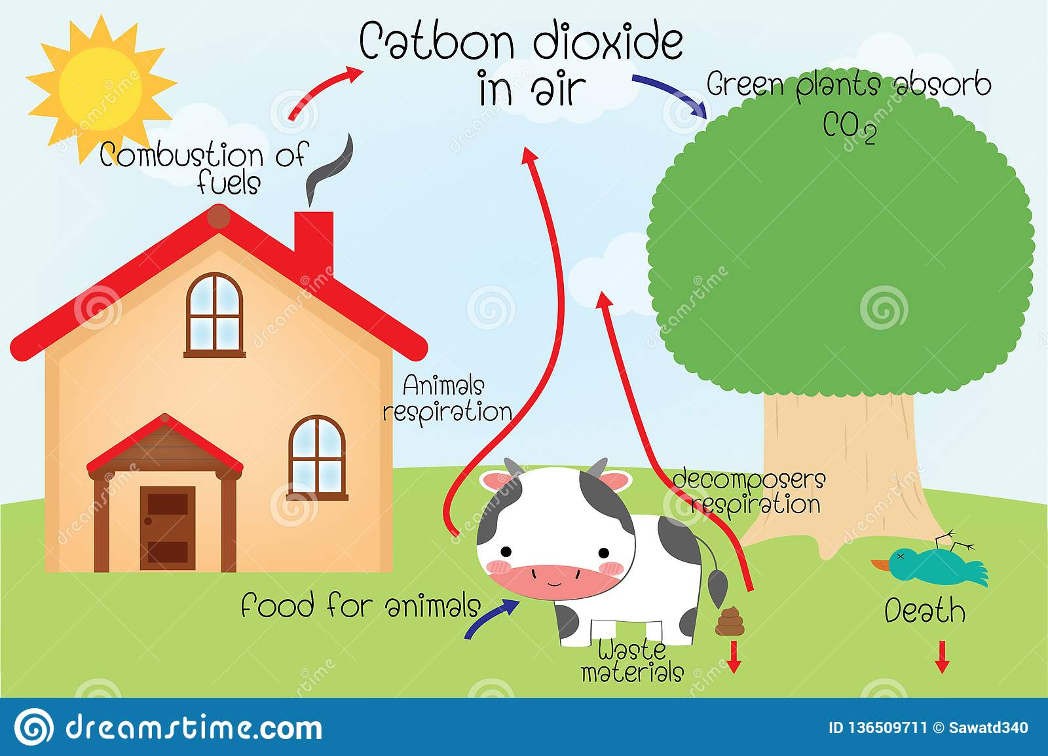**Q 3.Write some sources of carbon dioxide?**

**Ans:**

**1) Animals produce this gas when they breathe out.**

**2) Fuels such as wood, oils or some natural gas burn, they also Produce carbon dioxide.**

**Pakistan School , Kingdom of Bahrain**

**E- Support and Learning Material / Session 2020-2021**

**Subject: G.Science Grade : 4**

**Book: Simply Science FIRST TERM**

**Unit 2: Gases around us. Pg. No: ___22__**

**Topic: Some more everyday gases.**

**Q.4 Write some uses of nitrogen?**

**ANS:**

1. **It is mainly used to make fertilizers.**
2. **Used in dyes and drugs.**
3. 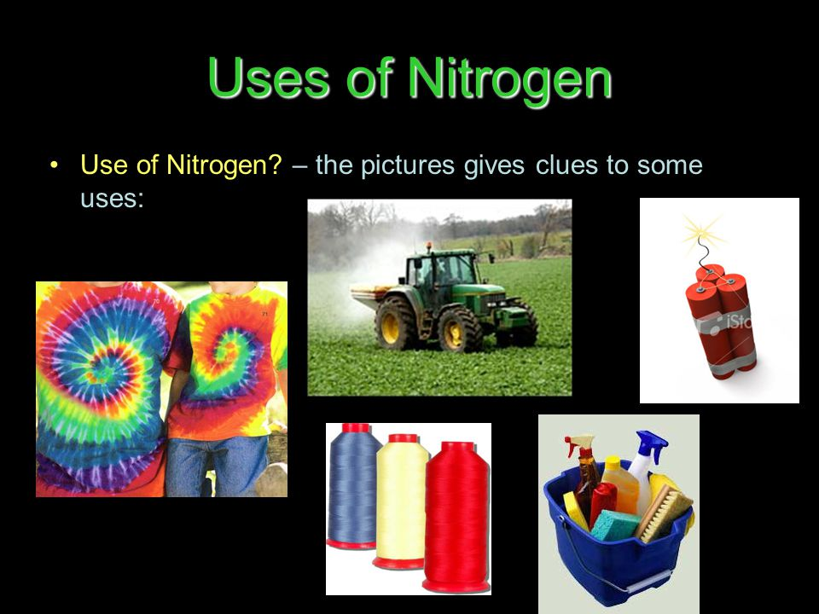**Used to fill the containers where oils or some explosives are stored.**

**(A) MCQS**

**Choose the correct answer from the given option.**

**1 When plants and animals breathe out they produce ..………….**

**(a) Oxygen (b) Carbon dioxide (c) Nitrogen (d) None**

**2. ………………and cakes are light and fluffy because of carbon dioxide.**

**(a) Bread (b) Jams (c) Drinks (d) None**

**3 .Green plants use ………......to make their food.**

**(a) Nitrogen (b) carbon dioxide (c) Oxygen (d) None**

**4..........is very light and does not burn.**

**(a) Helium (b) Carbon dioxide (c) Nitrogen (d) None**

**5. Fizzy drinks contain large amount of ……….**

**(a) Nitrogen (b) carbon dioxide (c) Oxygen (d) None**

**ANS;**

**Mcq 1…….carbon dioxide**

**Mcq 2……….Bread**

**Mcq 3………..Carbon dioxide**

**Mcq 4………….Helium**

**Mcq 5…………… Carbon dioxide**

**Pakistan School , Kingdom of Bahrain**

**E- Support and Learning Material / Session 2020-2021**

**Subject: G.Science Grade : 4**

**Book: Simply Science FIRST TERM**

**Unit 2: Gases around us. Pg. No: ___20_**

**Topic: OXYGEN**

**Activity 1**

**Write true or false:**

**1. There is not much air near the top of the highest mountains. T/F**

**2 .Firefighters not carry oxygen with them. When they fight smoky fires . T/F**

**3.For respiration we need oxygen T/F**

**4. Neon glows orange-red when electricity flows through it. T/F**

**5 . Nitrogen used to make fertilizers. T/F**

**6 .For respiration we need oxygen T/F**

**Activity 2**

**Fill in the blanks.**

**1. River Amazon in South America produce…………..of oxygen.**

**2. About ……………of the air, we breathe is oxygen.**

**3. ………….also burns the fuel in a spacecraft.**

**4. When some cakes are made, chemicals called…………….. is put in the mixture.**

**5. …………… makes up about 78 percent of the air.**

**6. …………. is used to fill weathers balloons and modern airships.**

**Activity 3**

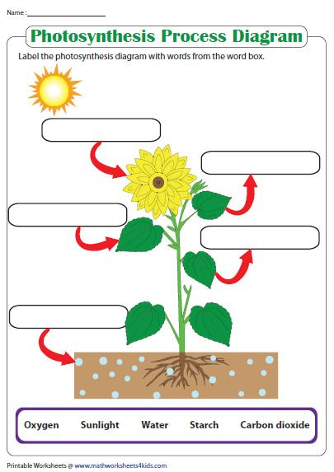

**Activity 4:**

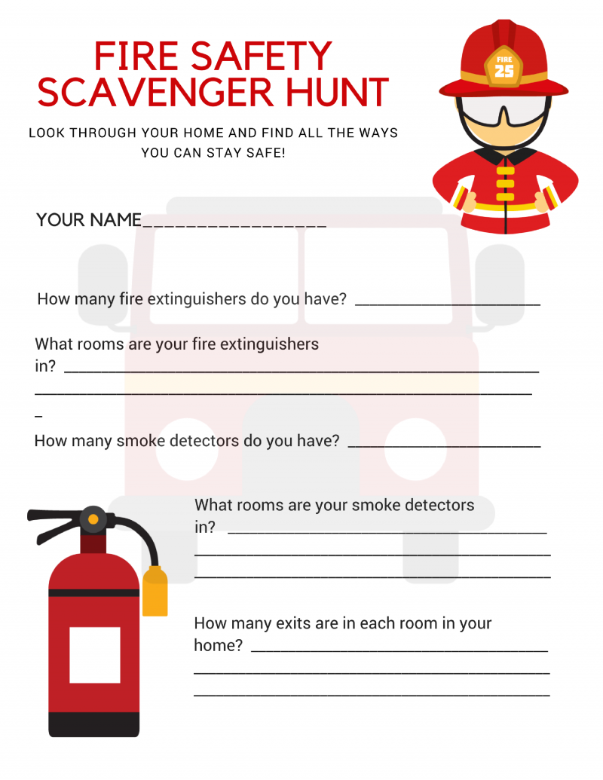

**Activity 5:**

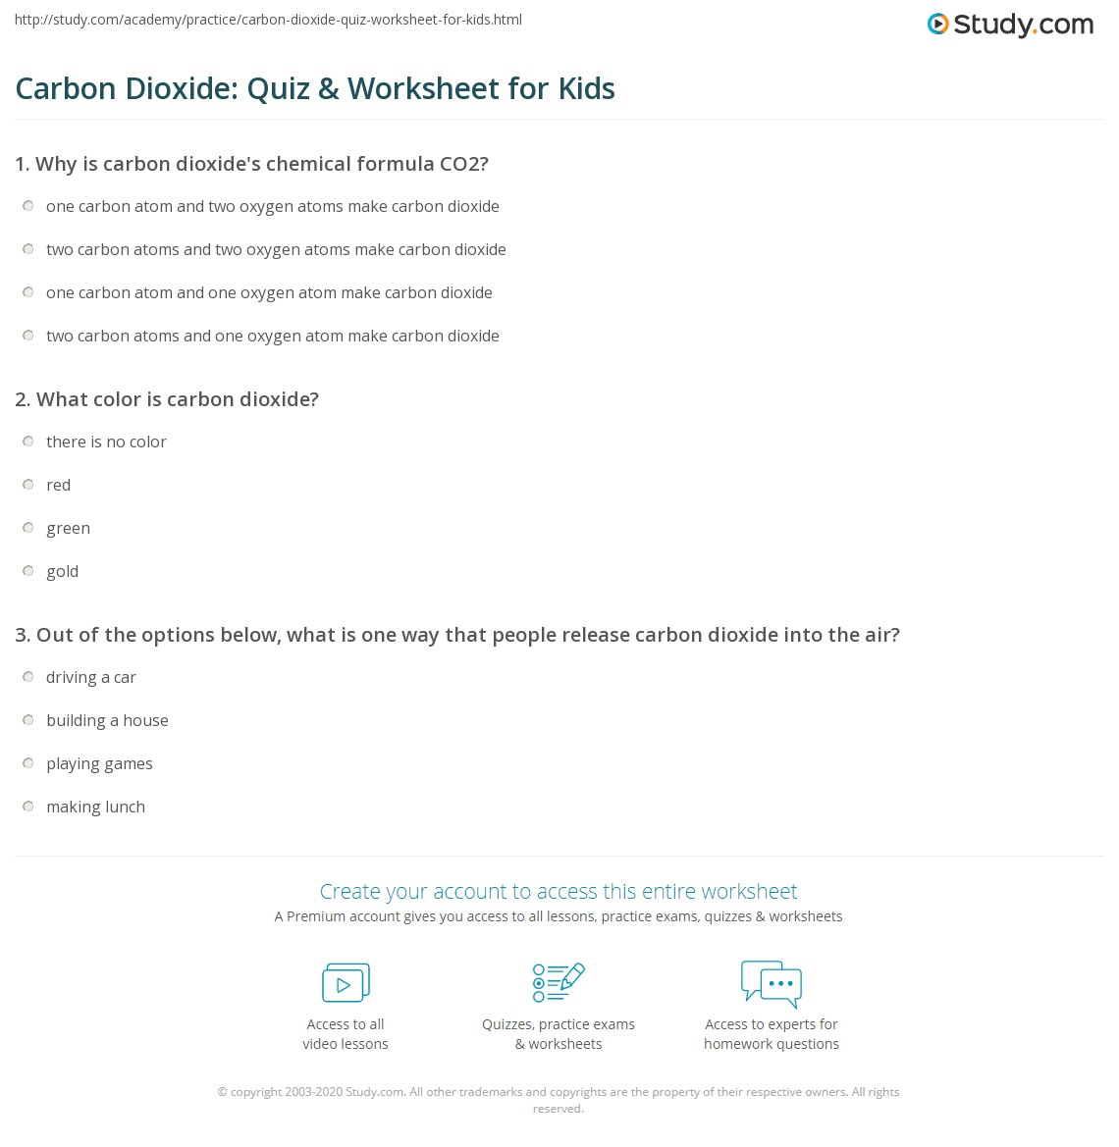

**(Homework)**

**Q.1. Think about the different fuels you know. write the names of the fuel which is a**

**solid, liquid and gas.**

**Q.2. A pale green gas is dissolved in the water in swimming pools. Find out**

**Out what it is called. Why is it used? What else can you find out about this**

**Gas?**

**Read the lesson and also learn the questions/Answers.**