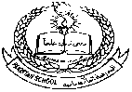**Pakistan School, Kingdom of Bahrain**

**E- Support and Learning Material / Session 2020-2021**

**Subject: Islamiyat Grade: 4**

**Book: Islamiyat for Primary Classes Second Edition FIRST TERM**

**Unit 2: Allah’s names**

**Topic: Memorization and translation**

**Ref. Book Pg. 6**

Allah’s names



Allah has many qualities. The 99 names of Allah, Asma-e-Ellahi tell us about some of His qualities.

|  |  |  |
| --- | --- | --- |
| **Sr. #** | **Allah’s names** | **Meaning** |
| 1. | Image result for allah names | The Witness |
| 2. | Image result for allah names | The Truth |
| 3. | Image result for allah names | The Trustee |
| 4. | Image result for allah names | The Most Strong |
| 5. | Image result for allah names | The Firm One |
| 6. | Image result for allah names | The Protecting Friend |
| 7. | Image result for allah names | The Praiseworthy |

**Homework: Recite and learn the translation of Allah’s names.**

**WORKSHEET**

**Unit 2: Allah’s names**

**Topic: Memorization and translation**

**Note: Write answers of any 2 of the following questions.**

**Q.1 Match Allah’s names with their meaning.**

|  |  |  |  |
| --- | --- | --- | --- |
| **Sr. #** | **Allah’s names** | **Meaning** | **Answers** |
| 1. | Image result for allah names | The Trustee |  |
| 2. | Image result for allah names | The Witness |  |
| 3. | Image result for allah names | The Truth |  |

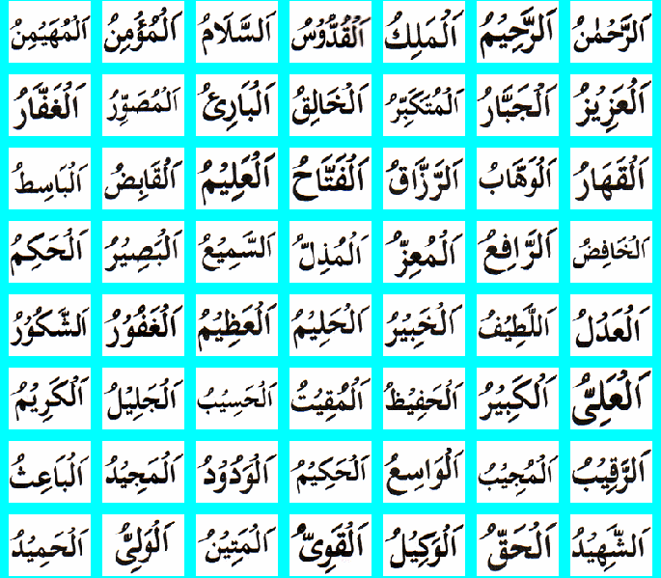**Q.2 Write the meaning of the following Allah’s names.**



**____________________ _____________________**

**Q.3 Write the Arabic of the following meanings of Allah’s names.**

1. **The Protecting Friend**
2. **The Praiseworthy**

**Pakistan School, Kingdom of Bahrain**

**E- Support and Learning Material / Session 2020-2021**

**Subject: Islamiyat Grade: 4**

**Book: Islamiyat for Primary Classes Second Edition FIRST TERM**

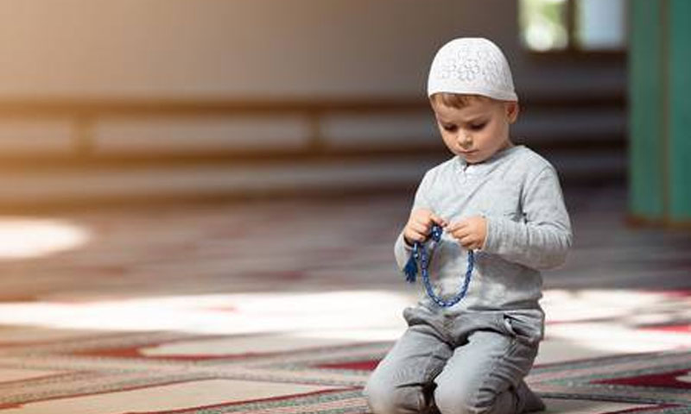 **Unit 2: Pillars of Islam: Namaz**

**Short Q/A**

**Q.1 Name the five pillars of Islam?**

Ans. Tauheed, Namaz, Zakat, Roza, Hajj

**Q.2 Who taught us how to pray?**

Ans. The Prophet (SAW) has taught us how to pray.

**Q.3 What has the Prophet (SAW) said about namaz?**

Ans. The Prophet (SAW) has said “Namaz has been made the coolness of my eyes”.

**Q.4 What is meant by qaza namaz?**

Ans. Namaz offered quite late from its due time is called qaza namaz.

**Q.5 What do we ask Allah for when saying our namaz?**

Ans. We stand humbly before Allah and ask for His guidance and mercy.

**Detailed Q/A**

**Q.1 What is the second pillar of Islam and what do we learn from it?**

Ans. The second pillar of Islam is namaz. It is the worship of Allah. It is compulsory for all the Muslims. It makes our lives disciplined. It teaches us obedience to Allah and keeps us clean in mind and body. It also teaches us the importance of punctuality.

**Q.2 Write at least 5 things you must do when you pray.**

Ans. Important points about offering the Namaz are:

1. Our clothes must be clean.
2. Pray softly and clearly.
3. Face the Khana-e-Kaaba, the house of Allah in Makkah.
4. The place where we say Namaz must be clean.
5. Do not talk or laugh while others are praying.

* **Exercise: FIB Book Pg. 10**
* **Complete these sentences using suitable words given.**

|  |  |  |  |  |
| --- | --- | --- | --- | --- |
| **obedience** | **qibla** | **qaza** | **worship** | **Compulsory** |

1. Namaz is the worship of Allah.
2. Namaz teaches us obedience and punctuality.
3. Namaz becomes compulsory from the age of ten.
4. The Khana-e-Kaaba is the qibla or direction we face for praying.
5. Namaz offered quite late from its due time is called qaza namaz.

* **Write True for the true statements and False for the wrong ones.**

1. Namaz is the second pillar of Islam. (True)
2. Namaz is farz, that is compulsory for all the Muslims. (True)
3. Do not talk or laugh while others are praying. (True)
4. Children start saying namaz when they are three years old. (False)
5. Namaz is broken down into parts that are called rakats. (True)

**WORKSHEET # 1**

**Note: Write answers of any 2 of the following questions.**

**Q.1 Complete these sentences using suitable words given.**

|  |  |  |  |
| --- | --- | --- | --- |
| **clearly** | **mind** | **clean** | **laugh** |

1. The place where you say your namaz must be _______________.
2. Pray softly and ____________________.
3. Do not talk or __________________ while others are praying.
4. Namaz keeps us clean in___________________.

**Q.2 Name the following.**

1. Namaz offered quite late from its due time. ___________________________
2. The house of Allah. ___________________________
3. It makes you clean before you say your namaz. ___________________________

**Q.3 Write at least 4 things you must do when you pray.**

**Ans.**_____________________________________________________________________________________________________________________________________________________________________________________________________________________________________________________________________________________________________________________________________________________________________________________________

**WORKSHEET # 2**

**Note: Write answers of any 2 of the following questions.**

**Q.1 Complete these sentences using suitable words given.**

|  |  |  |  |
| --- | --- | --- | --- |
| **passages** | **rakats** | **different** | **farz** |

1. Namaz is _______________ that is compulsory for all Muslims.
2. Each namaz has a ___________________ number of rakats.
3. Namaz is broken down into parts that are called ________________.
4. We read ___________________ from the Quran in our namaz.

**Q.2 Write the number of rakats offered in each namaz.**

|  |  |  |  |  |  |
| --- | --- | --- | --- | --- | --- |
|  | **Fajr** | **Zohr** | **Asr** | **Maghrib** | **Isha** |
| **No. of Rakats** |  |  |  |  |  |

**Q.3 Write the importance of namaz in your own words.**

**Ans.**_____________________________________________________________________________________________________________________________________________________________________________________________________________________________________________________________________________________________________________________________

|  |  |  |  |  |  |  |  |  |  |  |  |  |  |  |  |  |
| --- | --- | --- | --- | --- | --- | --- | --- | --- | --- | --- | --- | --- | --- | --- | --- | --- |
| **Content Accuracy** | | | | **Creativity** | | | | **Completeness** | | | | **Neatness** | | | | **Total Points** |
| **1** | **2** | **3** | **4** | **1** | **2** | **3** | **4** | **1** | **2** | **3** | **4** | **1** | **2** | **3** | **4** |  |
| **1- Excellent 2 – Good 3- Satisfactory 4- Needs Improvement** | | | | | | | | | | | | | | | | |

**Rubric:**