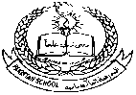**Pakistan School, Kingdom of Bahrain**

**E- Support and Learning Material / Session 2020-2021**

**Subject: General Science Grade: 6**

**Book: Oxford Secondary, Science 1 WORKSHEET 02 FIRST TERM**

**Unit 4: Living things and the environment pg 30-36**

**1. Select the correct answer:**

Pincers host Mutualism

Oxpeckers lichens herd

Parasitism

**1. Group of lions living together ___________**

**2. An animal or plant living at the expense of another living thing ____________**

**3. Alga and fungus benefit each other by living together ______________**

**4. Birds that cling onto the skin of large mammals and other invertebrates for ticks _____**

**5. The crab picks up a sea anemone using ____________**

**6. A parasite that gets its food from the living body of another organism __________**

**7. Two different type of organisms living together to benefit to each other without any harm ________**

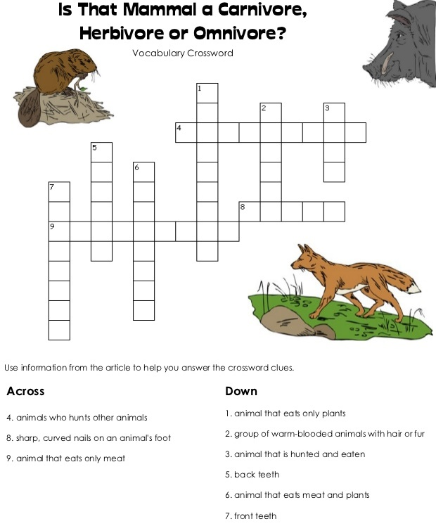

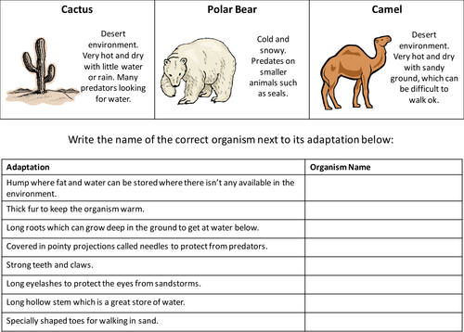

**HOMEWORK**

**Note: It should not exceed 7-8 lines** 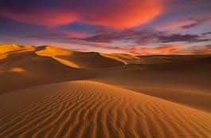

Write about any living organism, plant or animal of your choice from any one of the mentioned habitat

**Desert or Tropical Rainforest**

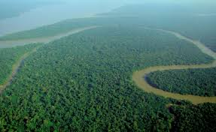

*Don’t forget to learn the question and answers*