**Pakistan School , Kingdom of Bahrain**

**E- Support and Learning Material / Session 2020-2021**

**Subject: English Grade : 8**

**Book: Student Book 3 FIRST TERM**

**Unit 1.1 It was the band Pg. No: 4 to 7**

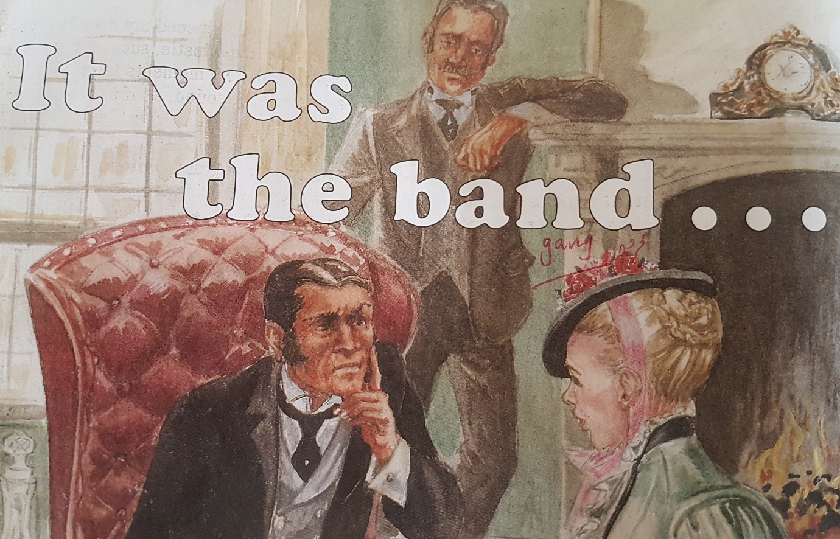

**Q.1 Vocabulary Words. Page 4 to 5**

|  |  |  |
| --- | --- | --- |
| Detective | Fatal | Mentioned |
| Splashing | Terrified | Wrapped |
| Rushed | Clanging | Withered |

**Q.2 Words Meanings. Page 6**

|  |  |  |
| --- | --- | --- |
| **No.** | **Words** | **Meanings** |
| **1** | Fatal | Endind in death |
| **2** | Security | Guard / secure |
| **3** | Blanched | Pale |
| **4** | Plantation | A large area for growing crops |
| **5** | Revolved | To turn around a center or point |
| **6** | Convulsed | Jerk / agitated |

**Q.3. Words sentences. Page 6**

|  |  |  |
| --- | --- | --- |
| **No.** | **Words** | **Sentences** |
| 1 | Fatal | The council had also a fatal defect in its constitution. |
| 2 | Security | Our security services have been improved. |
| 3 | Blanched | His face blanched with horror. |
| 4 | Plantation | The wretched gypsies lived in the plantation |
| 5 | Revolved | His world revolves around his father. |
| 6 | Convulsed | She **convulsed** on the cold marble floor. |

**Q.4 Comprehension. Page .5**

**Fill in the missing words.**

1. Dr. Roylott smoked ***cigars.***
2. Helen's sister had a low , clear ***whistle*** in the night.
3. Helen’s thought it might be the ***gypsies*** whistling.
4. The sister locked their bedroom at night because Dr. Roylott kept a ***cheetah*** and a baboon.
5. When Helldn's sister came out of her bedroom , sge seemed to be in terrible ***pain.***

**Q. 5 Answer the questions. Page . 6**

**Explain the following in your own words.**

1. Alight sleeper**.**  A light sleeper is a person who wakes up easily if there is any noise.
2. Your custom . It describesan action which is done by a lot of people for a long time.
3. Horror stricken. It means extremely shocked and frightened. This phrase gas been used for Hellen, who was scared to see her sister's door unlocked.

Q2.why do you think the writer describe on “That fatal night"?

**Ans.** The writer describes that night as fatal night because it brings death to Helen's sister.

Q3. Do you think the gypsies gad anything to do with the girl's death?

**Ans.** Gypsies sound were similar to speckles hissing that's why Hellen thought the whistling was coming from plantation.

Q4. Do you think Hellen’s sister had died by being:

Shot poisoned stabbed

**Ans.** Hellen’s sister had been died by poisoned because Dr. Roylott used a poisoness spackled banned for that purpose.

**Grammar and Punctuation page 7**

**Q.A. Copy and comete the table to show which type of noun each word is.**

|  |  |  |
| --- | --- | --- |
| **Noun** | **Common** | **Proper** |
| India |  | ● |
| Cheetah | ● |  |
| Dr. Watson |  | ● |
| Passage | ● |  |
| Wing | ● |  |
| Holmes |  | ● |
| God | ● |  |
| Band |  | ● |
| Sir Arthur Conan Doyle | ● |  |
| Gypsies |  | ● |

**Q.B. page 7.**

**Copy the Proper nouns and add the capital letters.**

|  |  |
| --- | --- |
| **saturday** | **dr roylett** |
| **voice** | **Lawn** |
| **november** | **Light** |
| **london** | **Lock** |
| **sam** |  |

**Ans.** Saturday November London Sam Dr. Roylett

**Q.C. Choose two proper and two common nouns from B and use them in sentences of your own.**

|  |  |
| --- | --- |
| **Noun** | **Sentences** |
| London | My friend lives in London. |
| Dr. Roylett | Dr. Roylett was very famous in our locality. |
| Voice | He heard a strange voice last night. |
| Lawn | They were playing in the lawn. |

**Work Book page 7**

**Circle the common noun and underline the proper nouns**

1. Helen was frightened of the baboon.
2. Dr. Roylett smoked cigars.
3. Sherlock Holmes was interested in the story.
4. Her step – father had liven in India.
5. Sir Arthur Canon Doyle wrote the Sherlock Holmes stories.

**Ex. B page 7 Write the nouns under the correct headings.**

|  |  |
| --- | --- |
| **Common Nouns** | **Proper Nouns** |
| **Door** | **Saturday** |
| **Rain** | **Africa** |
| **Whistle** | **Wednesday** |
| **Hands** | **Mr. Green** |
| **Passage** | **Dr. Drake** |

**Ex.C. page 7**

**Use these pairs in a sentence of your own.**

1. **There is a green train in Birmingham.**
2. **A huge crowd was supporting Manchester United.**