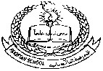**Pakistan School, Kingdom of Bahrain**

**E- Support and Learning Material**

**Subject: English Grade : HKG Sec: _____ Isa Town / Manama Student’s Name: _________________________________________________**

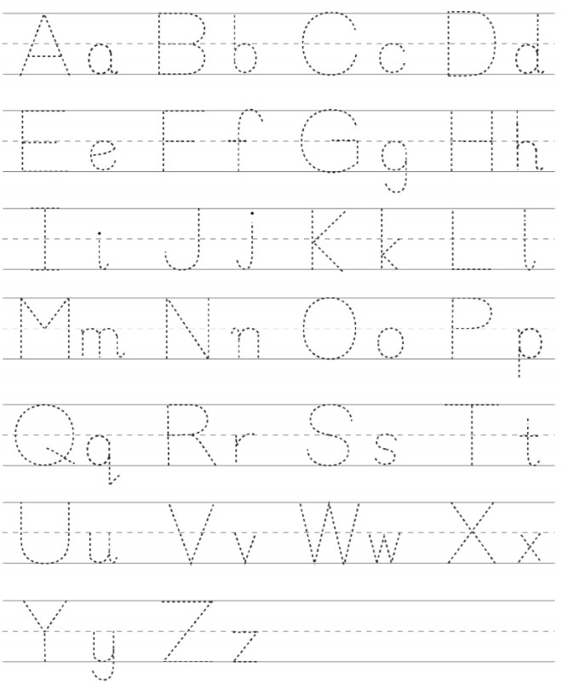**Q.1: Trace and write alphabets:**

**Q.2: Draw a line to match the capital letter to its small letter:**

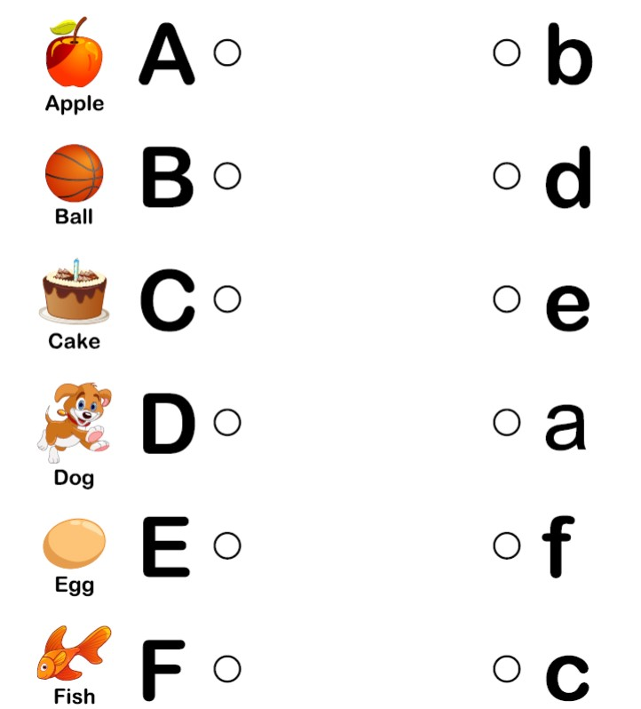

**Q.3: Fill in the missing alphabets:**

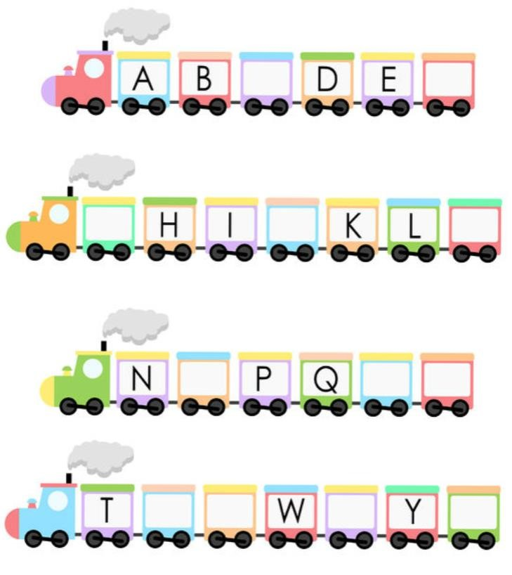

**Q.4: Write small letters of given alphabets:**

**,**

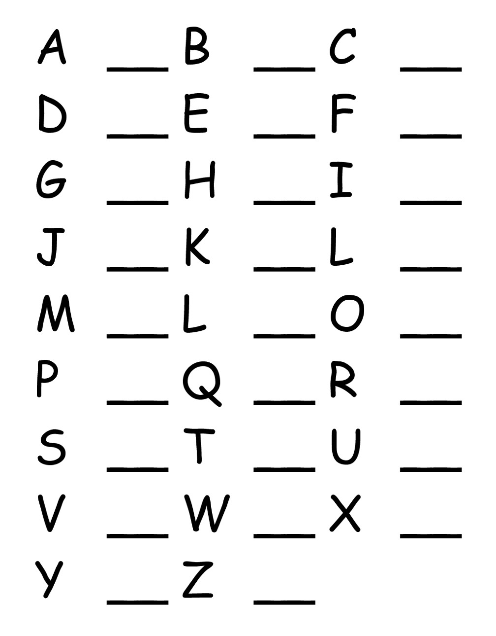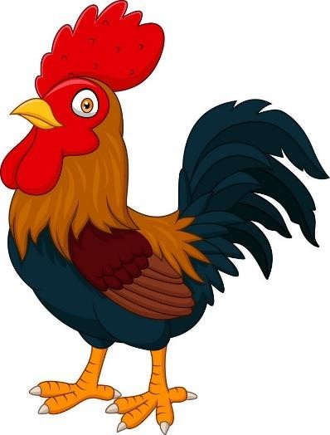

**HOMEWORK: Read and practice book page no. 2 ,3 , 4 ,5**