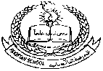**Pakistan School , Kingdom of Bahrain**

**E- Support and Learning Material / Session 2020-2021**

**Subject: islamiyat Grade: 1**

**Book: Islamiyat FIRST TERM**

**Unit 2 : Allah Pg. No: 7**

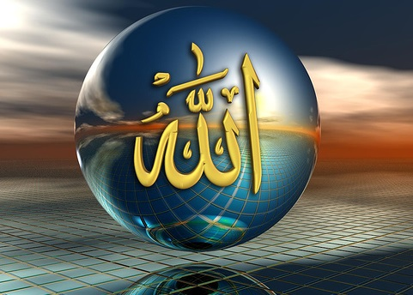

**Vocabulary words**

* Allah
* creator
* maker
* made
* world

**Write the answers of the given questions:**

**Q1:Who is Allah?**

Ans: Allah is our maker.

**Q2: Who made us?**

Ans: Allah made us.

**Q3: Where is Allah?**

Ans: Allah is everywhere.

**Q4: Who made our father and mother?**

Ans: Allah made our father and mother.

**Use these words to fill in the blanks:**

**mother, maker, sister.**

1. Allah made our brother and **sister.**
2. A creator is also a **maker.**
3. Our parents are father and **mother.**

**LEARN THESE Q/A.**

**WORKSHEETS**

**Unit 2: Allah is one, Allah the creator**

**Read notes carefully and solve this activity**

**Q1. State whether the statements are True or False :**

**1. Allah is the greatest. ________**

**2. Allah can do everything . ________**

**3. Allah did not make the sun and moon. _______**

**4. Allah has a family. ______**

**5. Allah created the sun ,moon and star. ________**

**Q:2 Complete these sentences to write the name of things created by Allah.**

* **Allah created the ____________**
* **Allah created the _____________**
* **Allah created the _____________**
* **Allah created the _____________**
* **Allah created the ____________**

**Q:3 Match the following:**

|  |  |  |  |
| --- | --- | --- | --- |
|  | **Allah is always** | **fruits and vegetables** |  |
|  | **Allah can** | **The only one God** |  |
|  | **He is Allah** | **do every thing** |  |
|  | **Allah knows** | **With us.** |  |
|  | **Allah gave us** | **everything** |  |

**Circle the things that Allah made for us:**

**[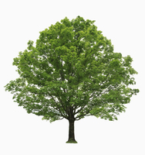](https://www.google.com.bh/url?sa=i&url=https://dictionary.cambridge.org/us/dictionary/english/tree&psig=AOvVaw3UoHnpRLKCrk7bINmGmURh&ust=1585033699828000&source=images&cd=vfe&ved=0CAIQjRxqFwoTCJi9sOiEsOgCFQAAAAAdAAAAABAm) [](https://www.google.com.bh/url?sa=i&url=http://clipart-library.com/sunlight-cliparts.html&psig=AOvVaw23ymcLVCRclWnRRoK2BAXK&ust=1585033978277000&source=images&cd=vfe&ved=0CAIQjRxqFwoTCICN4_aFsOgCFQAAAAAdAAAAABAD)** 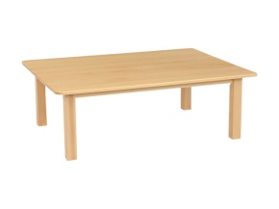

**[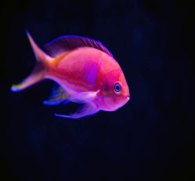](https://www.google.com.bh/url?sa=i&url=https://unsplash.com/s/photos/tropical-fish&psig=AOvVaw2wR7SDboKPulB5kduvy9Nd&ust=1585036473374000&source=images&cd=vfe&ved=0CAIQjRxqFwoTCNiS9ZKPsOgCFQAAAAAdAAAAABAD)** **[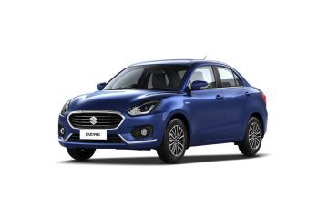](https://www.google.com/url?sa=i&url=https://www.zigwheels.com/newcars/Maruti-Suzuki/Swift-Dzire/on-road-price-bokaro&psig=AOvVaw0XhHml3DRVdKuaLe1F5uCU&ust=1585036535568000&source=images&cd=vfe&ved=0CAIQjRxqFwoTCPid9bCPsOgCFQAAAAAdAAAAABAO)** [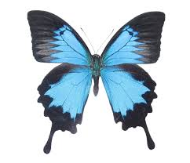](https://www.google.com/url?sa=i&url=https://bicbugs.com/product/papilio-ulysses/&psig=AOvVaw194bn9IcApHCJ8yJNxg-br&ust=1585037144896000&source=images&cd=vfe&ved=0CAIQjRxqFwoTCKjQ4dORsOgCFQAAAAAdAAAAABAD)

**Rubric**:

|  |  |  |  |  |  |  |  |  |  |  |  |  |  |  |  |  |
| --- | --- | --- | --- | --- | --- | --- | --- | --- | --- | --- | --- | --- | --- | --- | --- | --- |
| **Content Accuracy** | | | | **Creativity** | | | | **Completeness** | | | | **Neatness** | | | | **Total Points** |
| **1** | **2** | **3** | **4** | **1** | **2** | **3** | **4** | **1** | **2** | **3** | **4** | **1** | **2** | **3** | **4** |  |
| **1- Excellent 2 – Good 3- Satisfactory 4- Needs Improvement** | | | | | | | | | | | | | | | | |