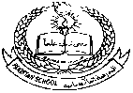**Pakistan School , Kingdom of Bahrain**

**E- Support and Learning Material / Session 2020-2021**

**Subject: Islamiat Grade : 3**

**Book: Islamiat for Primary Classes**

Unit 2: -**** **Pg. No: 8 (Reading of the lesson)**

s-e-r-v-a-n-t-s

servants

p-a-r-e-n-t-s

parents

**Difficult words:**

c-o-m-p-a-n-i-o-n

companion

c-h-i-l-d-r-e-n

children

c-r-e-a-t-o-r

creator

v-e-g-e-t-a-b-l-e-s

vegetables

m-o-u-n-t-a-i-n

mountain

g-r-a-t-e-f-u-l

grateful

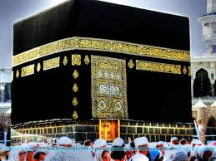

Answer these questions- Pg. 10

B

**1- Does Allah have a family?**

Ans- No, Allah does not have a family.

**2- Name some things that Allah has made.**

Ans- Allah has made the sun, the moon, the stars,

the seas, the rivers, the mountains and everything .

**3- Why has Allah made the day?**

Ans- Allah has made the day time for us to do our work.

**4-** **Why has Allah made the night?**

Ans- Allah has made the night for us to sleep.

**5- Why we must thank Allah?**

Ans- We must thank Allah for all His blessings.

**6- Who has made everything for us?**

Ans- Allah has made everything for us.

**6- How do you know Allah loves us?**

Ans- Allah loves us because He made everything for us.

**7- What is the best way to thank Allah?**

Ans- The best way to thank Allah is to pray and obey Him.

Write T for true and F for false statements

1- Allah has made only the sun. **False**

2- Allah has created the three seasons only. **False**

3- Allah has no companion. **True**

4- The best way to thank Allah is to obey Him. **True**

5- Allah cannot see us at night. **False**

**Use these suitable words to fill these blanks.**

Allah, birds, everything, thank, obey, time, animals, Maker

Book page# 11

1. Allah has made **everything** in this world.

2. Allah sees us all the **time**.

3. Allah is our **maker**.

4. We must pray only to **Allah**.

5. We must **thank** Allah for everything that He has given us.

6. The best way to thank Allah is to **obey** Him.

7. Allah’s creations include **birds** and **animals**.

**WORKSHEET**

Book page# 9

Here are some beautiful things that Allah has made. Name them

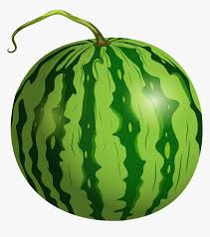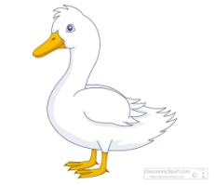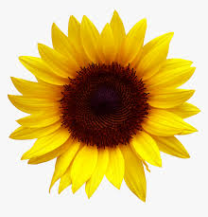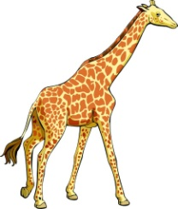

­______________ _______________ ______________ _______________

Draw and name four seasons Allah has created.

( Book page- 9)

**Rubric:**

|  |  |  |  |  |  |  |  |  |  |  |  |  |  |  |  |  |
| --- | --- | --- | --- | --- | --- | --- | --- | --- | --- | --- | --- | --- | --- | --- | --- | --- |
| **Content Accuracy** | | | | **Creativity** | | | | **Completeness** | | | | **Neatness** | | | | **Total Points** |
| **1** | **2** | **3** | **4** | **1** | **2** | **3** | **4** | **1** | **2** | **3** | **4** | **1** | **2** | **3** | **4** |  |
| **1- Excellent 2 – Good 3- Satisfactory 4- Needs Improvement** | | | | | | | | | | | | | | | | |