Class: 7th

Subject: Islamiyat

Chapter 2: Faith and prayers

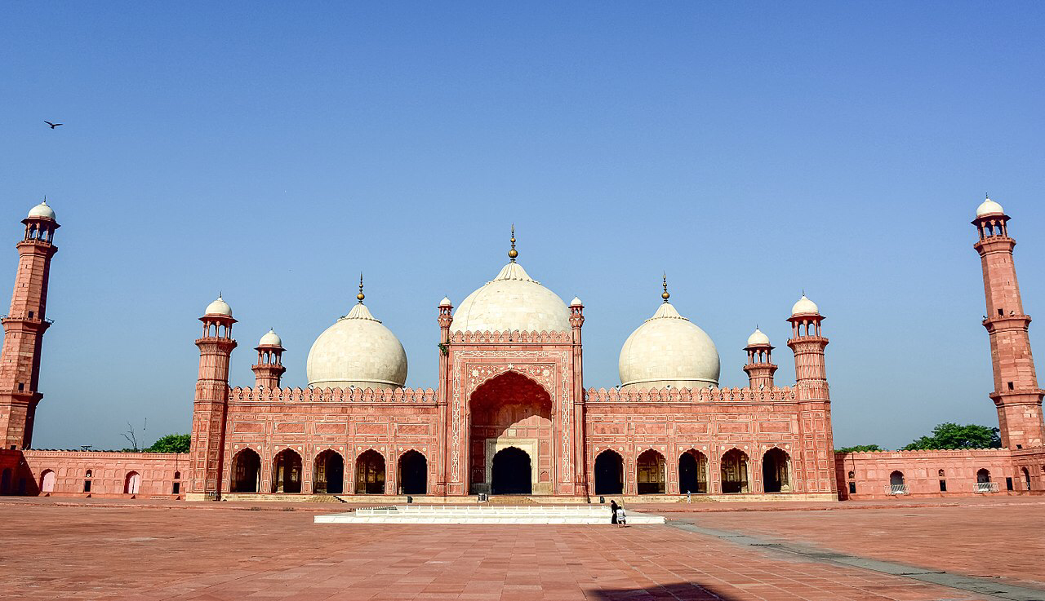

**Topics included:**

* Faith- Belief on Prophets (Risalat)
* Prayers (Concept of worship in Islam).

**Pakistan School , Kingdom of Bahrain**

**E- Support and Learning Material / Session 2020-2021**

**Subject: Islamiyat Grade : 7**

**Unit 2: Faith and Prayers. Pg. No: 8-11**

**Week - 2**

**Topic:1 Faith- Belief on Prophets (Risalat)**

**Short Q/A 1,2,3**

**Q1.What is the real purpose of our existences in this world?**

**Ans. The real purpose of our existence in this world is worship of Allah.To obey Allah and to live peacefully and amongst ourselves and His other creations.**

**Q2. What is the meaning of Risalat and who appointed to Rasuls and Prophets?**

**Ans. Risalat or Prophethood means conveying Allah's message. Rasuls or prophets are Allah's messenger whom He appointed to guide us through His angels and books.**

**Q3.What is the difference between Nabi and Rasuls?**

**Ans: Not all of messengers were given scriptures to relate us.These messengers are called Nabi ,Rasuls are Allah's messengers upon whom books were reveled to guide a particular ummah or community at a given time period in history.**

**Short Q/A 4,5**

**Q4.Who was the last prophet of Allah and why did he call the last prophet?**

**Ans. Hazrat Muhammad(S.A.W) of Allah. He was sent as a messenger for all humanity, and for all times to come. That is the reason he called the last prophets.**

**Q5.Write the name of six articles that form the base of Islam.**

**Ans. There are six articles that form the base of Islam.**

* **Belief in Allah**
* **Belief in Angels**
* **Belief in Allah's books**
* **Belief in Prophets**
* **Belief in the Day of Judgement**
* **Belief in destiny**

**WORKSHEET**

**Subject: Islamiyat Grade : 7**

**Unit 2: Faith and Prayers. Pg. No: 8-11**

**Week - 2**

**Topic:1 Faith- Belief on Prophets (Risalat)**

**Read Pg 8, 9,10 and find out the meanings of difficult words.**

**>Purpose >Existence > Spotless**

**>Yearned >Compassionate > Oppression**

**>Scripture >Tolerant >Immorality**

**>Humanity**

**Read Page 8,9 . Solve the two activities given below.**

**Activity#01**

**1)How many articles of faith are there in Islam?**

**Ans.**

**2)What is the purpose of our existence?**

**Ans.**

**3)What is our permanent home?**

**Ans.**

**4)What is the meaning of Risalat?**

**Ans.**

**5)Who was the first prophet of Allah?**

**Ans.**

**Activity#02**

**Fill in the blanks:**

**1)The prophets were able to impress upon their_________.**

**2)We must do ________deeds in this world.**

**3)All the prophets were_________messengers.**

**4)Prophethood means conveying Allah's___________.**

|  |  |  |  |  |  |  |  |  |  |  |  |  |  |  |  |  |
| --- | --- | --- | --- | --- | --- | --- | --- | --- | --- | --- | --- | --- | --- | --- | --- | --- |
| **Content Accuracy** | | | | **Creativity** | | | | **Completeness** | | | | **Neatness** | | | | **Total Points** |
| **1** | **2** | **3** | **4** | **1** | **2** | **3** | **4** | **1** | **2** | **3** | **4** | **1** | **2** | **3** | **4** |  |
| **1- Excellent 2 – Good 3- Satisfactory 4- Needs Improvement** | | | | | | | | | | | | | | | | |

**Rubric:**