Class: 8th

Subject: Islamiyat

Chapter 2: Faith and prayers

# E-Notes 2020

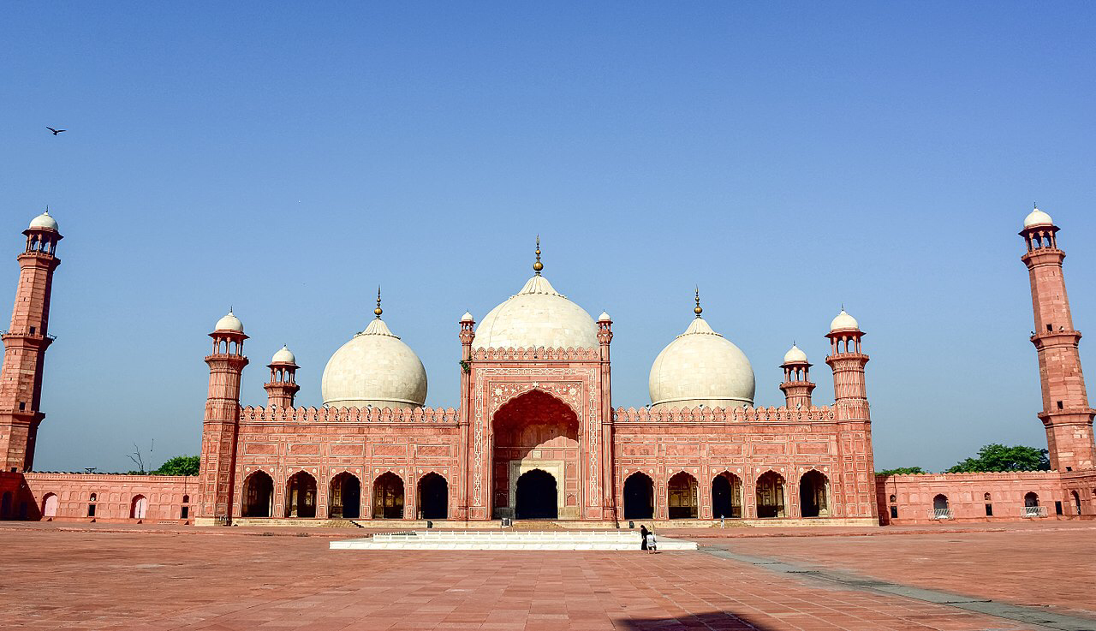

**Topics included:**

* Faith- Belief in life after death.

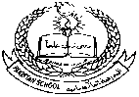**Pakistan School , Kingdom of Bahrain**

**E- Support and Learning Material / Session 2020-2021**

**Subject: Islamiyat Grade : 8th**

**Unit 2: Faith and prayers. Pg. No: 8-11**

**WEEK - 2**

**Topic:1 Faith- Belief in Life after Death**

**Short Q/A (LEARN)**

**Q.1.What is belief in life after death?**

**Ans. One of the basic articles of faith in Islam is the belief in life after death and accountability on the Day of Judgement. Life on this earth is not permanent and death is not end of our existence.**

**Q.2.What is accountability?**

**Ans. Each one of us will be shown the record of our actions in our lives and will be judged by Allah accordingly. We will have to answer for our actions. This is accountability.**

**Q.3. What does Quran tell us about the Day of Judgement?**

**Ans. The Quran tell us clearly that the Sun will lose its brilliance, the stars will clash, the mountains will explode into pieces, and the whole world will come to an end.**

**WORKSHEET**

**Subject: Islamiyat Grade : 8th**

**Unit 2: Faith and prayers. Pg. No: 8-11**

**Read Page number 08 and fill in the blanks with suitable words.**

**1.One of the basic _________ of faith in Islam.**

**2.Life on earth is ___________.**

**3.Each one of us will be shown the ________ of our actions.**

**4.Those who virtues _________ their sins will be pardoned.**

**5.The time of the __________ is known only to Allah.**

**Read Page number 10  and choose the correct answer from the given words.**

**1.The Quran tell us clearly that the __________ will lose its brilliance.**

**(a).Sun               (b). Stars (c). Planets**

**2.Every thing in this will come to an end and we will be __________ again.**

**(a). learn           (b). turn (c) born**

**3.Allah has given us the _______ to distinguish between right and wrong.**

**(a). money        (b). ability   (c) property**

**4. Every person is responsible for his ______.**

**(a) deeds           (b). goods (c) principles**

**5.Life on the earth is ________.**

**(a) permanent  (b). exemplary (c). temporary**

**Read Page number 11 and write True OR False for the given statements.**

**1.The belief in life after death has a very negative impact on our lives __________.**

**2.If there is no concept of life after death and accountability by Allah ‘the world would be a very chaotic place. ____________.**

**3.If we follow the principles laid down for us by Allah ‘we will lose our sense of direction ___________.**

|  |  |  |  |  |  |  |  |  |  |  |  |  |  |  |  |  |
| --- | --- | --- | --- | --- | --- | --- | --- | --- | --- | --- | --- | --- | --- | --- | --- | --- |
| **Content Accuracy** | | | | **Creativity** | | | | **Completeness** | | | | **Neatness** | | | | **Total Points** |
| **1** | **2** | **3** | **4** | **1** | **2** | **3** | **4** | **1** | **2** | **3** | **4** | **1** | **2** | **3** | **4** |  |
| **1- Excellent 2 – Good 3- Satisfactory 4- Needs Improvement** | | | | | | | | | | | | | | | | |

**Rubric:**