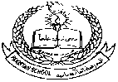**Pakistan School , Kingdom of Bahrain**

**E- Support and Learning Material / Session 2020-2021**

**Subject: Islamiyat Grade : H.K.G Sec: ____**

**Name : ______________________ Isa Town / Manama**

***Topic no: 2 Learn these Duas:***

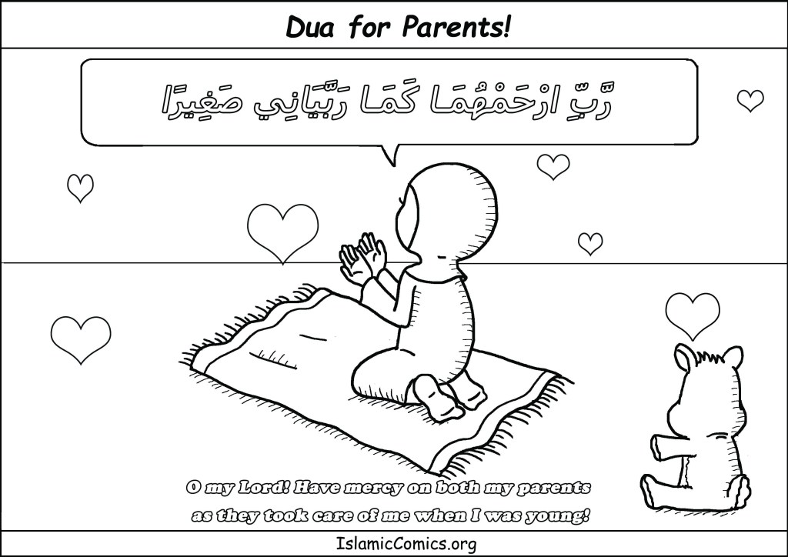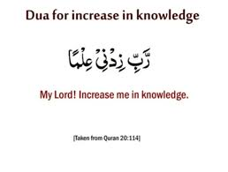

Dua before eating

Watch and Listen : <https://youtu.be/he3RhtApdX0>

