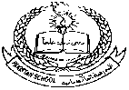**Pakistan School , Kingdom of Bahrain**

**E- Support and Learning Material / Session 2020-2021**

**Subject: Islamiyat Grade : L.K.G Sec: _____**

**Name : _________________________ Isa Town / Manama**

Dua before eating

Watch and Listen : <https://youtu.be/he3RhtApdX0>

