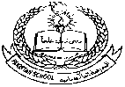**Pakistan School, Kingdom of Bahrain (Junior Section)**

**E- Support and Learning Material / Session 2020-2021**

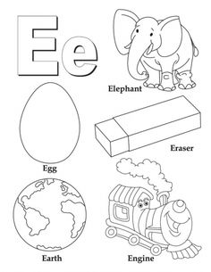Color letter E:



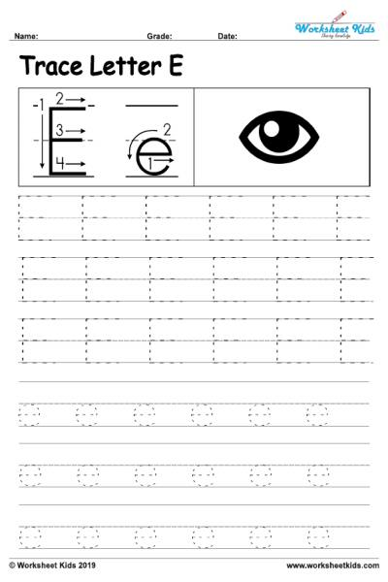

**Trace the letter E:**



Circle letter E:

E E B N E M E T E

V B N G E B L I E



**Pakistan School, Kingdom of Bahrain ( Junior Section)**

**E- Support and Learning Material / Session 2020-2021**

**Subject: English Grade: LKG**

**NAME**____________________________  **DATE**_______________

Color the friends of letter F:

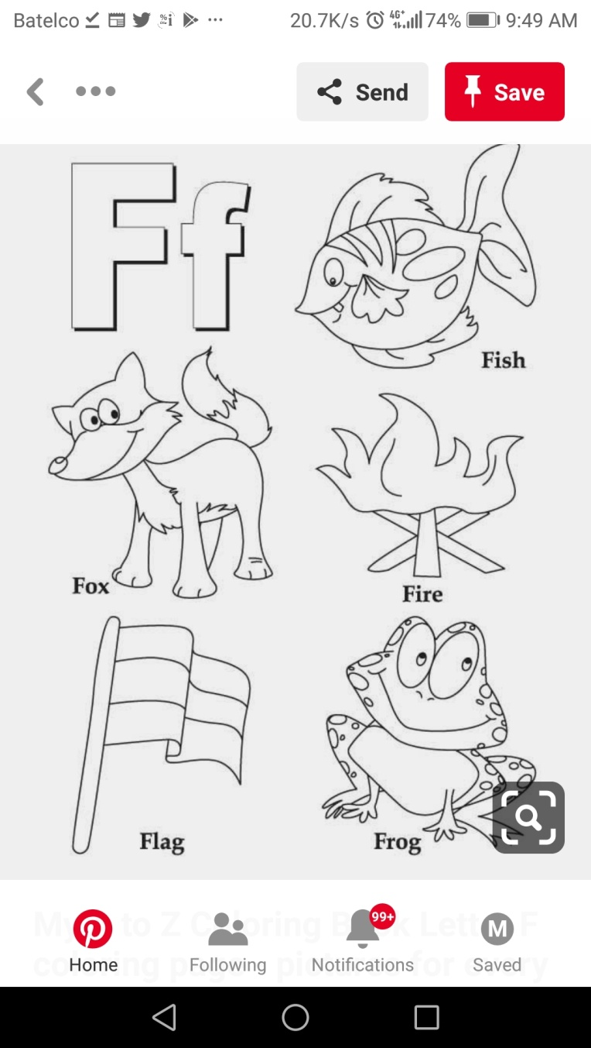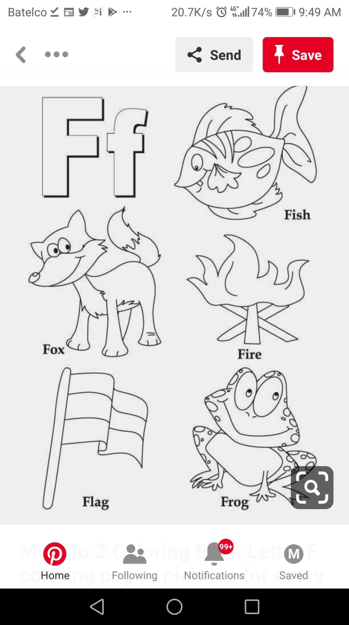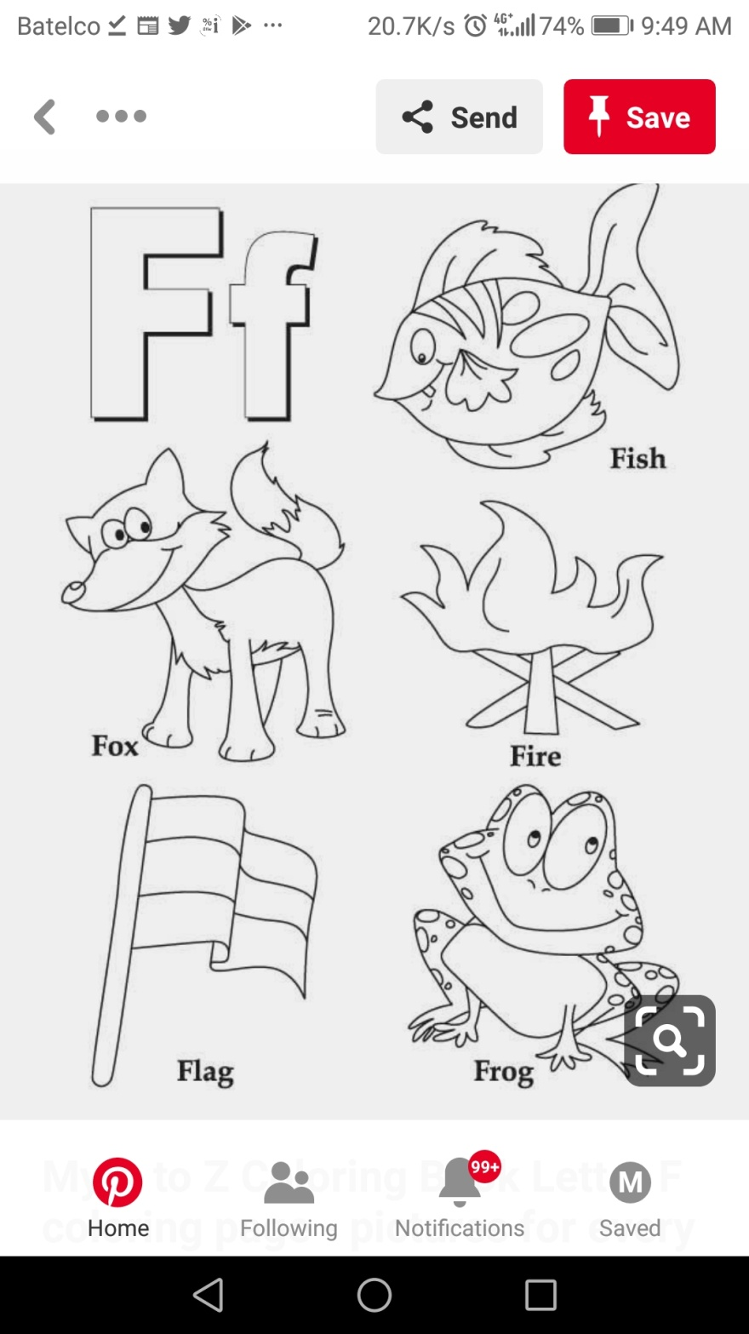

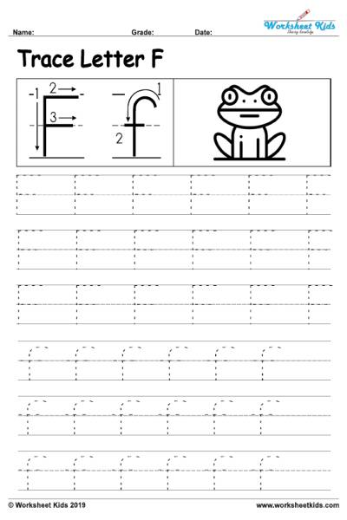

**Trace the letter F:**

Circle letter F:

F F B N F M F T F

V B N G F B L I F



**Pakistan School, Kingdom of Bahrain ( Junior Section)**

**E- Support and Learning Material / Session 2020-2021**

**Subject: English Grade: LKG**

**NAME:** ____________________________________

* 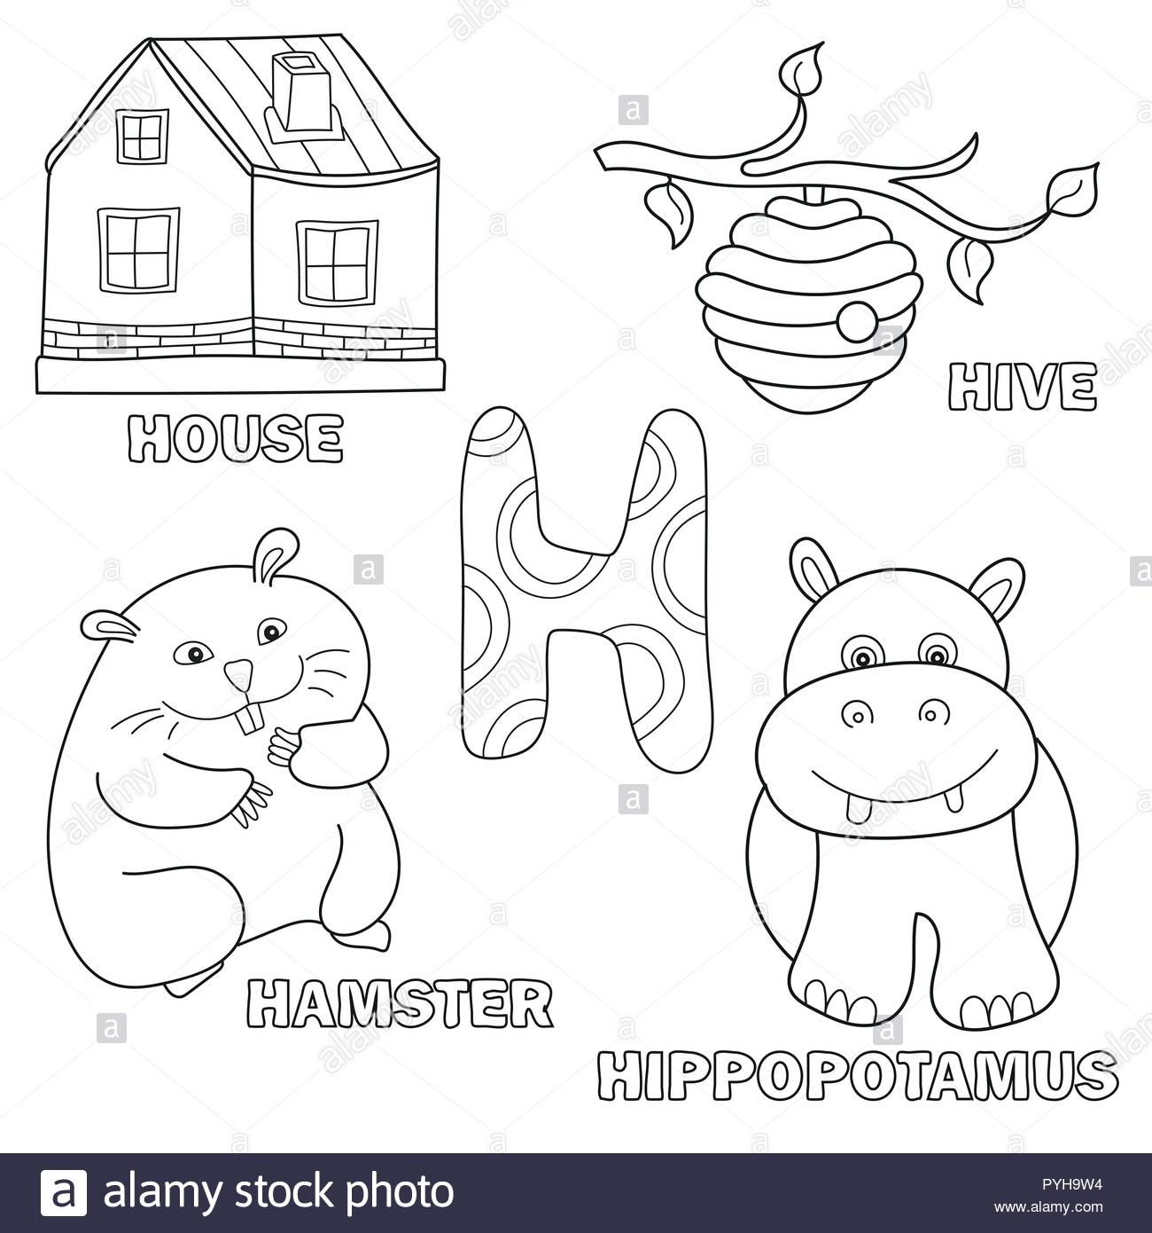Color the friends of letter H:



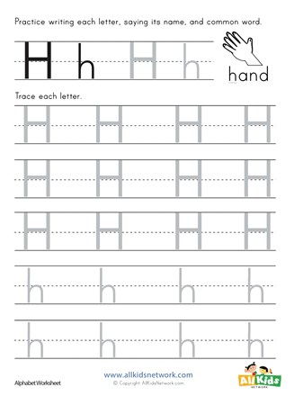

**Trace the letter H:**

Circle letter H:

H H B N H M H T H

V B N G H B L I H



**Pakistan School, Kingdom of Bahrain ( Junior Section)**

**E- Support and Learning Material / Session 2020-2021**

**Subject: English Grade: LKG**

**Name:_____________________**

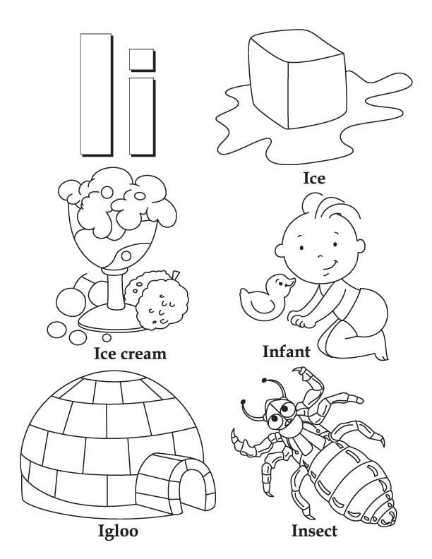Color the friends of letter I:



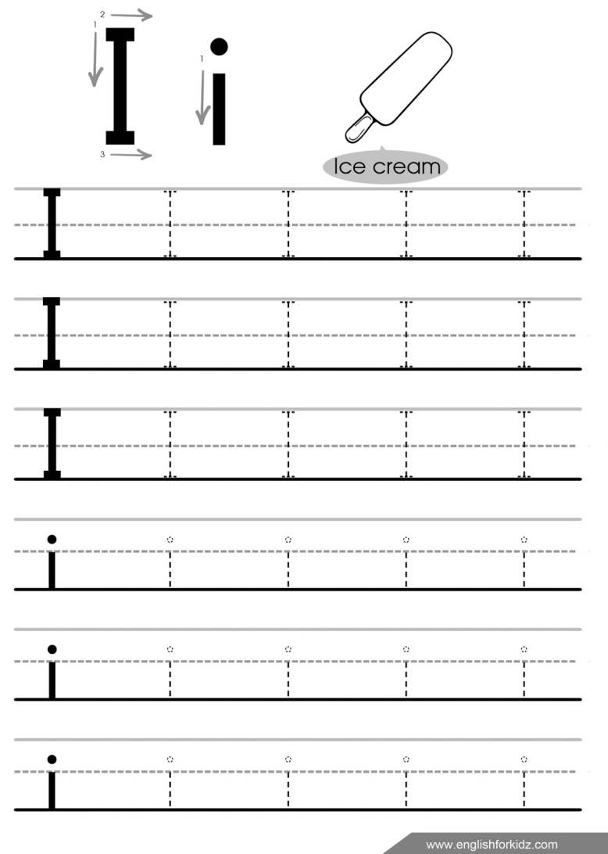

**Trace the letter I:**

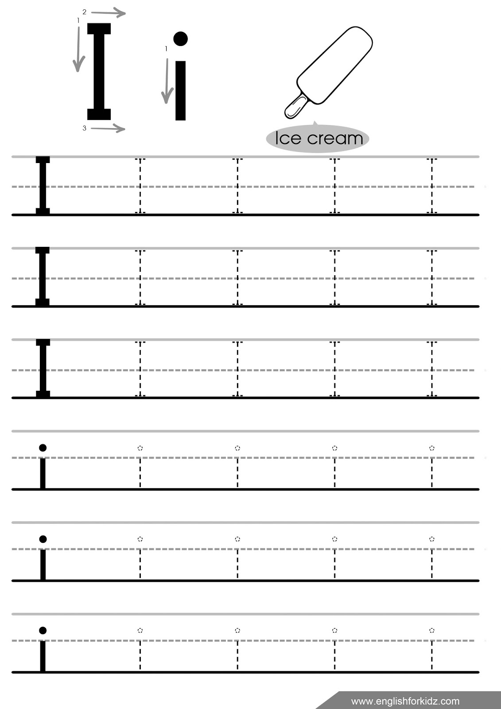

Circle letter I:

I I B N I M I T I

V B N G I B L I

**Pakistan School, Kingdom of Bahrain ( Junior Section)**

**E- Support and Learning Material / Session 2020-2021**

**Subject: English Grade: LKG**

**Name: _____________________ Date:__________**

**COLOUR THE LETTER L**

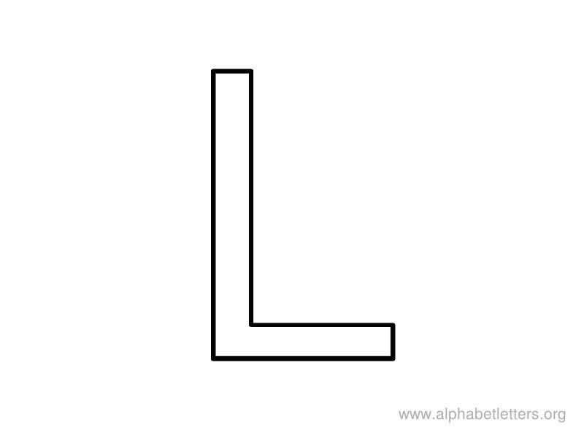



**L is for Lion**

**TRACE THE LETTER L:**

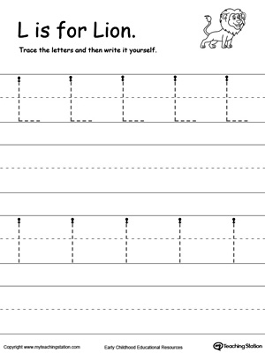

**CIRCLE THE LETTER L:**

O L J R L H M L V

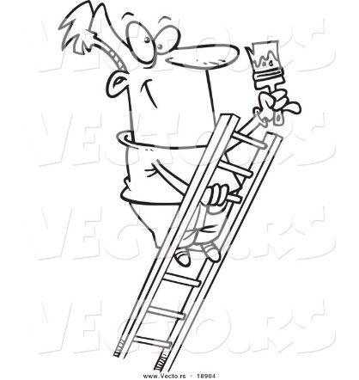

ENGLISH BOOK 1– Seeing Difference Do (Pg. 2 , 3 , 4 , 5 )