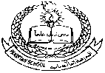**Pakistan School , Kingdom of Bahrain**

**E- Support and Learning Material / Session 2020-2021**

**Subject: Islamiyat Grade : LKG ( ) ( Isa Town / Manama)**

**Name : ________________________**

Recite and learn it by heart.

Kalima Tayyab

