**Pakistan School, Kingdom of Bahrain**

**E- Support and Learning Material / Session 2020-2021**

**Subject: Social Studies Grade: 2**

**Book: New Oxford Social Studies FIRST TERM**

**Unit 2: Lsn: 3: Your School Pg. No: 12 (Notes)**

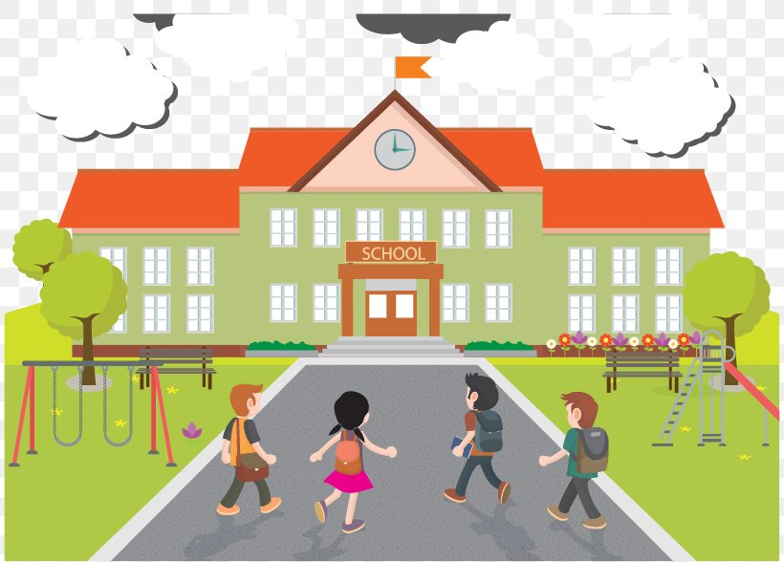

**Junior, Middle ,Senior , computer lab, library ,play ground,Principal’s office,subjects.**

**Difficult Words:**

**Q1: What is the name of your school?**

Ans: The name of my school is Pakistan School .

**Q2: How long have you been studying here?**

Ans: I have been studying here for three years.

**Q3: What are the different levels of school?**

Ans: 1. Junior 2. Middle 3.Senior 4.College 5.University.

**Q4: In which subject do you learn about numbers?**

Ans: In Mathematics.

**Q5: Write the names of the languages you learn in school?**

Ans: Urdu , Arabic, English.

**Q6: Why are sports good for us?**

Ans: Games help us relax and keep us healthy.

**library __ canteen _Principal’s office__ Computer lab _ play ground**

1. There are computers in **Computer lab.**

2. We enjoy and play in **playground.**

3. We buy eatable things from **canteen.**

4. We read books in **library.**

5. Principal works in **Principal’s office.**

**Write Whether these statements are true or false.**

1: When you are older you will go to a primary school. ( **F**  )

2: There is principal’s office in the school. (  **T)**

3: There is no library in the school. (  **F**)

4: When students leave the school, they go to a college. **(T)**

**Match the following**

|  |  |  |  |
| --- | --- | --- | --- |
| 1 | History | reading,writing,and speaking | 3 |
| 2 | Mathematics | about plants,animals,and how things work | 6 |
| 3 | Languages | about numbers | 2 |
| 4 | Art | Exercising the body | 5 |
| 5 | Sports | about the past | 1 |
| 6 | Science | about the people and countries of the world | 7 |
| 7 | Geography | Drawing and painting | 4 |

**WORKSHEET**

**Name: _______________ Grade :3 Social Studies**

**Read the notes of Your school carefully and complete this worksheet.**

**Q1: Choose the right answer:**

**1. When you are older, you will go to a ___________________ school. (senior/ primary)**

**2. We read books in _________________________. (canteen/ library)**

**3. We enjoy and play in ___________________. (playground / Computer lab)**

**4. There are computers in ____________________. (computer lab / library)**

**5. We buy eatable things from___________________. (library/ canteen)**

**Q2: Try to answer these questions about your school:**

1. **Is there a staff room? _____________**
2. **Is there a library? _________________**
3. **Is there a playground? ______________**
4. **Is there a canteen? _________________**
5. **Is there a Principal’s office? ____________**

**Q3: Fill in the form below:**

**1. My favourite subject:__________________________________**

**2. My teacher:__________________________________________**

**3. Title of my textbook:___________________________________**

**4. Author’s name:_______________________________________**

**5.Number of pages:______________________________________**

**6.I like_________________________________________________**

**Home work: Draw picture of your school, and write few sentences about your school.**

|  |  |  |  |  |  |  |  |  |  |  |  |  |  |  |  |  |
| --- | --- | --- | --- | --- | --- | --- | --- | --- | --- | --- | --- | --- | --- | --- | --- | --- |
| **Content Accuracy** | | | | **Creativity** | | | | **Completeness** | | | | **Neatness** | | | | **Total Points** |
| **1** | **2** | **3** | **4** | **1** | **2** | **3** | **4** | **1** | **2** | **3** | **4** | **1** | **2** | **3** | **4** |  |
| **1- Excellent 2 – Good 3- Satisfactory 4- Needs Improvement** | | | | | | | | | | | | | | | | |

**Rubric:**